Fold two pieces of paper or thin card in half.
One piece will be the outside of the card and one piece will be the inside.

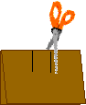 | On the piece that will be the inside, cut two short lines near the middle of the fold.

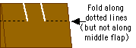 | Fold the two outside flaps that you just made (but do not fold the middle flap). Unfold the flaps.

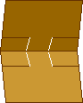 | Open the card.  Push the two flaps towards the inside of the card - they will form 2 step-like protuberances. | 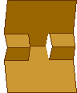

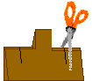 | Refold the card. Cut two short lines through both the folded flaps on the sides.  Fold the outside flaps that you just made. Unfold the flaps. | 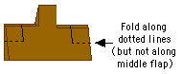

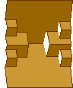 | Open the card. Push the two flaps towards the inside of the card - they will form 4 more step-like protuberances.

 | Cut some small flowers, stems and leaves from stiff paper. Decorate them with crayons or felt tip pens if you like.

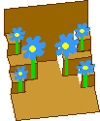 | Glue the flowers to the flaps. Make sure that the flowers do not stick out of the card when the card is closed.

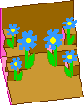 | Glue the card to the other piece of folded card. To make sure that you do not glue the flaps down, apply the glue only to the outside of the inner card and then carefully place it on the outer card.  Write a message on your lovely flower garden pop-up card. | 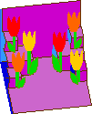
Source : http://www.enchantedlearning.com/

