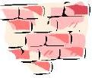
Let there be peace on earth
Add a brick to our unit peace wall.
Global

Awareness
When you join Guides you become part of a very special family with over 10,000,000 sisters in 144 countries around the world.
The name of our Guiding family is
W.A.G.G.G.S. but what does this
stand for? Have a look in your
G-File to find out.
Design a poster to tell people
about our Guiding family.

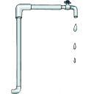
We use and need water every minute of every
day. It is essential to
sustain life. Over 2/3 of
the world is water in oceans,
rivers, lakes and ground water.
Much of this has been exploited,
mismanaged and polluted, and is taken
for granted in many parts of the world.

How sussed are you about water? Do this quiz to find out.
1.How far do you have to travel to get a drink of water?
2.What is the average distance that women in Africa will walk to collect water?
a) 1kmb) 300metresc) 3kmd) 10km
3.How many litres of water does the average person in the UK use every day?
a) 135b) 10c) 250d) 60
4.How many litres of water, on average, does a person in a developing country have access to
every day?
a) 100b) 150c) 10d) 40
5.Approximately how many litres of water do you use every time you flush the loo?
a) 1b) 25c) 10d) 25
6.How many litres of water does it take to make 100g chocolate?
a) 1b) 5c) 100d) 5
7.Dirty water can lead to which of the following diseases?
a) diarrhoeab) cholerac) eye infectionsd) blindness
8.How many people in the world get water from a pump, well or hole in the ground?
a) 1/4b) 2/3c) 1/10d) 1/2
Do you like chocolate? Most people do.....in Britain we spend £3 billion on it every
year.
When you buy a bar of chocolate, what is the first thing you think of? The taste? What it looks like? How much it costs? Or the people who grow the cocoa beans? - They're probably the last thing on your mind! However, the farmers who grow the cocoa beans to make your bar of chocolate are the people who get the worst deal from your purchase. Instead, it is the big chocolate companies and the advertising

agencies who take most of the profits.
But there is an alternative - Fair Trade! This gives the people that produce the goods you buy a
fair deal. Sound too good to be true? Not necessarily - read Lucy Mansa's story:
Lucy Mansa is a cocoa farmer who makes her living by growing and selling cocoa beans. She lives in a small village in Ghana called Fenaso Domeabra. Most of the cocoa beans grown in Ghana are sent to the UK and other countries in Europe where they are made into chocolate. The price farmers receive for their cocoa beans is often very low and few of them can afford
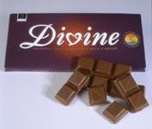
to buy chocolate.
A few years ago Lucy and other farmers in her village were struggling to survive. They were forced to sell their cocoa to the Ghanaian government. They were often cheated and earned very
little money for their hard work.

Fair? Of course not. But what could she do? Very little, until 1993, when other cocoa farmers in the same situation decided to get together and form their
own company.
They called their company Kuapa Kokoo, which means "good cocoa farmer." It has really helped Lucy and thousands of other farmers. Kuapa Kokoo pays all its farmers a fair
price for their crop, in cash, and on time.
The Fair Trade Mark
When you're shopping remember to look out for the Fair Trade Mark. This is an international label which appears on Fair Trade goods. It shows that what you're buying really does help those who have produced it. And remember - if your supermarket doesn't sell Fair Trade goods then ask

them to. You can make a difference.
Try this recipe for chocolate truffles from the Oxfam Active 8 website and share the results with
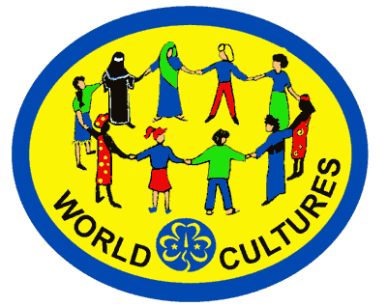
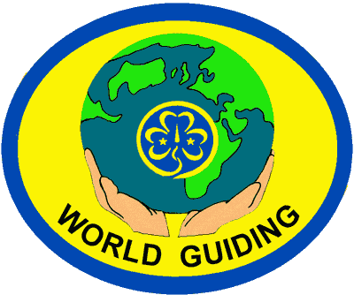
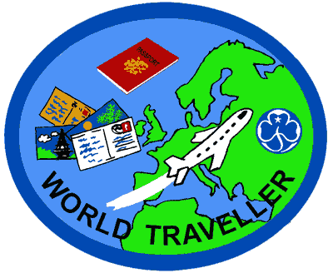
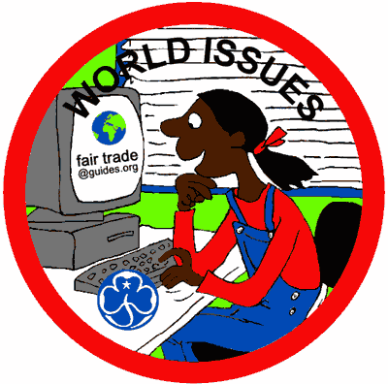
your patrol.
If these ideas
look interesting
why not have a
go at the World
Cultures, World
Guiding, World
Issues & World
Traveller badges.
Ingredients:
100g (4oz) Fair Trade dark chocolate 100g (4oz) unsalted
2 teaspoons Fair Trade instant coffee butter
2 tablespoons Fair Trade cocoa 100g (4oz) icing sugar
Method:
Melt the chocolate in a bowl over a pan of simmering water.
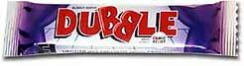
Carefully beat in the butter, sugar and coffee. Chill the
mixture in the fridge for 30 minutes until it has hardened
sufficiently to be rolled into balls. Roll them in the cocoa
and store in the
fridge until ready
to serve.
Do something for our
community - maybe
you could raise
some money for
your favourite
charity, do the
shopping for
your gran, look
after a neighbour's
garden, wash your dad's car
or take part in a service
project with your patrol or
the whole unit.
All Guides should try to
come to Church Parade
which is usually held at
half past nine in the
morning on the third
Sunday of every
month, during term
time.

Come to Church
Parade and don't
forget to say hello
to the vicar!
Maybe you will get
the chance to
carry a flag,
to read a
prayer
or to
help
take the
collection.
Celebrating Diversity
Festivals of Light.
Did you know that light is an important symbol in lots of different religions?
Jews celebrate Hanukah,
Christians celebrate
Christingle, Sikhs and
Hindus celebrate Diwali,
and Buddists celebrate
Loi Krathong.
Find out about one of
these festivals.
Produce a leaflet that
you could give to
someone who wanted
to know about the festival you have chosen.
Imagine what it
would be like if
you were deaf.
Work out how to
spell your name using the manual alphabet.

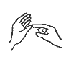 |  |  | 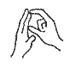
A | B | C | D
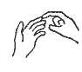 |  |  | 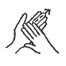
E | F | G | H
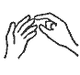 | 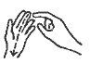 | 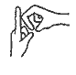 | 
I | J | K | L
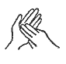 |  | 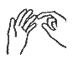 | 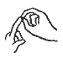
M | N | O | P
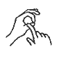 | 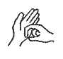 | 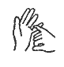 | 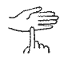
Q | R | S | T
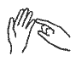 |  | 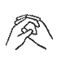 | 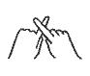
U | V | W | X
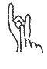 |  |  | 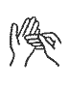
Y |  |  | Z

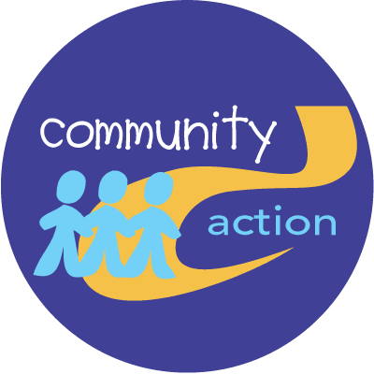
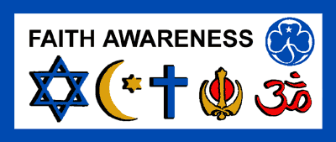
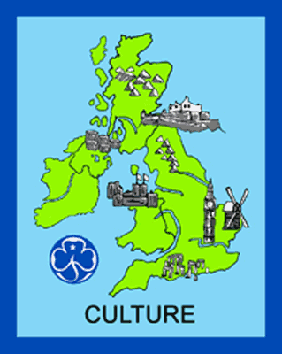
If these ideas have
inspired you why
not have a go at the Community Action, Culture or Faith Awareness badges.
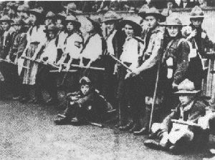
Have a go at the G-File quiz in your welcome pack. All the answers are in the G-file somwhere!
Ask the Guiders or the other Guides for help if you can't find some of the answers.
Crystal Palace
London
4th September 1909

Dear ...

Guides started all the way back in 1910 after a group of girls went to the first Scout rally in 1909 at Crystal Palace in London and convinced Lord Baden-Powell to let them join in the fun.

Imagine you were
one of those girls
and write a letter
to a friend about
your big day out.
Have a look in
your G-file for
some ideas.

God save our gracious Queen,
Long live our noble Queen,
God save the Queen.
Send Her victorious,
Happy and glorious,
Long to reign over us:
God save the Queen.

Thy choicest gifts in store
On Her be pleased to pour,
Long may She reign.
May She defend our laws
And ever give us cause
To sing with heart and voice,
God save the Queen.
Learn 2 verses of our National Anthem:

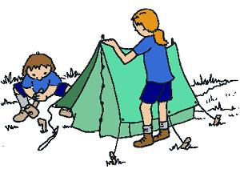
Find out the 3 different types of pegs used to put up a Patrol tent and how to hammer them into the ground correctly. Demonstrate this to a Guider.

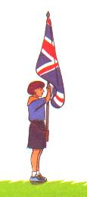
Discovery
Find out and demonstrate how to carry a flag properly.
Have a go at carrying
both the Union Flag and our Guide flag.
Find out why the
Union Flag should not
normally touch the
floor and when it can.
Don't forget, you'll
need to ask the Guiders for help with this one.
The Queen used to be a Guide. She and her sister, Princess Margaret
were members of the 1st Buckingham Palace Guides.
Princess Margaret was the President of Girlguiding
UK until she died in 2002.
Our current president is
the Queen's daughter-
in-law, HRH the
Countess of Wessex.
Did you know...?
If these ideas
look interesting
why not have a
go at the
Traditions of
Guiding badge.
