




So you've just joined Guides.....You may have been a Rainbow and a Brownie
before or not - it doesn't matter.
There are lots of fun things to do in Guides and one of the
first things you'll probably want to do is make your Promise.
This is a very important moment for all Guides. You can make
your Promise in all sorts of places - on a Guide trip, at
Guide camp, perhaps at a special event like a Guide fun day,
or maybe by candlelight in the Guide meeting. It's up to
you.
So what do you need to do before you're ready to make your
Promise?
Well the first thing to do is to learn the Guide Promise and the
Guide Law. You'll find these in your G-file and in your welcome
book.
You also need to complete 5 activities - one from each section of this special book called a "Go For It!"
What is a Go For It!...?
Go For Its! are fun patrol activity packs. They are all based on
different themes e.g. Teamwork, Peace, Survival, Flights of Fancy,
Healthy Eating, Take Action, Football, Chocolate and Animal Active.
This Go For It! is a special one, just to help you get ready to make your Promise.
It is divided into 5 sections - Healthy Living, Life Skills, Global Awareness, Celebrating Diversity and Discovery. All you need to do is choose one activity from each section, let your Guider know which one's you're going to do and then check with her when you think you've finished each of them.
So let's get started.....


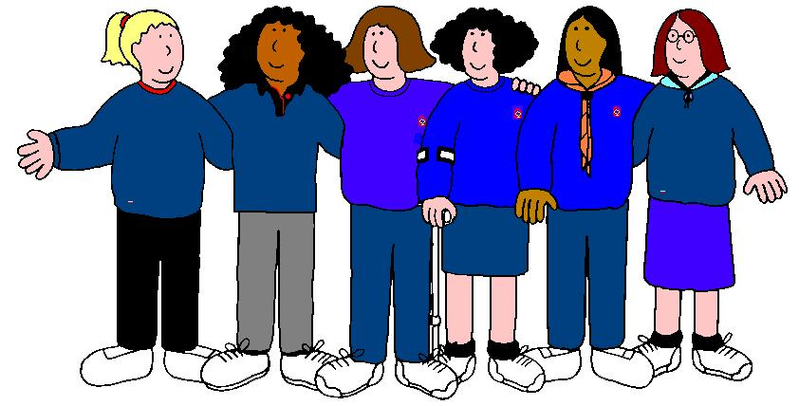

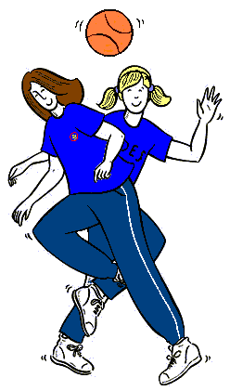
Set yourself a fitness challenge - maybe you could make sure you get at
least 8 hours sleep a night for a week, try to stop biting your nails,
drink 2 litres of water every day or give up chocolate or crisps
for a week!
Make yourself a chart to record how you did.
Join in - enthusiastically! -
with an active game at Guides.
Healthy Living

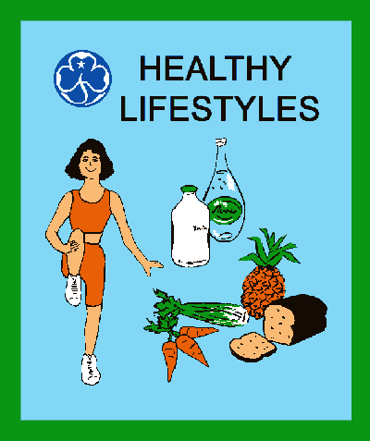
If these ideas look interesting why not have a go at the Healthy Lifestyles badge.
It is recommended that we eat at least 5 portions of fruit and
vegetables every day. Design a poster to advertise this fact.


What would your
ideal bedroom look like? Produce
your own design for it. You could
draw it, do it on a computer, use
pictures from magazines &
catalogues, even make a model...
The only limit is your
imagination!

How well do you know the other Guides in your patrol?
Some of them you may
have known from
school or Brownies,
others you may
have met for the
first time at
Guides. If you're
not friends already,
hopefully you soon will
be! Complete the "Getting
to Know your Patrol" quiz in
your Welcome booklet to find out more about them...

Life Skills
Do you know what to do in an emergency?
Explain to a
Guider how to
call the
emergency services.

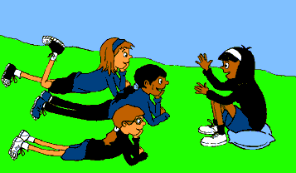
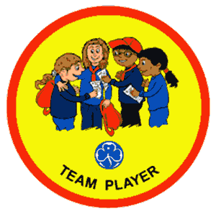
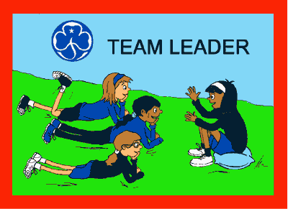
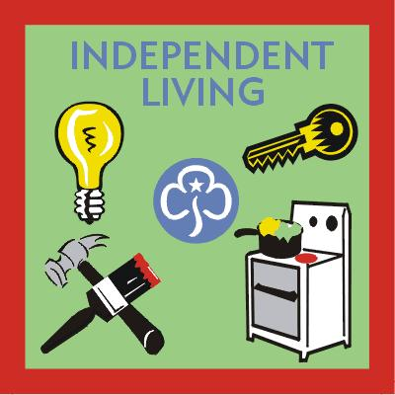
Take part in a planning session with your patrol - patrols get to work
together on lots of cool things, including Go For Its! similar to this one.
You can't just jump
straight in though!
You need to think about
what you want to do, what you're going to
need, who's going to bring what and how
much it's going to cost. Don't forget to
check with your Guider that your ideas are
ok and then get yourselves organised.....
what are you waiting for!

Everyone should know the Green Cross Code. Find out what it is (if necessary) and
then make a poster explaining it for Rainbows.
X
If these ideas look interesting why not have a go at the Team Player, Team Leader or Independent Living badges.

