WESTERN HEMISPHERE
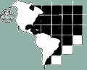

Try some activities from the Western Hemisphere. You could try a craft,
a recipe, a game, a song…

Games

Cascudinho (Little Bee) - Brazil
You need 2 teams and one goal. If you have a goalkeeper they do not belong to any team; their role is keeping the goal. When one team attacks, the other one plays defensively, trying to stop the ball reaching the goal. When the other team succeeds in stealing the ball, it tries to kick it into the goal and the other team then defends.

DeadBox - USA
To play Deadbox, you either chalk or paint a large box in the street. In the centre of this box was a smaller box with the picture of a skull and cross bones in it. Along the inside of the outer box were 13 small squares, one inside each of the four corners and the rest along the sidelines. The playing pieces were bottle caps, the small flat ones with the ridges.
The object of the game is to flick the bottle caps into each numbered box in order from 1 to 13. However, if you landed in the centre box which was the deadbox, you were either out of the game or you had to start back at square 1, depending on which set of rules you decided on at the beginning of the game.
When you number the squares you try and do it so the bottle cap has to cross the deadbox as many times as possible.

Basketball is very popular in the USA… can you work out a version we can play in the hall? Try it out and then teach it to the rest of the unit.

Song and dance
Learn or practice a song and teach or lead it at a unit campfire.
- Who stole the cookie from the cookie jar? (USA)
- On my honour (USA)
- Be kind to your web footed friends (USA)
- Canoe song (my paddles keen and bright) (Canada)
- Rum Macca Run (Mexico)
- Land of the Silver Birch (Canada)
- It’s a small world (USA)

If you don’t want to sing…
Try line dancing, Caribbean steel drumming or make a rainstick (see below) & find a way to use it!

Food to make and eat!

- Make popcorn
- Try nachos with salsa – maybe you could make your own salsa?
- Make brownies or muffins

Cookies
Girl Scouts in the United States of America sell cookies every year to raise money. Make some cookies or sweets, sell them and send the proceeds to The Guide Friendship Fund or another charity.

Things to Make

Mexican Festivals
Launching of cohetes (homemade skyrockets), is a tradition in Mexico going back centuries when the noise was considered to scare away the devil and vanish all evil. Make and use film canister rockets!

Mexican Gods Eyes
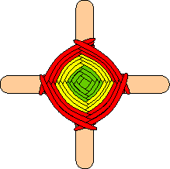

You Need
Wool in several colours
2 lolly sticks or cocktail sticks.
Scissors
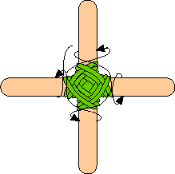
How To Make It

Put the two sticks together in a cross.
Take one colour of wool and tie it onto the two sticks where they cross.
Wrap it over and around one stick, then over and around the next, over and around the next, and so on. Keep doing that until the colour is used up.
Tie a different colour wool onto the old one with a tight knot.
Repeat until complete.
Take a piece of string for a hanger, cut it, and tie or glue it to your God's Eye. Hang it up in your room to enjoy.

Dream catchers
Try making a native American dreamcatcher.

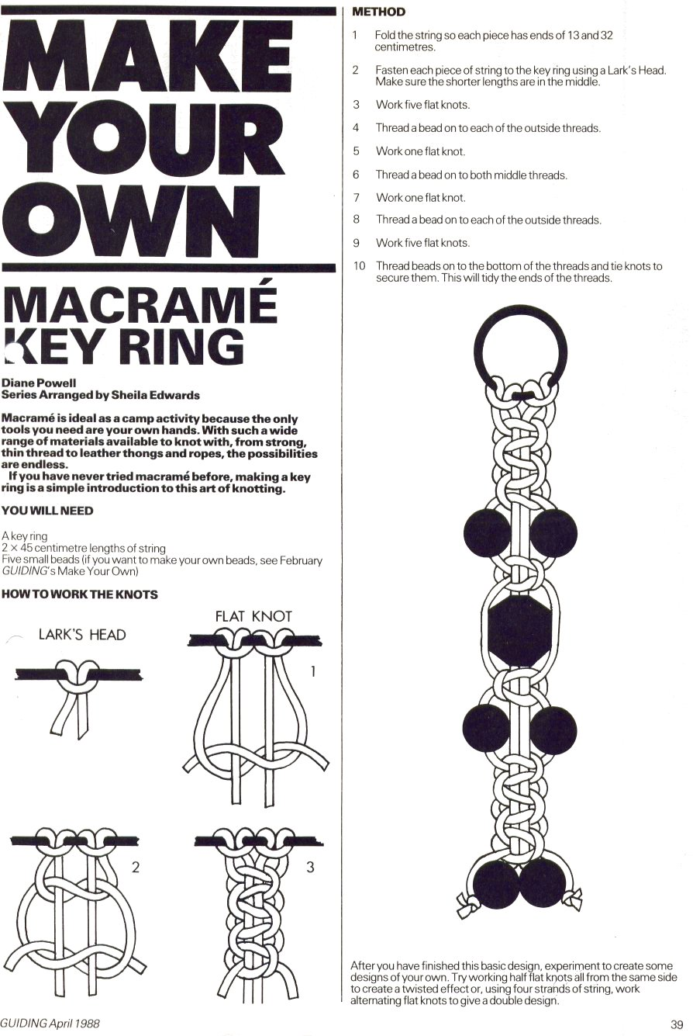
Make a Rainstick

Rainsticks are ceremonial musical instruments used to invoke the rain spirits. They are made by people who live in the deserts of northern Chile. In Chile, rainsticks are traditionally made from dead cactus tubes with hundreds of cactus spines hammered into the tube. Tiny lava pebbles cascade gently through the tube, sounding much like rain.

This rainstick is definitely not traditional. It is made from a cardboard tube (instead of the dried cactus) and aluminum foil (in place of cactus spines).

Supplies needed:
A paper towel tube or other long cardboard tube
Aluminum foil
Small dried beans (like lentils), unpopped popcorn, dry rice, or tiny pasta.
Brown paper (from a grocery bag) or construction paper
Glue
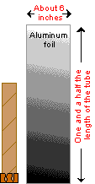
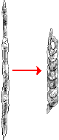
Scissors
Crayons or markers

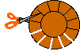

- Trace around the end of your tube onto a piece of brown paper (or construction paper).
- Draw a bigger circle around that circle and then draw a lot of spokes between the two circles.
3. Cut along the spokes.
- Put glue on the spokes and glue the cap onto one end of your tube.
- Cut a piece of aluminum foil that is about one and half times the length of your tube and about 6 inches wide.
- Crunch the aluminum foil into two long, thin, snake-like shapes.
- Then twist each one into a spring shape.
- Put the aluminum foil springs into your tube.
- Pour some dry beans, dry rice, or unpopped popcorn into your tube. The tube should only be about 1/10 full. You can experiment to see how different amounts and different types of seeds and beans change the sound.
- Make another cap from brown paper (the same as the first three steps) and cap your tube.
- Optional – decorate your rainstick
- Decide on a song and make up a rainstick accompaniment to it.

Can you label the countries between you?
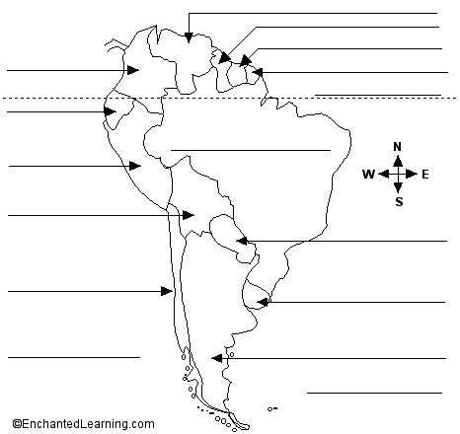

Argentina - A large country in southeastern South America.  Atlantic Ocean - The ocean that borders South America on the east.  Bolivia - The westernmost of the two landlocked (not bordering an ocean) countries in South America.  Brazil - The biggest country in South America. It is the easternmost country in South America.  Chile - A long, thin country in southwestern South America.  Colombia - A country in the far northwest of South America. The equator passes through southern Colombia.  Ecuador - A country in northwestern South America; the equator passes through northern Ecuador. Ecuador borders the Pacific Ocean, is south of Colombia, and north of Peru.  Equator - An imaginary line around the earth, halfway between the North and South Poles. | French Guiana - An overseas department of France that is located in northern South America. It borders the Atlantic Ocean, Brazil, and Suriname.  Guyana - A small country in northern South America. It borders the Atlantic Ocean, Brazil, Venezuela, and Suriname.  Pacific Ocean - The ocean that borders South America on the west.  Paraguay - The easternmost of the two landlocked (not bordering an ocean) countries in South America.  Peru - It borders the Pacific Ocean.  Suriname - A small country in northern South America. It borders the Atlantic Ocean, Brazil, Guyana, and French Guiana.  Uruguay - A small country in southeastern South America that is bordered by Brazil, Argentina and the Atlantic Ocean.  Venezuela - A country in the far north of South America. It borders the Atlantic Ocean, Colombia, Brazil, and Guyana.

These countries are all in the Western Hemisphere – can you think of another activity to do which comes from one or more of these countries?

Antigua and Barbuda
Argentina
Aruba
Bahamas
Barbados
Belize
Bolivia
Brazil
Canada
Chile
Colombia
Costa Rica
Dominica
Domincan Republic
Ecuador
El Salvador
Grenada
Guatemala
Guyana
Haiti
Honduras
Jamaica
Mexico
Netherlands Antilles
Nicaragua
Panama, Republic of
Paraguay
Peru
Saint Kitts & Nevis
Saint Lucia
Saint Vincents and The Grenadines
Surinam
Trinidad and Tobago
United States of America
Uruguay
Venezuela

