Go For It – Arab Region
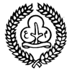

Games
The Hunter, or Mazen Al Qurawi, a traditional game from Saudi Arabia
Played with five to ten children. First, choose one player to be the hunter. Then the hunter counts from one to ten with his or her eyes closed, and everyone else runs off and hides. After the hunter has counted to ten, s/he goes to seek the others. If s/he finds someone, the person spotted tries to escape, and the hunter chases them. If the hunter manages to catch all of the others, the first person caught becomes the new hunter. If the hunter doesn't catch all the others they remain the hunter for the next turn.
SPEAKING ARABIC (Egypt)
For each guide, make a copy of the following story as well as a copy of the ten words (in Arabic only):
An Egyptian Bazaar is an exciting place to be. It is like an open-air mall with lots of things for sale. You can buy yummy __________to eat, __________if you are thirsty, _______________to wear, _________________for your feet, ____________to use for making clothes, and _____________for your neck, hands and ears. There is lots of noise! _____________are yelling to attract customers,_ _________________argue about the cost of their purchases and_____________ and_____________________ are running all over the place.
HILYA-T (jewellery),  BAYYA' (shopkeepers),  A'YILA-T (housewives),  QAMAS (material).  QUT (food), | ALBISA-T (dresses),  DAWWAB (animals),  MARAKIB (shoes),  MASRUBAT (drinks),  ATFAL (children)
Each guide chooses an Arabic word to fit into each blank in the story. You could try to read it out loud first. Then the leader gives the translation of each word and each guide could then read aloud the story they actually wrote, filling in the English words they chose.
Game from guidinguk.com

SEEGA (Egypt)
You will need: paper and pencil, and three markers for each player

This is a simplified children's version of a traditional game which has been played in Egypt for more than 5000 years, similar to noughts and crosses. It is played in pairs.

Draw a board as shown, and one person places their markers on the top row, the other on the bottom row.
They take turns moving one of their markers either one or two squares in any direction. A marker may not pass over another. The winner is the first player to get three markers in any straight line across, down or diagonally, as long as it is not in the player’s original line.

Camel Racing
Basically piggy-back racing but the camel is two people, the back one bent over & holding onto the waist of the front one. The rider needs a mounting block (chair, box, stone, fence ....) and there are reins round the front of the camel which the rider has to keep hold of all the way. The course can be as long & complex as you like. Check with your guider before trying this!

Less energetic camel racing.
Divide into teams, and each team makes a cardboard camel which will stand up, possibly using a bigger copy of this template:
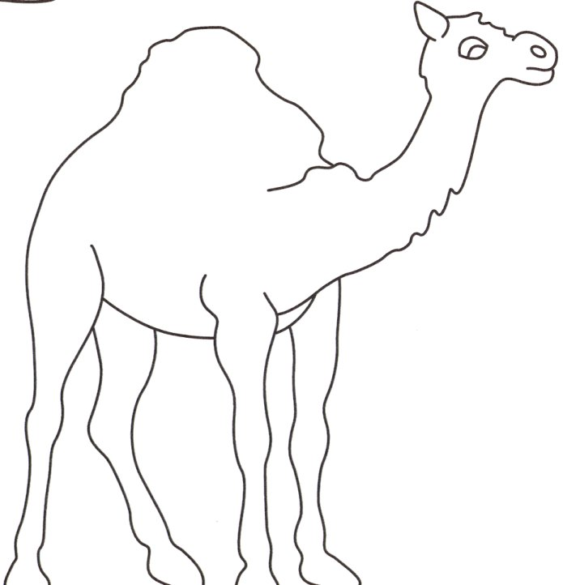
Make sure it will stand upright, then punch a small hole with a pencil and thread a long piece of wool or string through the hole and tie it off. You should now have a camel on a long line. Sellotape the other end of the wool to a pencil. Now your camels are ready to race!

Line up your camels at one side of the hall, with the line leading across the hall to the rider. When the referee shouts go, the rider has to pull the camel towards them by winding the wool around the pencil as fast as they can. You could choose to disqualify anyone who knocks their camel over. Hold heats and then a grand final – who is your champion camel racer?
Crafts
Paper Pyramid Craft
For over a thousand years, Egyptians built pyramids as tombs for their pharaohs (kings and queens). There are over 90 royal pyramids in Egypt... 35 of them major works.

It's easy to build a small model of a pyramid. Use it as a standalone decoration or include in a diorama.

You will need: paper, scissors, glue
Optional: sand, thin cardboard

Directions:
Copy the template (see below) twice onto paper or thin card.
OR you can make your own template by making four identical equilateral triangles (with small tabs on the side for gluing)
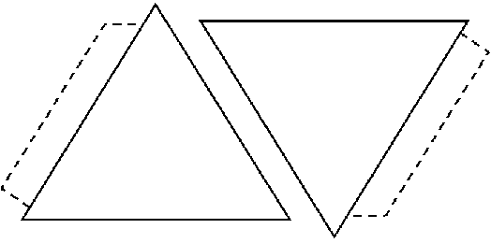
Fold dotted line tabs, glue the tab of one triangle to the free side of the next triangle. Repeat until all triangles are attached.

OPTIONAL: Cover entire pyramid with a coat of glue, sprinkle sand over top.

If you decide to use the sand, you should make sure you backed the template pieces with thin cardboard or the pyramid will collapse under the weight!

From dltk-kids.com
If you want to make a whole diorama (scene) then why not make the sphinx out of modelling clay to go with the pyramids?

Arabic patterns

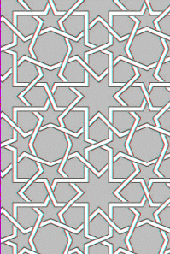 | These are based on simple geometric shapes like circles and squares, some explanation and examples are below (from http://www.sfusd.k12.ca.us/)  Why not make up some of your own?  Or copy some of these & colour them in to decorate your patrol box or any other suitable item?
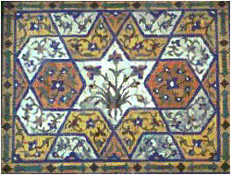 | 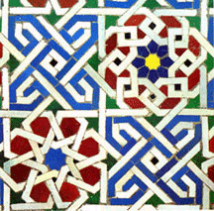

Calligraphy
Calligraphy is a valued skill in many Arab countries. Maybe you could borrow a book and have a go?

Weaving
Weaving is still a traditional craft in much of the Arab world. Try this easy but stylish paper weaving craft idea from kidsdomain.com

The result of this project is two similar but different pieces of artwork woven into each other.

You will need: masking tape, scissors, ruler, piece of card, pencil, and
2 pieces of artwork you are willing to cut up

Choose the two pieces of artwork, piece A and piece B, that you are going to cut. They should be the same size, and they should be on paper and in paint, marker, or crayon (pencil could smear), or you could use magazine pictures.
Measure equal increments along the length of piece A, and draw lines forming strips on the back of the piece. Number each piece in numerical order on the back.

Measure equal increments along the width of piece B, and draw lines forming strips on the back of the piece. Letter each piece in alphabetical order on the back.

Cut along the lines of pieces A and B -- forming two sets of strips.
Using masking tape, tape the ends of the strips of piece A onto a piece of card - reassembling the artwork. Use the numbers to help keep the strips in order.

Carefully weave the strips from piece B into piece A -- tightly. Use the letters to help keep the strips in order.

When finished you can either laminate the finished piece or wash over the painting with some watered down white glue

Hieroglyph bookmarks.

Check out the heiroglyphs on the next pages. Why not make a bookmark with your name on it in heiroglyphics, or try writing secret messages to each other.
Alphabet from http://www.angelfire.com/wi/egypt/hiero.html

short A | cat, bar | 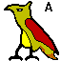 |  | long O | rose, sew, mow, boat | 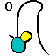
long A | make, air, way, hey |  |  | OO | food, blue | 
B | baby | 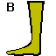 |  | OO | book, push
soft C | nice, circus | 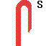 |  | P | pet | 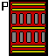
hard C | camel, sick, Christmas | 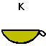 |  | QU | Q+U sounds like K+W, so combine the K and W hieroglyphics | 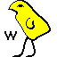
CH | cheese, catch, picture |  |  | R | rain | 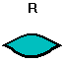
D | dog, delta | 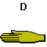 |  | soft S | sit, nice, rats
short E | earn, pet |  |  | sharp S | dogs, fission, measure | 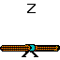
long E | be, bleach, Mary, radio |  |  | SH | ship, sugar, mission, friction, machine | 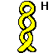
F | fish, phone, tough | 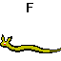 |  | T | tiger | 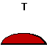
soft G | gorgeous, gym, judge | 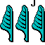 |  | TH | Egyptians had no sound for TH in the. D is probably the closest match.
hard G | girl, ghost | 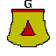 |  | TH | They also didn't have a sound for the TH in thing. Closest match is probably T.
H | how, who |  |  | short U | cut, about, ugly | 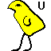
short I | hid, bit |  |  | long U | rude, food, blue
long I | hide, byte |  |  | V | viper | 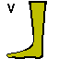
J | jungle, judge |  |  | W | wind, what, cow
K | pick, kid, technology, clique |  |  | X | X sounds like K+soft S, so combine the K and soft S hieroglyphs
L | lead, bell | 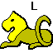 |  | hard Y | you, rayon | 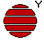
M | mummy | 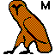 |  | vowel Y | use hieroglyph for long E in words like ready and Mary
N | Nile | 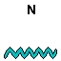 |  | vowel Y | use hieroglyph for short and long I in words like gym and byte
short O | dog, all, shawl |  |  | Z | zebra, dogs, fission, Xerox
Food
Here are some recipes for the Eid festival (from http://www.lbcma.org.uk ). This is celebrated through much of the Arab world.
At celebrations sweets are given to children. There are many sweet recipes you can use - here is one example. You could also decorate little boxes or cartons to put them in, or make your own boxes or gift bags.

Eid sweets:

8oz. icing sugar
5 tablespoons of condensed milk
few drops of food flavouring (peppermint, almond, lemon or orange)
few drops of food colouring

Mix ingredients into a fairly stiff dough, put icing sugar onto a table or board and give each child a piece. The dough could be made into round sweets or, cutters could be used to make star or moon shapes. Sweets could be decorated with 'hundreds and thousands'. Marzipan could also be used to make sweets.

Wedhmi
Wedhmi is a traditional Eid dish. Traditionally it would be made with strong plain flour dough. The dough would be shaped into small pasties with coconut filling. The edges would be turned and twisted to seal in the filling. They would then be deep fried in oil. This is a slightly easier version

Pastry
4oz. Self Raising flour
Pinch of Salt
4oz Sunflower Margarine
Water
Mix flour and salt. Rub in margarine. Mix to a stiff dough with water.

Filling
8oz Desiccated coconut (soak in water for approximately 30 minutes)
4 tablespoons of sugar
cardamon seed
cinnamon bark
Mix together all the ingredients. Melt a little sunflower margarine in a pan and gently fry all the ingredients. Roll out and cut out rounds of pastry. A spoon of filling can be put in the centre and the pastry folded in half, push together the edges with a fork. Bake in a hot oven (200C, 400F, gas mark 6) for 15 minutes.

Try some dates or humous.
If there is a Lebanese or other Arab restaurant or shop in your area, see if you can try some of their food.
Eggs - BAYD

Eggs are plentiful in the Middle East and are prepared in a variety of ways, samneh, or qawwrama. They eat these along with Arabic bread, pickles, romaine lettuce, mint, green marjoram and spring onions.

Hard boiled eggs are relished everywhere. They may be mashed and seasoned with salt, pepper and olive oil. Or they may be sliced and arranged on a platter with shredded lettuce, mint leaves, scallions, sliced tomatoes, onions, boiled potatoes and cucumbers for a light summer meal. Oil and lemon is the favourite dressing for this egg salad.

Many variations of omelettes are prepared. A parsley omelette is a particular favourite. It is customary to fry the omelettes in olive oil or vegetable shortening rather than butter. Sometimes the egg mixture is fried by the spoonful in a pan made especially for this purpose which has half a dozen depressions in its surface to give shape to the small omelettes.

More Arab recipes on these sites:
http://almashriq.hiof.no/general/600/640/641/khayat/contents.html
http://www.geocities.com/NapaValley/2332/food.html
http://www.uaeforever.com/Dishes/
http://www.forbiddenfruitsbazaar.com/food.htm

Other activities
Ask an arab or Muslim lady to visit your unit and explain about the dress of Muslim women. Maybe she could show you how the basic scarf is worn. Otherwise you could get squares of material & try for yourselves - it's not as easy as it looks!
Can you find someone to demonstrate or teach belly dancing? There is a list of some UK teachers at http://www.bellydancer.org.uk/teacherlist.html
Can you identify all the Middle East countries on this map?
[Map and descriptions from the Enchanted Learning site]
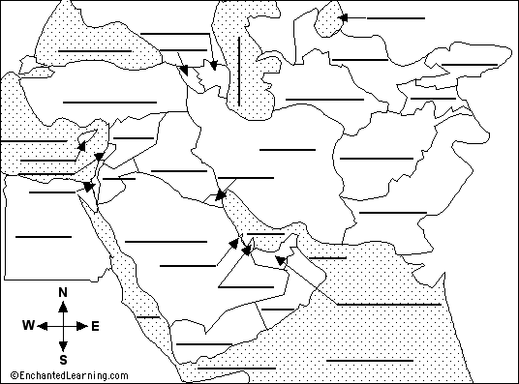
Afghanistan - a landlocked country bordered on the west by Iran, on the south by Pakistan, and on the north by Turkmenistan, Uzbekistan, and Tajikistan.
Azerbaijan - a country on the western shores of the Caspian Sea; it is bordered by Armenia on the west and Iran on the south.
Armenia - a landlocked country bordered by Azerbaijan on the east, Iran on the south, and Turkey on the west.
Bahrain - a tiny country in the southern Persian Gulf bordered by Saudi Arabia.
Cyprus - a small, island country in the eastern Mediterranean Sea.
Egypt - a country in the northeast of Africa, bordered on the north by the Mediterranean Sea and on the east by the Red Sea.
Iran - a large country between the Persian Gulf and the Caspian Sea; it is bordered by Iraq and Turkey (on the west), Turkmenistan (on the northeast), Armenia and Azerbaijan (to the northwest), and Afghanistan and Pakistan (to the east).
Iraq - a country west of Iran, south of Turkey, east of Syria and Jordan, and north of Saudi Arabia.
Israel - a country on the eastern shores of the Mediterranean Sea bordered by Egypt on the southwest, Jordan on the east, and Lebanon on the north.
Jordan - a landlocked country south of Syria, west of Iraq, north of Saudi Arabia, and east of Israel.
Kyrgyzstan - a landlocked country north of Tajikistan and east of Uzbekistan.
Kuwait - a small country at the northwest of the Persian Gulf; it is bordered by Saudi Arabia (on the south) and Iraq (to the north).
Lebanon - a country on the eastern shores of the Mediterranean Sea bordered by Israel on the south and Syria on the northeast.
Oman - a country on the Arabian sea; it is bordered by Yemen on the southwest, Saudi Arabia on the west, and U.A.E. on the northwest.
Pakistan - a country north of the Arabian Sea, east of Iran, and south of Afghanistan.
Qatar - a tiny country on the Persian Gulf; it is bordered by Saudi Arabia and U.A.E.
Saudi Arabia - a country east of the Red Sea, bordered by Yemen, Oman, U.A.E., Kuwait, Iraq, Qatar, Bahrain,and Jordan.
Syria - a country in on the eastern shores of the Mediterranean Sea; it is bordered by Turkey (on the north), Iraq (on the east), Jordan (on the south), and Israel and Lebanon (on the southwest).
Tajikistan - a landlocked country south of Kyrgyzstan.
Turkey - a country located between the Black Sea and the Mediterranean Sea.
Turkmenistan - a country on the southeastern shores of the Caspian Sea; it is bordered by Iran on the south, Afghanistan on the southeast, by Uzbekistan on the northeast.
United Arab Emirates (U.A.E.) - a country bordering the Persian Gulf, Qatar, Saudi Arabia, and Oman.
Uzbekistan - a country south of the Aral Sea; it is bordered on the south by Turkmenistan, bordered on the southeast by Tajikistan, and bordered on the east by Kyrgyzstan.
Yemen - a country south of Saudi Arabia, bordered by the Red Sea and the Gulf of Aden.

Arabian Sea - a large body of water south of the Middle East.
Aral Sea - a small sea located at the north of Uzbekistan.
Black Sea - a large body of water located north of Turkey.
Caspian Sea - a large body of water north of Iran, east of Azerbaijan, and west of Turkmenistan.
Gulf of Aden - the body of water between the Red Sea and the Arabian Sea; it is south of Yemen.
Gulf of Oman - the body of water between the Arabian Sea and the Persian Gulf; it is between Oman and Iran.
Mediterranean Sea - a large body of water between Europe and Africa.
Persian Gulf - a body of water off the Gulf of Oman; it is bordered by Iran, Kuwait, Saudi Arabia, Bahrain, Qatar, U.A.E., and Oman.
Red Sea - a long, thin body of water between Africa and the Arabian peninsula.

