The Finger-Spelling Alphabet for the Deaf *

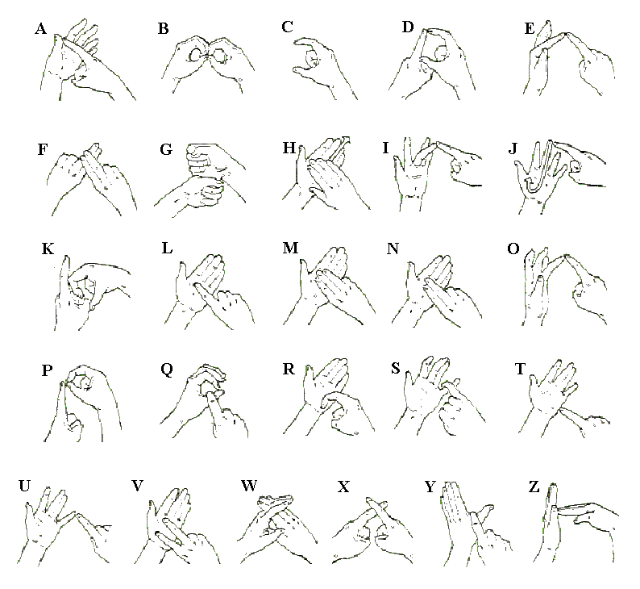

* NB. The Deaf-Blind finger-spelling alphabet is not exactly the same as this one

