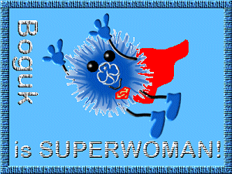
BOGUK is SUPERWOMAN!!!

Complete all clauses

Clause 1 : Complete ten of the Boguk Interest badges, to include two from each of the following groups and any two others of your choice :

Home skills :
Boguk in the house
Boguk in the kitchen
Boguk is handy round the house
Boguk is safe at home
Boguk cares for children
Boguk has green fingers
Boguk goes car crazy
Boguk keeps healthy

Outdoor skills :
Boguk goes camping
Boguk gets traditional
Boguk the camp QM
Boguk the Holiday QM
Boguk the campfire singer
Boguk gets lost
Boguk gets knotted
Boguk is safe out of doors
Boguk gets adventurous

Computer and admin. skills etc.:
Boguk the Web Designer
Boguk the Computer Whizz
Boguk On-Line
Boguk can communicate
Boguk goes public
Boguk the administrator
Boguk the bookworm

Creative skills etc. :
Boguk gets needled
Boguk in stitches
Boguk gets crafty
Boguk the Author
Boguk the Musician

Clause 2 : Learn to say “NO” occasionally. The next time your DC asks you to do something that you a) haven't time to do or b) don't want to do, say "No" to her.
When she asks you again...and again…. and again, continue to say "No."
Stick to your decision

You may earn more than one “Boguk is SUPERWOMAN!!” badge but you may not count the same Boguk badges towards a second Superwoman badge, i.e.in order to earn three Superwoman badges you will have to complete ALL 30 Boguk badges!

