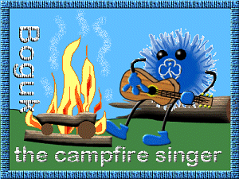
BOGUK the campfire singer
Complete clauses 1 - 4, and a further 4 clauses, which provide a personal challenge to you. You should participate or run at least three campfires whilst working for this badge, and at least one must be outdoors.

- Develop and maintain a collection of campfire songs. Be aware of copywrite. Understand how many songs have been handed down by tradition, and thus words or tunes may vary slightly across the country. Be aware of songs which may cause upset or controversy if used.
- Run a campfire for a group, to include at least one song from each of the following areas:
- Action songs
- Rounds or part songs
- Quiet songs
- Traditional songs
- Songs that are new to the group
- Non-singing items such as stories, sketches etc

- Be aware of safety at a Campfire. You should pay particular attention to the size of fire, and those responsible for keeping it going. Know what to do if a fire gets out of control, or a camp blanket catches fire.

- Take part in or lead a "formal" campfire, which is structured and follows a programme.

- Write a new song to an old tune, and teach it to a group.

- Accompany a campfire song on a musical instrument of your choice, such as a guitar or recorder. The instrument should be portable and suitable for use at camp or outdoors

- Introduce a group to 5 or more "traditional" Guiding songs.

- Make at least 4 types of home-made musical instrument to use during a campfire.

- Hold a campfire or singing session for a group of mixed ages. E.g Brownies & Guides. Be aware of the different interests and abilities of the different age groups.

- Learn 5 songs that are new to you. Teach at least one of these to a group.

- Sing a song in a foreign language.

- Develop a collection of campfire stunts and activities and submit two to BOGUK

- Attend a training session about music in the unit or similar.

- Lead a campfire item which relies on rhythm, such as "Rain Storm" or a clapping rhythm.

- Produce a tape of yourself/your unit singing easy campfire songs and give this to a new Guider.

- Run a campfire for an age group you do not normally work with - e.g. Brownies, Trefoil Guild …

- Plan a campfire on a particular theme (e.g. animals), using songs, sketches etc.

- Participate in a campfire with people from 4 or more countries. Share songs etc from your own traditions and cultures.

- Run a campfire for a large group of people (over 40). Be aware of the particular difficulties when leading a group of this size, especially ensuring that they can all hear.

