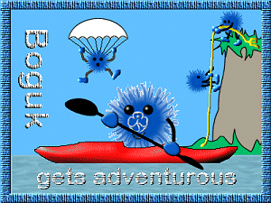
BOGUK gets Adventurous
Complete clause 1 and any two further clauses. Throughout you should be aware of the safety precautions and equipment required. Note: not all the activities listed below are recognised Guiding activities. If you intend to participate with girls, or within Guiding, please refer to the Guiding Manual.

- Have a go at three of the activities listed below. At least one should be totally new to you.

- Canadian Canoeing
- Kayaking (single person)
- Rafting
- Sailing
- Wind surfing
- Water Skiing
- Abseiling
- Climbing
- Orienteering
- Horse Riding
- Off-road Vehicles
- Skiing/Snow boarding
- Backpacking/Trekking
- Caving
- Weaseling
- Pot Holing
- Fell Walking
- Archery
- Shooting
- Fencing
- Diving
- Snorkeling
- Jet Skiing
- Bungee Jumping
- Parachute Jumping
- Parascending
- ParaGliding
- Hang Gliding
- Aerial Runway
- An adventurous activity of your choice

- Develop your skills in one adventurous activity, by participating in at least 3 further sessions.
OR
Complete an Instructors course in an adventurous activity.
OR
Complete a tuition course in an adventurous activity, leading to a qualification or award.
OR
Organise an activity day or camp for a group of Guides.

