Chinese Name Bookmarks

Chinese writing uses characters instead of letters. If you look at the sheets with the Chinese characters on you will see that they can be put together to make English words. For example to make the name Katie you put together Kai and Te.
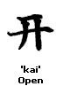
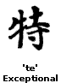

Also all Chinese characters have words for them, so Katie means “open and exceptional”. Chinese names use two or three characters.

See if you can make your own name using chinese characters, what does it mean?

To make a bookmark:

- Cut out the characters needed to make you name.

- Stick them to a piece of coloured card, don’t forget Chinese writing goes from top to bottom!!

- Decorate it however you want!!

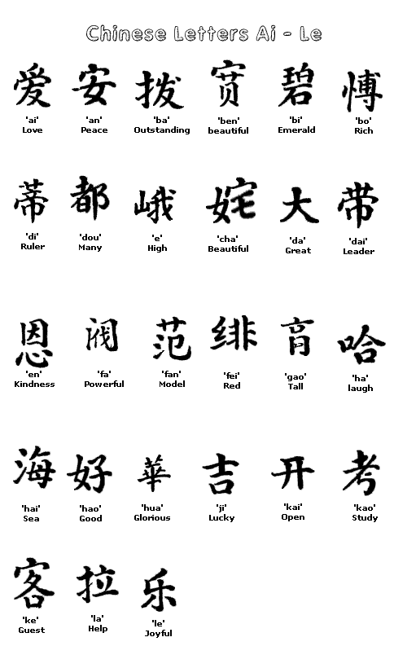

Chinese letters Li - Zhou
