Contents  Communication Problems  Deaf People  Extra Help for Deaf People  Fingerspelling  British Sign Language  Etiquette when talking to a  deaf person  Hearing Dogs for the Deaf  More Activities  Blind People  Braille  Moon  Etiquette when meeting a  blind person  Guide Dogs for the Blind  More Activities  Deaf-Blind People  More Activities  Signed Songs in BSL | Wheelchair-bound People  Activities  Refugees  Fingerspelling Alphabet  Deaf-Blind Alphabet  Braille Alphabets  Moon Alphabet  Back Page  Equipment to Help Deaf People  Codes  Looking Forward

Communication Problems

Obviously if you are deaf, blind or deaf/blind, or cannot speak, you will have difficulties communicating with other people. Deaf people use lip reading, finger spelling and British Sign Language (BSL) to communicate. For people who are deaf/blind, you would have to finger spell in their hand using a slightly different fingerspelling alphabet. It is easier to communicate with blind people, but don’t forget that they cannot see the expression on your face, so you must be more careful to make your voice express how you feel, without exaggerating too much.

Don’t forget that deaf and blind and deaf/blind people are often treated as though it was their brains and not just their hearing or eyesight that is deficient. Just treat them as you would any other person, but be aware that they may have problems understanding you because of their disability.

Deaf People

Don’t forget, if you meet a deaf person:
- Speak clearly without shouting.
- Face the person while you are speaking, don't turn away.
- If the person does not understand you, don't give up, either draw a picture or write it down.

However, there are problems with lip reading because many words look the same. Pick one of the following words and mouth it to a partner. See if she knows which word you have chosen.

Dog cat bat ball bar car coat moat chair moon hair fair frog spoon sheep ship frog train rain wall goat crane

Fingerspelling

Now, if you learn the Fingerspelling Alphabet, and spell the first letter of each of the words, does this make it easier for your partner to work out what you are saying?
If you don’t have a copy of the Fingerspelling Alphabet, you can find it at the end of this, or at:

http://www.royaldeaf.org.uk

Remember that for many letters the left hand is used like a piece of paper that you are writing on. Remember to hold your hands out slightly so that your partner can read them more easily.

If you visit the RDA site, then you can find some fun quizzes at:

http://www.royaldeaf.org.uk/edu.htm

Now that you have found out about the fingerspelling alphabet, see if you can spell your name with it. Try your friend's names too!

British Sign Language (BSL)

If you enjoyed the above activity, you might like more information. You might want to learn about BSL. You can find examples of British Sign Language at:

http://www.britishsignlanguage.com/

and also on Best Of GuidingUK at:

http://guidinguk.freeservers.com/BSL.html

and lots of information at the web site of the British Deaf Association:

http://www.britishdeafassociation.org.uk/

Did you know that we measure how loud or noisy something is in special units called Decibels? If you were sitting quietly in a library reading a book, the noise level would be about 30 Decibels.
Try shouting as loudly as you can....
Shouting is about 80 Decibels. Only people who can't hear us shouting like that are actually deaf. There are about 180,000 deaf people in the UK.

A Code

The answer to the next code is on the back page.

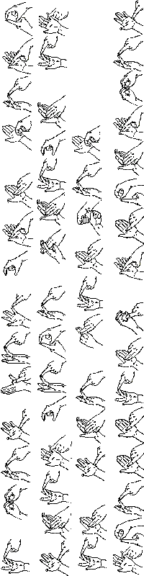

Extra Help for Deaf People

Deaf and other hearing impaired people need special equipment to help them to live independently. You can discuss this with your patrol. Imagine that you are deaf.
- How would you use a telephone, if you couldn’t hear or speak?
- How would you get up in time if you couldn’t hear an alarm clock?
- How would you know if there was someone at the front door if you couldn’t hear the bell?
- How would you know if there was a fire if you couldn’t hear a smoke alarm?

When you have thought about this, turn to the back page to see if your answers agree with what is actually used.

Etiquette when talking to a Deaf Person

If you want to talk to a deaf person, it is no use speaking to attract attention. If the deaf person is close enough but looking away, this can be done by tapping gently twice on her arm or shoulder. Tapping anywhere except on the arm or shoulder is rude, and tapping too hard or too often may cause the deaf person to retaliate. If the person is further away, you can wave your hand, or perhaps even an object such as a magazine.

Some ways of getting attention are not considered at all polite. Never wave directly in front of someone’s face. You sometimes see children trying to turn their parent’s head by tugging at their chin. This is only acceptable in a very close relationship, and then only usually during arguments.

Lipreading

If the person you are talking to lipreads, then if possible position yourself with light on your face, this makes it easier to read your lips. Don’t forget that only about 30 – 40% of speech is possible to lipread. Make sure you face the person to whom you are speaking, and don’t talk with your hand over your mouth. Speak slightly slowly, but not agonisingly slowly. Speak clearly, and not too quietly.

Try to minimise background noise, and also speak one-at-a-time.

Use everyday language, and make sure that the deaf person knows what subject is being discussed. Get to the point quickly, and break up complex messages into short sentences. Use natural body language and facial expressions.

Use whole sentences as words spoken in isolation give no hint of their context.

Hearing Dogs for the Deaf

Why don’t you contact the Hearing Dogs for the Deaf Association and ask if they can send someone local to talk to your Guide unit. You must ask your Guider before you do this. The association may be contacted at:

http://www.hearing-dogs.co.uk/

Hearing Dogs for Deaf People Training Centre
London Road (A40),
Lewknor,
Oxon OX49 5RY
Tel: 01844 353898 (Voice and Minicom)
Fax: 01844 353099
E-mail: info@hearing-dogs.co.uk

More Activities

Now imagine what it would be like if you were deaf. Think about all the things you would not be able to hear. Now get a sheet of paper each, and draw 4 things that you would miss hearing most.

Signed Songs in BSL

It was hoped that it would be possible to put some signed songs into this Go 4 It!, including Taps. However, it is really better if you are taught them by someone who can sign BSL fluently, or by seeing them as animated gif files. So some songs and the Guide Promise have been translated into BSL and can be found on the Best Of GuidingUK web site at:

http://www.guidinguk.com

Blind People

If someone is blind or cannot see well, then he or she cannot read an ordinary book. Some people are able to read large-print book, and other like to be able to listen to tapes of books, and this is called the “Talking Book” service. Other blind people like to read books in Braille.

Braille

Braille is a method of reading by touch. Braille letters are made of raised dots, like the six dots on a domino. Braille was devised by a Frenchman, Louis Braille, and originally had no letter W. The Braille alphabet is given at the end of this.

A Code

The answer to the following is on the back page.

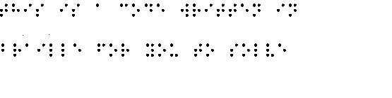We would like to thank the Royal National Institute for the Blind (RNIB) for permission to use the Braille font, and other graphics. For further information on the RNIB, the contact details are: 224 Great Portland Street, London W1W 5AA, or visit their website at:

http://www.rnib.org.uk

The RNIB produces an information pack for the Sight Awareness Staged Badge (for Brownies and Senior Section). Contact them at the above address, or via their web site. They do ask for a donation for this as it costs about £5 to produce and post.

Moon

As well as Braille, there is an alphabet called the Moon Alphabet, this uses raised shapes based on the standard alphabet, it is easier to learn than Braille. Moon also has short forms for some common words, like and, the and punctuation.

Etiquette when meeting a Blind Person

If you meet a blind or partially-sighted person for the first time, you may wonder how to behave. The obvious advice ‘behave normally’ may not be much help. However, the only thing that blind and partially-sighted people have in common is just that: their blindness. Don’t forget that blind people cannot see if you smile at them, so don’t expect a response to a smile. Also, you may think that blind people look strange because they are moving their head, or looking out of the bottom or top of their eyes. This is probably because they are trying to look at you through the best part of their eyes. How often have you seen an older person hold a book or paper and look through the bottom of their eyes? Once again, this is because that part of the retina has been least damaged by age.

Some blind people are young, but most are elderly as sight loss is most common in later life. Sight loss is rarely total: most blind people can see something, though it may not be very much.

Don’t be afraid to say “Nice to see you.” Blind people say it as well. It is fine to talk about colours to blind people, either they have become blind later in life and will know all about colours, or, if they were born blind, they will have their own idea about what colours mean. When you first speak to a blind person, remember to say who you are, even if the person knows you well, it’s possible that your voice won’t be recognised. Don’t forget to let the blind person know you are leaving – you’d feel foolish if you were left talking to empty space.

If one of your sister Guides is blind, always ask if she wants to take part, you’ll probably be surprised at what she is able to do, and what games she can join in with. However, you must never tease any blind person about the extra equipment used to help them to take part in normal life.

Indoors

If a blind person comes to visit you at home, don’t worry that ornaments will be knocked off, most blind people move around without destroying things. You may want to guide the blind person around the room and describe the furniture as you pass it, mentioning any head-level hazards.

If you need to help a blind person into a chair, put his or her hand on the seat or back of the chair and he or she will be able to do the rest. Don’t leave doors half open, and don’t leave things lying around on the floor when a blind person is visiting you. If you are the visitor, don’t move anything unless absolutely necessary, and if you have to move something remember to say where you have put it.

When you invite a blind person for a meal, say what the food is when you serve it. Don’t fill cups or glasses right to the brim – full cups are easy to spill. When serving bony fish or chicken, offer to take the bones out. Generally, your visitor will tell you if any help is needed.

In the street

Some blind people like to be helped to cross the road, but not all do. As has already been said, blind people have only one thing in common: their blindness. Always ask first if you would like to help a blind person; how would you feel if someone grabbed your arm in the street with no warning! However, if your offer of help is refused, don’t feel snubbed; the next blind person you meet may welcome your assistance.

First of all , ask if you can help and, if so, how to guide the person. Most will prefer to hold your arm, just above your elbow. Keep your guiding arm relaxed and walk half a pace ahead of the person you are guiding so he or she can tell from your movements when to turn or stop. When you reach a kerb, tell the person you are stopping, then stop and tell your companion whether it’s ‘kerb up’ or ‘kerb down’. Always cross roads by the shortest route and use a crossing if there is one. Don’t take risks.

When approaching steps or a slope, tell the blind person whether the steps or slope go up or down, and whether there is a handrail. Give your companion time to find the first step and the handrail, if there is one. Always walk off one step ahead of the blind person so he or she can tell from your position when you have reached the level again.

So don’t forget, always lead a blind person from in front, never push him or her ahead of you. Explain things he or she can’t see.

Remember there are ways in which you can help blind people you have never met.. Don’t leave your bikes and toys on the pavement for blind people to trip over. Get your parents to trim back any trees or bushes which overhang a pavement – these can give blind people a very nasty smack in the face. Get your parents to report broken paving slabs or unguarded holes in the roads or pavements to your local council. These simple measures keep the streets safer for everyone.

We would like to thank the RNIB for the information for the section on Etiquette.

Guide Dogs for the Blind

Why don’t you contact the Guide Dogs for the Blind Association and ask if they can send someone local to talk to your Guide unit. You must ask your Guider before you do this. The association may be contacted at:

http://www.gdba.org.uk/

The Guide Dogs for the Blind Association, Burghfield Common, Reading RG7 3YG Tel: 0870 600 2323
Email: guidedogs@guidedogs.org.uk

More Activities

Now imagine what it would be like if you were blind. Think about all the things you would not be able to see. Now get a sheet of paper each, and draw 4 things that you would miss seeing most .

Take it in turns to put on a blindfold, and get another Guide in your patrol to “show” you round your meeting place. Swap over and you be the leader. Do you have any steps at your meeting place? Did you remember to tell your friend about them?

Draw a plan of your meeting place showing all the hazards a blind person might encounter. You could ask your Guider to look after it for you, and use it if ever a blind girl joins your unit.

Find out all you can about Louis Braille and/or Dr William Moon, and give a presentation either to your patrol, or, with your Guider’s consent, to the whole unit.

Deaf/Blind People

People who are both deaf and blind have even more problems communicating. If a deaf/blind person attends a meeting, he or she will need an interpreter who types on a keyboard, and the letters are translated into Braille, which pops up as studs through a plate about 40 cm (16 inches) wide. The deaf/blind person feels the studs, and reads from left to right, returning to the left-hand side of the plate for the next words.

If you see someone walking along the street with a white stick with a red band round it, this means the person has a hearing impairment as well as a sight impairment.

If you want to find out more about dead/blind people, the charity in the UK which supports them is called “Sense” and has a web site at:

http://www.sense.org.uk

Have you heard about Helen Keller? She became deaf and blind when she was ill as a young child. See what you can find out about her, and either make a presentation about her to your patrol, or ask your Guider if you may make a presentation to your unit.

Wheelchair-Bound People

Many people who need wheelchairs to get around also experience difficulties with communications. That sounds surprising, but it is amazing how many people think that if a person uses a wheelchair, then that person’s brain, as well as legs must be deficient in some manner.

There used to be a programme on the radio called: Does He Take Sugar? This was for people with disabilities and was called that because so often the person in the wheelchair is disregarded and the person pushing the wheelchair is asked such questions. That sounds fantastic, doesn’t it? I’m sure that you, as a Guide, would have more sense than that. However, just to let you see how horrid it can be, get one of the girls in your patrol to volunteer to be the “disabled” person, and someone else as her “carer”. Then for ten minutes of your patrol time discuss something, but never speak to the “disabled” one, always refer to her “carer”. Make your volunteer sit on a chair, and some of the time, stand up to have your discussion. Don’t let this go on for longer, because the “disabled” volunteer will probably be getting quite upset even after that short time. At the end, ask your volunteer how she found the experience.

Wheelchair users have lots of other problems, most public buildings are accessible to wheelchairs nowadays, and also public toilets. However, if you have ever seen anyone at a supermarket checkout in a wheelchair, trying to sign a credit card voucher, then you will know that it is not an easy task. The checkout probably doesn’t have a board to put the voucher on so that the person in the wheelchair can sign easily.

Get your patrol to think of other situations when a really simple gadget would make the wheelchair user’s life much simpler.

Another thing to keep your eyes open for is that wheelchair users have their heads lower than everyone else. Many people who smoke do not seem to realise this, and frequently move a hand, with a lighted cigarette, down to about waist level, and round behind their back. A person in a wheelchair thus receives the full “benefit” of the cigarette.

More Activities

If you can get hold of a wheelchair for an evening, and you have a kitchen at Guides, take a chair into it, and see what each one of your patrol could reach when sitting in the wheelchair. You will probably discover that you can only reach some of the cupboards, and that it is difficult to get the door of lower ones open without manoeuvring the chair quite a lot. If you can’t get a wheelchair, you could try this using an ordinary chair.

Another problem for a wheelchair user, is if a leg is in plaster. Tie one of your legs up with a smooth wooden pole along it, and past your knee, using old triangular bandages or padded rope. Then see how difficult it is to go up or down stairs, or even to sit on the floor.

Refugees

How do you think you would feel, if you were quietly living with your parents, and going to school, when suddenly there was a war, and you had to flee? You might find yourself in a country where it was a lot colder or hotter than you were used to; where the people not only spoke in another language, but wrote using a different alphabet. If this refugee was you, I’m sure you would like it if another person smiled at you. So if you have any refugees in your school, make sure you smile at them. Don’t tease them because they are different from you. They didn’t want to leave their home. Maybe a favourite uncle or aunt – or even brother or sister - was killed in the war. How do you think you would feel if a close relative – who never forgot your birthday – were suddenly missing, and probably dead?

If you want to find out more about refugees, contact the United Nations High Commission for Refugees (UNHCR) in Geneva:

P. O. Box 2500, 1211 Geneva 2, Switzerland

Or look at the web site, at: www.unhcr.ch

Activities

In the meanwhile, to show you some of the extra difficulties that refugees may have, see if you can read the following, which is in a strange alphabet:

Δαφνε ωεντ το τηε χινεμα το σεε α δραμα.

Now take a piece of paper and write your name on it backwards, so that when you hold it up to a mirror, it reads correctly.

The following numbers are written in Roman Numerals. Sometimes, a smaller number is used in front of a larger number to indicate that it is subtracted, so IV = 4, and IX = 9. Can you do the following sums?

CXXIII + CCXXXIV

CCCLXXIV – CLII

LXVII x XII

LXXXI ÷ IX

Where:
I | 1 |  | C | 100
V | 5 |  | D | 500
X | 10 |  | M | 1000
L | 50

Fingerspelling Alphabet

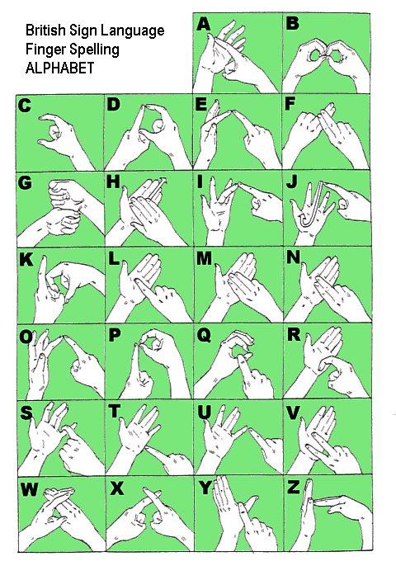

We would like to thank the Royal Association for Deaf People (RAD) for permission to reproduce this chart, and to use the Fingerspelling font. For further information on the RAD, visit their website at:

http://www.royaldeaf.org.uk

Deaf-Blind Alphabet

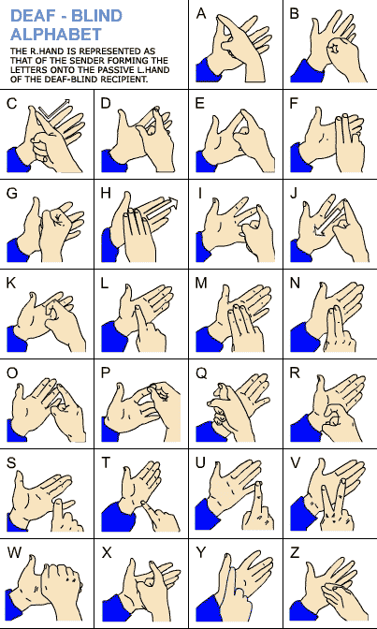

Alphabets

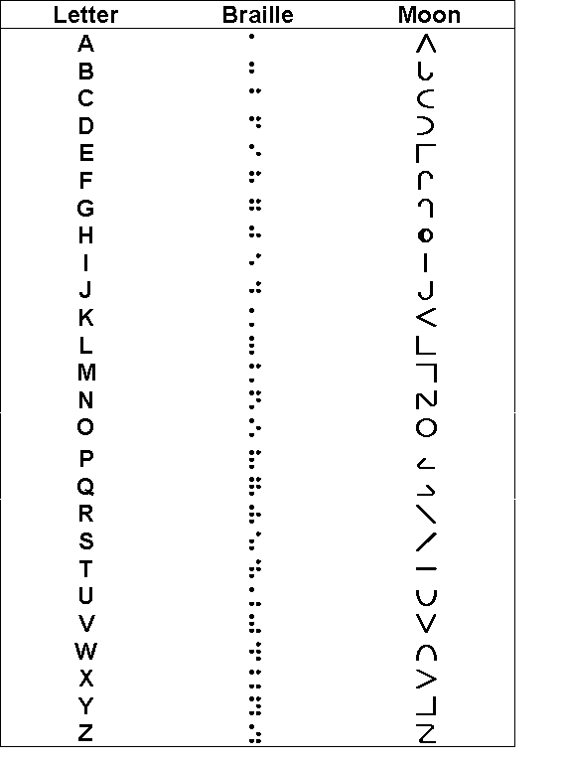
Back Page

Equipment to help Deaf People

Textphone or Minicom
Deaf people, and people who cannot speak easily or clearly, cannot use an ordinary telephone. They need a telephone called a minicom or textphone, that has a typewrite keyboard, and either a little screen or a roll of paper (it looks rather like those till tapes you get in shops, but a bit wider). Then they type in what they want to say and the words appear on the screen or on the paper at the other end. If you want to call a deaf person using an ordinary phone you need to telephone a service called Typetalk.

Alarm Clocks
Deaf people can use a vibrating alarm clock that shakes them awake, and goes under their pillow.

Flashing Doorbells
Instead of a door bell, deaf people use a door light, which flashes in some of the rooms. Some deaf people have the doorbell connected to their house lights so lights flash in every room.

Smoke Detectors
A deaf person’s smoke detector has a very bright flashing light. For night-time use, it has a pad, which goes under the deaf person's pillow. If the alarm goes off, the pad shakes to wakes the person up.

Codes

I bet you can read this code which is in the fingerspelling alphabet

This is a code written in Braille for you to solve

Dafne went to the cinema to see a drama.

Answers to sums: CCCLVII CCXXII DCCCIV IX

Looking Forward

If you have enjoyed this Go 4 It you may be able to think of a way you can use the knowledge you have gained as a basis for doing your Community Action Badge, or your Interpreter Badge.
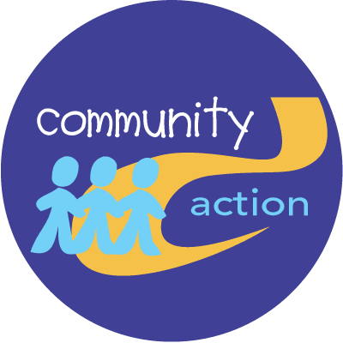 | 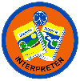

If you are lucky enough to be a Pack Leader, you might ask Brown Owl if she would like you to help her to teach the Brownies so that they can get either their Deaf or Sight Awareness badge.

 | 
Furthermore, if you are about to go on to the Senior Section, either as a Ranger or Young Leader, then you also will be able to gain these badges.

