Instructions for a Turk’s Head Woggle from Leyland St James’ Scout Group - http://www.smithc4.pwp.blueyonder.co.uk/kaaskorner.htm
1. Place the rope or braid around three fingers of your left hand, palm up (Fig 1). The working end of the rope/braid will be known as X, and the stationary end as Y. | 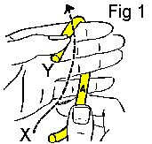
2. Bring end X over the stationary end Y (Fig 1) and around the back of the hand (Fig 2). | 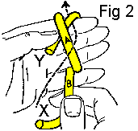
3. Thread end X over A and under Y, thus forming B (Figs 2 & 3). | 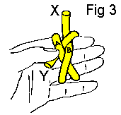
4. Turn your left hand over, palm down (Fig 4). | 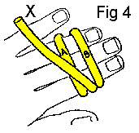
5. Loop A over B, and B under A (Fig 5). Hold in position by placing the forefinger of your left hand between A and B. | 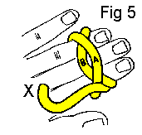
6. Thread end X under B through the crisscross loop formed by A and B (Fig 6). | 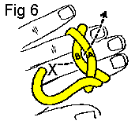
7. Thread end X over A (Fig 7), and under B again (Fig 8). | 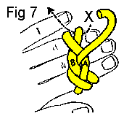
8. Turn your hand over, palm up (Fig 9). Bring end X alongside of and parallel to end Y by threading the strand under A and over B (Fig 9 & 10). Follow the direction of the dotted arrow. | 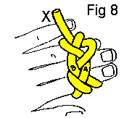
9. The Turks head woggle is formed by following this strand Y around three times; i.e., until there are three rope/braid strands parallel to each other all around the woggle (Fig 10, 11 & 12). | 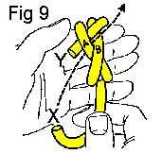
10. The second time around is indicated in Fig 11 as well as the beginning of the third time around. Fig 12 indicates end X on the completion of its third time around. | 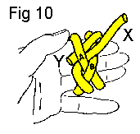
11. In doing this it may be necessary to take in the slack from time to time in order that there will be a sufficient amount of material to complete the woggle. | 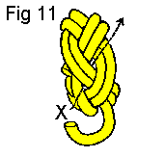
12. A fid or any blunt-pointed tool is a useful aid in this step. It is important to adjust the woggle so that it will be neat as well as the right size. Then, it will be necessary to remove the woggle from the fingers when you thread end X around for the second and third time (Figs 11 & 12). The woggle ends at the same point at which it was begun (Y). This completes the Turks head woggle. | 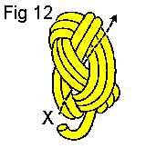

From Leyland St James’ Scout Group - http://www.smithc4.pwp.blueyonder.co.uk/kaaskorner.htm

