Thinking Day Quiz

1) What is Thinking Day?
- A day when we think, unlike other days when we don’t think.
- A day when we think about other Guides and Brownies all over Great Britain
- A day when we think about Guides and Girl Scouts all over the world

2) When is Thinking Day?
- The day we meet at Guides which is nearest to February 22nd
- Always on February 22nd , whatever day it falls on
- The Sunday when we have our Thinking Day service

3) Why do we celebrate Thinking Day on that date?
- Because it’s between half term and Easter
- Because it’s the anniversary of the Baden Powell’s wedding
- Because it’s both Lord and Lady Baden Powell’s birthday

4) Who celebrates Thinking Day?
- All the units in our district
- All the Guides in Great Britain
- All Guides and Girl Scouts around the world

5) Who was “B-P” ?
- Lord Robert Baden-Powell
- The person who first discovered petrol
- Barry Preston, the man who designed the first Scouts’ and Guides’ uniforms

6) Who founded Guides?
1) Lord Bernard Powell
2) Lord Baden Powell
3) Lady Baden Powell

7) What was Lady Baden Powell’s first name?
- Olive
- Olave
- Agnes

8) What does WAGGGS stand for?
- World Association of Girl Guides and Girl Scouts
- World Alliance of Girl Guides and Girl Scouts
- We’re All Girls, Guides and Girl Scouts

9) Why is the trefoil the symbol of Guides and Girl Scouts all over the world?
- Because it’s shaped like a lucky three-leaved clover
- Because it has three parts, like the Guide Promise
- Because it has three parts, like a shamrock, and Baden Powell was Irish

What colours are there in the World Flag?
- Red, white and blue
- Gold, blue and white
- Green, white and orange ( PTO for tie-breaker.)

TIE BREAKER

Draw and colour a Guide in full UK Uniform | Design a uniform YOU would like to wear

What countries are these uniforms from?

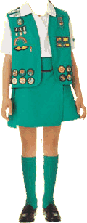 | England  France  Japan  USA  Australia | 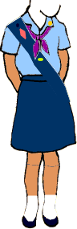 | England  France  Japan  USA  Australia | 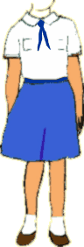 | England  France  Japan  USA  Australia
…. and what countries are these Promise Badges from?  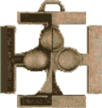 |  | 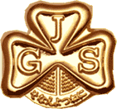 |  | 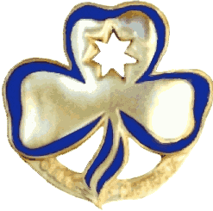
England France USA  Japan Australia |  | England France USA  Japan Australia |  | England France USA  Japan Australia

