The Boguk Standard

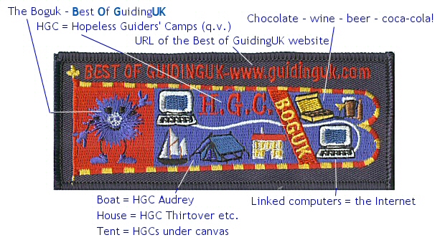

Description : on the hoist, on a red ground, stands the Boguk (http://www.geocities.com/Hairy_Boguk), the symbol of the Best Of GuidingUK group and website (http://www.guidinguk.com ). The Guide Blue fly is divided vertically by a diagonal red band with the initials BOGUK in gold and horizontally by the wavy white line connecting two computers, symbolising the Internet without which none of this would exist. The top left sector of the fly has the letters H.G.C. in red, standing for Hopeless Guiders' Camps - for more about these events, visit http://guidinguk.freeservers.com/HGC.html - and the bottom left has a sailing boat, a tent and a house to represent the venues of the HGCs. The top right sector shows a box of chocolates, a glass of wine, a pint of beer and a bottle of coca-cola, the staple diet of the average Hopeless Guider ...

PLEASE NOTE : although designed in the same style and manufactured to the same standard as official Guiding Standards, this badge is from GuidingUK, NOT Girlguiding UK

The design of this Standard is copyright © Dianne Davies / GuidingUK 2002 & 2004 and may not be reproduced in any format without permission; all rights strictly reserved.

