RUSSIA

Guiding in Russia, plus ideas on a Russian theme

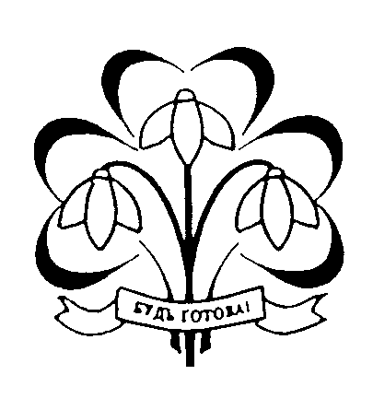
Compiled from the “Padrooogi Challenge” – East Yorkshire Guides 1998
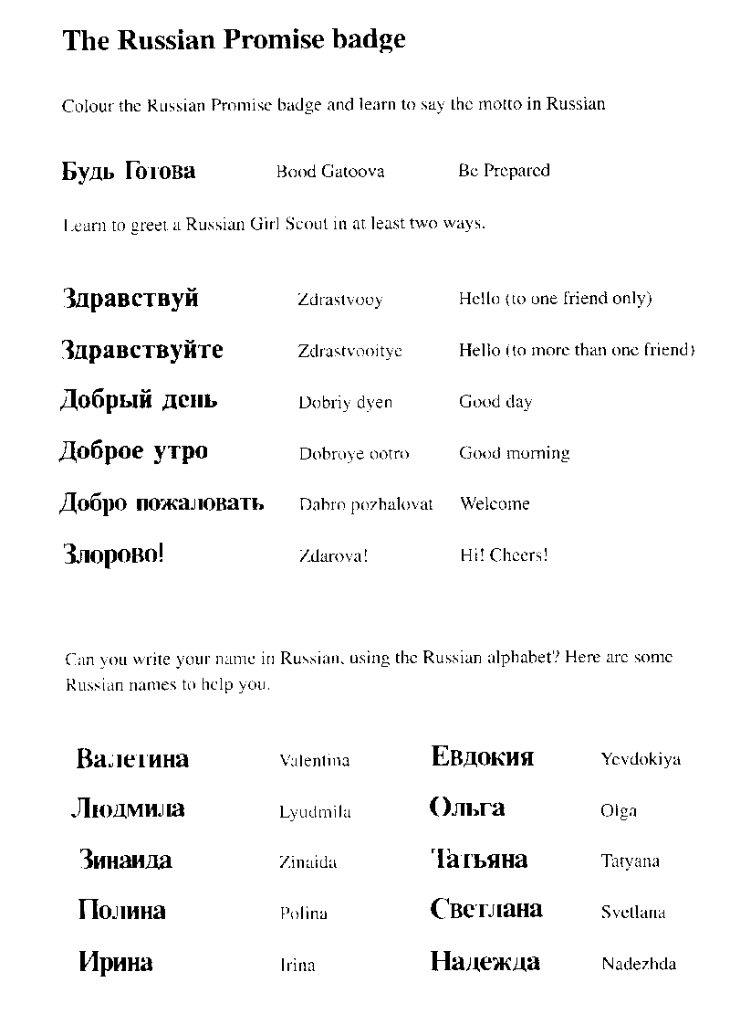

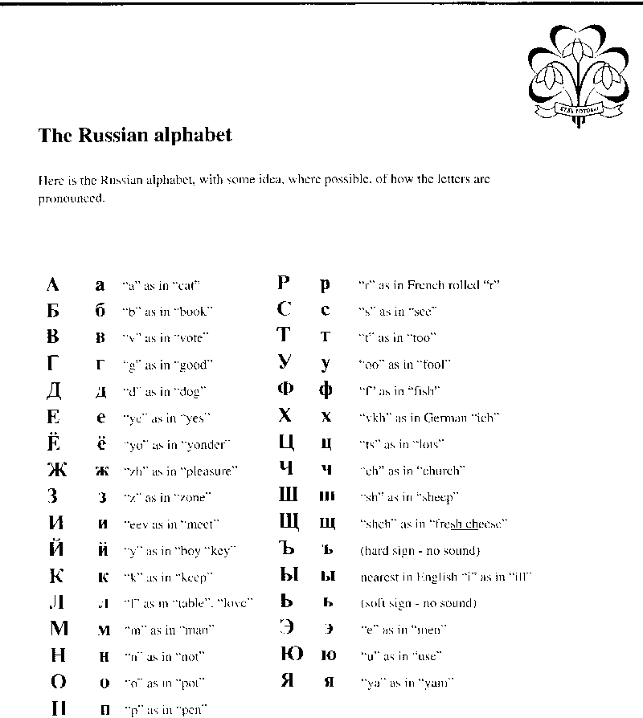

Russian Word-search

R | U | S | S | I | A | E | R | A | U | Q | S | D | E | R
K | W | T | A | R | O | S | T | O | V | O | N | D | O | N
P | S | A | I | N | T | B | A | S | I | L | C | I | D | S
E | F | J | N | L | O | M | O | S | C | O | W | O | P | A
T | C | R | T | E | T | C | H | I | A | A | S | R | G | D
R | Z | L | P | X | W | O | I | B | M | M | Z | L | U | G
O | A | E | E | S | A | M | N | E | V | L | O | M | S | K
P | R | O | T | M | X | A | I | R | L | V | K | V | O | S
A | B | R | E | P | U | B | L | I | C | I | K | N | A | Y
V | Z | I | R | J | A | T | M | A | Q | S | W | R | E | R
L | C | I | S | O | V | I | E | T | T | U | A | Y | T | R
O | P | O | B | P | L | K | R | U | J | T | H | I | G | F
V | Z | E | U | X | C | G | K | B | O | R | S | C | H | T
S | V | B | R | N | M | R | J | V | H | G | F | O | D | S
K | W | S | G | M | I | D | R | T | K | O | V | N | M | A

RUSSIA SARATOV
MOSCOW ROSTOV ON DON
SAINT PETERSBURG SAINT BASIL
KREMLIN ICON
SAMOVAR BORSCHT
SOVIET IRKUTSK
REPUBLIC PERM
OMSK VOLGA
PETROPAVLOVSK SIBERIA
RED SQUARE CZAR

