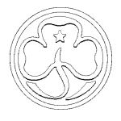
Round-the-world Quiz
(Just for fun!! The questions are in sections – some are harder than others!)

- Where in the World……

Easy – peasy : what countries do these suggest to you? (one point each )

Holland | Egypt | Russia | USA | China

And a bit harder……..
(One point for the country, one point for the city and one point for the correct name of the landmark.)

Statue of Liberty, New York USA | Taj Mahal, Agra, India | Colosseum, Rome, Italy | The Opera House, Sydney, Australia | The Space Needle, Seattle, USA
The Leaning Tower, Pisa, Italy | The Eiffel Tower, Paris, France | 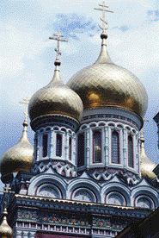  St Basil’s Cathedral, Moscow, Russia | 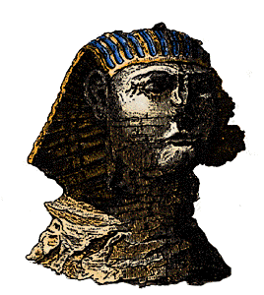  The Sphinx, Giza, Egypt | 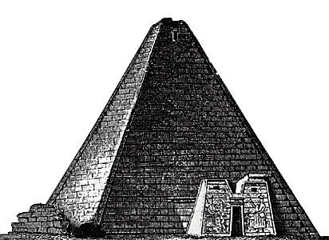  Temple of the Sun. Chichen Itza, Mexico

- Food for thought……

Where would you expect to eat the following foods? (20 - 1 point for the country and 1 for type of food.)

- Couscous ……Turkey / Middle East etc. 6. Parkin …Yorkshire……
- Schnitzel ……Austria………… 7. Janssen’s Temptation …Sweden.
- Poppadums ……India………………… 8. Fajitas …Mexico / Spain………
- Lamingtons ……Australia……… 9. Bara Brith ……Wales………
- Pemmican ……North America………… 10. Bigos ……Poland……………

- International Guiding
A : In which countries would you find Guide sections with these names?? (10 points total)
Little Wings …Belgium……. Yellow Birds …Argentina………
Butterflies … Cyprus……………………. Daisies ……….USA…………….………….
Jeannettes……France…………………… Gumnuts ……..Australia……….…….………..
Bulbuls ………India…………………… Brigins ………Ireland……………….………….
Fairies ……….Mexico…………………… Little Bees … Switzerland…………….…………
B : Can you name the countries represented by these Trefoils? (10 points)
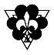  Sweden | 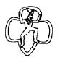  USA (Brownies) | 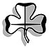  Switzerland | 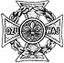  Poland | 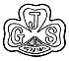  Japan
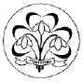  Russia | 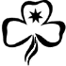  Australia | 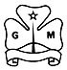  Mexico | 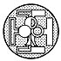  France | 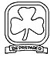  Canada

C : The World Association is divided into five Regions : the symbols for them are shown below – but which is which? (5 points)
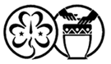  Africa | 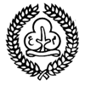  Asia | 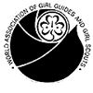  Asia-Pacific | 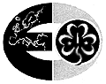  Europe |   Western Hemisphere

D : World Centres: There are 4 World Centres : what are their names, and where are they?
…Pax Lodge, London UK: Our Cabana, Mexico; Our Chalet, Adelboden, Switzerland, Sangam, India
and for 2 bonus points, which one was the first? ……Our Chalet……(Total points : 10)

E : General (International Guiding) Knowledge – (go on, guess – you might be right!!) (2 points each, to make a nice round 100.)
- When was WAGGGS founded? ………1928………………………………………………
- How many countries does WAGGGS represent? …………. 140………………………..
- How many Guides (of all ages) are there world-wide (to the nearest million)? …>10,000,000
- Which 2 of these were NOT Guides or Girl Scouts? ………………...…………………………..
Hillary Clinton, Mo Mowlam, Margaret Thatcher, Mariah Carey,
Carrie Fisher, Debbie Reynolds, Venus Williams, Serena Williams

