This is an UNOFFICIAL Go4It produced for the GuidingUK email group. It is based around the OFFICIAL Girlguiding UK Music Zone Badge but has no official status : see also the Disclaimer on the back page.



Go For It - Music Zone Badge

You don’t have to be “musical” or play an instrument to enjoy music – check out the activities below.

If you just want to count this as a go for it, you only need four activities. If you complete five of the clauses you can get the badge as well!

With your Patrol or some friends, choose three pieces of music and listen to them.    Each put the three in order of preference.  - Do you all agree?  - Can you explain why you think what you do?  If you play an instrument, you could do this with three pieces you play. If you play in a group it could be pieces your group play and you could discuss it with other members of the group. |  | Make a tape of a piece of your own 'music' and listen to it with your Patrol.  You could do this in various ways, for example you could:  - compose and perform a tune or song  - collect sounds  which hold some  meaning for you  (such as birdsong,  traffic, etc) or  - make up a sound story using everyday sounds.
Use a favourite piece of
music in an interesting
way. This could be
making up a dance or
aerobics routine to it or
something more unusual
like painting a picture of
what you see when you
listen to the music.

Make and play your
own instrument.

There are some
ideas at the back
of this pack.

Help organise a unit campfire or a show for parents or others or take part in a District, Division or County campfire.    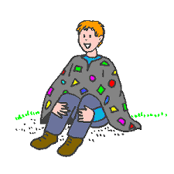 |  | Go to a concert or musical performance. This could be with family, friends, your Patrol or your unit.    Afterwards tell an interested adult about it, or chat about it in your patrol.
Investigate the history or use in other countries of some of the music and songs used at Guides such as Taps.    Learn Taps in another language or learn to sign it. |  | Make your  own camp-  fire song  book.
Make up a musical quiz for other members of your unit.      ? ?  Be as imaginative as you can about what sorts of questions you use. |  | Find out and the importance of doing breathing exercises before you sing or play a musical instrument, or show somebody else what you do to combat nerves before a performance.  
Learn or find out about a song or piece of music from three different cultures    Create an illustration for one of them to go into a songbook or music book.   |  | Learn how to DJ using the kind of record decks and mixing decks that professional DJs use.    In front of your friends, family or Patrol, show them that you can mix  two records or CDs together to form one continuous beat.  Make a tape of yourself doing this to play to your unit, or if you can borrow some equipment for a long enough time and feel confident enough, arrange to DJ at a party for your Patrol or unit.

Extra options
These can count towards this Go For It, but not the badge.

Bring in or borrow some musical instruments which you’ve never tried and have a go. Make sure you take care of them!    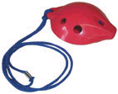 |  | Try ocarinas. They are a really easy musical instrument, a bit like a funny-shaped recorder.
Get hold of a “chill out” tape or CD, of music which is meant to be relaxing. Try it out. Does it work? |  | Write some new words to a well known campfire song – maybe make up some new verses for “You’ll never go to heaven”!
Musical sticks  Nigerian girls play this game with short lengths of wood, but rolled-up newspapers work just as well.  Everyone sits in a circle, holding a stick in their right hand. Only one girl does not have a stick. Start the music. Everyone must pass their sticks to the right, take a new stick and keep passing them on. Keep going until the music stops. Anyone holding two sticks, or no sticks at all, is out. Start the music again and keep playing until all but two are out! |  | Record bowl  Make a bowl from an unwanted old 78 record.  - Preheat oven to 180.  - Take a metal bowl and place it upside down on a baking tray (which may get damaged!).  - Take the record and place it on top of the bowl.  - Place in oven.  - Watch carefully! The record will start folding down the side of the bowl.  - You can take it out at any time it starts to melt down. When it comes out you have just a few seconds that you could shape it but it is hot so mind your fingers!  - Let it cool and than paint with acrylic paint.

CD Craft

Make something from old (unwanted!) CDs. Let your imagination run wild…
Musical decorations  Make some musical decorations for your room or Christmas tree  Drums – take two coloured screw tops from plastic milk bottles. Make a cylinder of card & put one bottle top on each end. Glue in place and decorate as you like. |  | Rainy day orchestra  Wait for a rainy day, then collect lots of metal pots and pans. Take them outside & put them under the drips from the roof, or just in the rain.  Can you get a wide selection of sounds?  Don’t forget to wash all the pots afterwards.
Bells – cut out individual sections from an egg box. Cover them in silver foil to make a host of Christmas bells. Add hanging loops

Fun foam models

Make magnets or badges of musical instruments from fun foam

Some musical instruments to make…

Drums
Make a collection of pots, pans, bottles etc. Use your hands or make your own “beater” by pushing a cork onto a piece of doweling, or cover the end of a stick with a wad of material. Experiment with different noises, tones and pitches. Make the drums “talk” by beating out the rhythm of your name or your unit.

Xylophone
Collect lots of glass bottles. Fill them with varying amounts of water & blow across the top or hit them with a beater to get different notes. Can you produce a recognisable tune?

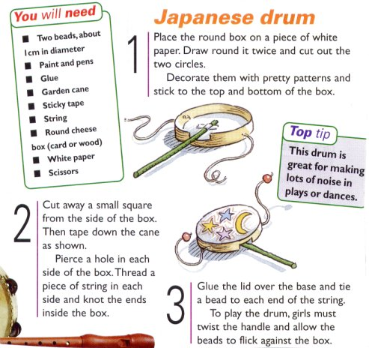

Shakers
Make shakers by putting some lentils, dried peas or other small hard objects into containers & sealing them.

Wind chimes
Can you make your own wind chimes? Experiment with different materials to find a sound you like.

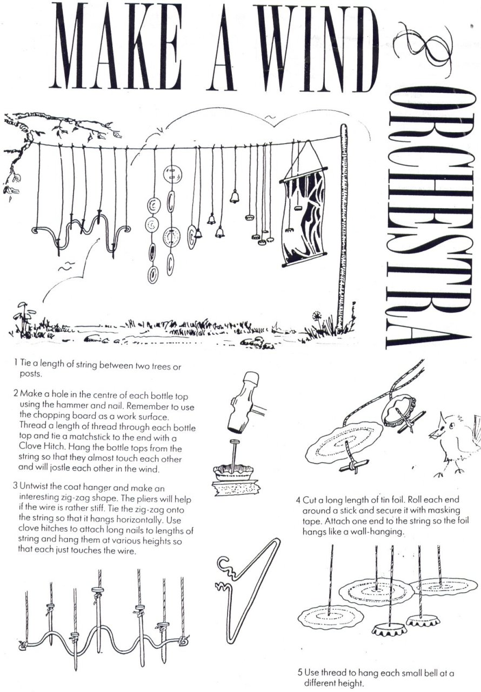

The Back Cover

Disclaimer

This is NOT an official Go For It! and is not in any way endorsed by Girlguiding UK.

Information for guiders

A Balanced Programme: One of your responsibilities as a Guider is to ensure there is a balanced and varied programme for your guides. You will need to work with Patrols to see that over time they take part in activities that cover all five zones (see Notes for Guiders) by doing unit activities, games etc. in addition to Go For Its!

Safety: Another responsibility is to ensure that the Guides are safe. The rules within the current guiding manual should be adhered to and, depending on their ages and abilities, you may need to supervise Guides.

[Taken from Girlguiding UK Go For It publications]

Acknowledgements

Clipart from

http://www.guidinguk.com
http://www.gif.com
http://www.girlguiding.org.uk
Edinburgh Gang Show

Japanese drum from Guiding magazine, November 1999

The “Wind Orchestra” is from an unknown source :
if you hold the copyright and can prove this, please contact us by emailing
webmaster@guidinguk.com

