Guides go GREEN

Guides Go Green

Guides Go Green

Have a go at making your own paper

Below you will find a simple papermaking recipe to get you started. If this is the first time you are making paper, don't be afraid to experiment with different fibers, you don't have to stick with paper related products. Add whole flower heads to the pulp mixture after it has been through the blender. You can add scraps of yarn, tin foil, even seeds. Its all comes down to what you want. Experiment with different textures and colors Remember, some of your ideas will turn out while others may not. Have fun with it, express your creativity.

Simple Recipe:

Many types of paper that can be used include:
- Computer Paper (unprinted)
- Newspaper (If you want a grayish colored paper)
- Magazines
- Egg Cartons
- Old Cards (For heavier paper)
- Paper Bags
- Non Waxed Boxes (Pre-soak in warm water)
- Office Paper
- Tissue Paper (For finer paper)
- Typing Paper
- Napkins
Supplies you'll need:

Sponge
Mesh, old tights
Wood Frame (old picture frame can be used too
Plastic Basin/Tub (Large enough to totally immerse frame)
Blender/Food Processor (For making paper pulp)
J clothes
Staples or Tacks (For tacking mesh/ tights on frame)
Instructions:
1. Select the pieces of paper to be recycled. You can even mix different types to create your own unique paper.
2. Rip the paper into small bits, and place into the blender. (About half full). Fill the blender with warm water. Run the blender slowly at first then increase the speed until the pulp looks smooth and well blended. (30 -40 seconds) Check that no flakes of paper remain. If there are, blend longer.
3. The next step is to make a mould. Simply stretching mesh/ old tights over a wooden frame and stapling it, in this case, make the mould. It should be as tight as possible.
4. Fill the basin about half way with water. Add 3 blender loads of pulp. (The more pulp you add the thicker the finished paper will be) Stir the mixture.
5 Place the mould into the pulp and then level it out while it is submerged. Gently wiggle it side-to-side until the pulp on top of the screen looks even.
6. Slowly lift the mould up until it is above the level of the water. Wait until most of the water has drained from the new paper sheet. If the paper is very thick, remove some pulp from the tub. If it is too thin, add more pulp and stir the mixture again.
7. When the mould stops dripping, gently place one edge on the side of a j clothes. Gently ease the mould down flat, with the paper directly on the fabric. Use a sponge to press out as much water as possible. Wring the excess water from the sponge back into the large plastic tub.
8. Now comes the tricky part. Hold the j cloth flat and slowly lift the edge of the mould. The wet sheet of paper should remain on the fabric. If it sticks to the mould, you may have pulled to fast or not pressed out enough water. It takes a little practice. You can gently press out any bubbles and loose edges at this point.
9. Repeat the steps above, and stack the j clothes on a baking sheet. Save one fabric square to place on the top of the stack to cover the last piece of paper. Use another cookie sheet to press the remaining water out of the stack. (Do this outside or in a sink, it can make a mess)
10. After you press the stack, gently separate the sheets. Hanging on a clothesline or laying them out on sheets of newspaper can dry them. When they have dried peel them off the fabric and voila! You have paper!

Which paper recycles easiest?

Materials
Collect 5 different sorts of papers, choosing from the following list:
- Newspaper
- Glossy magazine or glossy leaflets
- Office paper (ordinary white paper that has been printed, written or photocopied on)
- Greetings cards
- Brown paper or brown envelopes
- Gift wrapping paper
- Thin card, such as cereal packets

Equipment
You will also need:
- A bucket or other container for each type of paper
- Water
- Good magnifying glass or microscope
- Liquidiser
- Potato masher

What you will do
You are going to tear the paper into small pieces, soak it in water overnight and then mash it or liquidise it to a pulp. You will be looking to see which type is easiest to make into a smooth pulp. You can then use the pulp to make your own handmade paper. This is what happens when paper is recycled, only you are doing it yourself instead of it happening in a huge papermill.

Action | Answer these questions as you go | Answers
Choose a paper type to work with. | Which type of paper are you working with?
Tear each type of paper into small pieces, keeping the different types separated in their containers. | How easy is each type to tear?
 | Can you think of a way to measure exactly how easy?
 | Can you tear more easily in one direction than the other? Why might that be?
Look at the torn edges, first with your naked eye and then with a magnifier or microscope. | What do the fibres look like?  Long, short?  Colours, appearance?
Add the same amount of water to the pieces of paper in each container and leave them overnight or longer | When you came back the next day, had all the types of paper absorbed the water to the same extent?
Mash the paper with the potato masher. Decide how many minutes you will mash for so that you do the same for each type of paper. | How easy is it?
 | Is it different for different types of paper?
What does the pulp look like now?
Colour, texture?
Take a cupful of pulp and water and liquidise it. Measure how many seconds you run the liquidiser for so that you can do it the same for all the paper types. | What does the pulp look like now?  Colour, texture?
Look at some pulp under a microscope | Do the fibres look different from before you started the recycling?
Use the pulp from each type to make sheets of paper. Remember to label the sheets as you make them so you know which came from which paper. | What is the paper like?  Colour, texture, strength?
Which paper do you like best?
What was it made from?
 | What could it be used for?

Create a card

Why not make your own cards using old cards, magazines and wrapping paper.

Iris folding is ideal for this.

What You Will Need:
Scrap Papers - Any types of papers will do: Pearl, Metallic, Patterned and Plain
Scissors
Ruler and Pencil
Sellotape/Scotch Tape
Double sided Tape
Paper Quilting Template
Aperture Cards: These are cards with a hole cut out of them, aperture cut outs come in many shapes such as: circle, ovals, squares, hearts, butterflies and other novelty shapes.
If you don't have aperture cards you will need to make your own using:
A5 Card Stock
Tracing Paper
Craft Knife
Rubber Cutting Mat
How To Create:
- Before preparing your paper strips, take a look through your paper collection and pick out the ones that compliment and match each other. On average I used 3-4 different papers and patterns per card I created.
2. Using your ruler and pencil; measure your scrap paper into strips approx 1 inch wide, you may prefer to use your ruler width as a guide if you do not wish to measure. Cut down your pencilled lines using scissors.
3. Now fold all your paper strips in half-length ways so you are left with long thin folded strips.
- 4. Using your scissors snip the long strips into 1 and 2 inch long pieces (do not cut along the fold as you want to keep the folded part) so you are left with smaller folded strips.
Your paper strips are now ready for layering.
Creating Your Own Apertures
The instructions I give are for Aperture cards, but you may not have any to hand! All is not lost as you can make your own:
1. Print out the following templates, or use your own
2. Trace around the templaAperture tes onto tracing paper and transfer them to your sheet of card.
3. Place your card onto the rubber cutting mat and using your craft knife cut out the shape to reveal your handmade aperture.

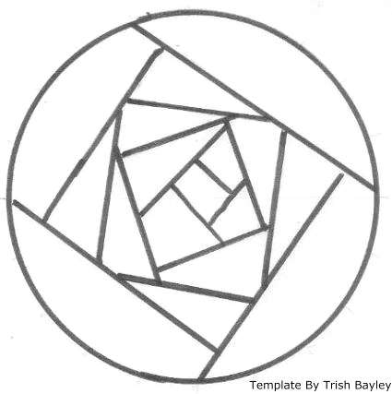
How To Paper Quilt (Iris Fold)
You can copy this template for use in your project. This template is ideal for circle aperture cards as it resembles an abstract 'Mackintosh Rose' when it is completed.
.
1. Copy out the template above
2. Place your template on your work surface, next place your circle aperture card front face down over the template so that the pattern is visible through the hole.
If you do not have a circle aperture you can position any shaped aperture over the pattern and use the lines as a guide for paper layering.
Next up you are going to place your paper layers down but before you do:
General Guide To Paper Quilting (Iris Folding)
First of all before you start always make sure the folded side of your paper strip is lined up with the line in the template, as it is this folded part of the paper creates the 3 dimensional 'applique' effect. In other words the fold needs to be in the middle of the design.
When you place down one paper layer secure it to the back of the aperture card using scotch tape or celotape. Then move to the next layer, place it down and secure with tape, continue in this fashion until you have completed the design.
Finally in the 'Iris Folding' technique you are supposed to place a piece of holograpgic paper or card in the very last central hole to create an eye or 'Iris'. This part is optional and really up to you! I have created cards both with and without an 'eye' which you can see in the gallery elsewhere.
Now Back To The Card Project....
This next part is difficult to explain in words so there is a Paper Layering Guide to go with the template you have printed out to help you to understand which you can see here:
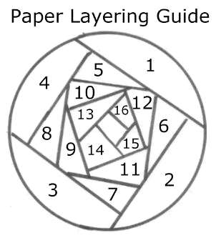
As you can see there are numbers within each lined section. These numbers represent the order in which you place your strips of paper to create the design.
You start from the lowest number 1 on the outside, and work your way inward layering paper strips to finish in the centre.
If you follow this guide you should have no problem at all:)
That’s it your design is now complete! All you need to do is secure the aperture card to finish it off using doubled sided tape.
If you have used a handmade aperture you will now need to crop the card and layer it to the front of a card blank using double sided tape to finish.

More Paper Quilting Templates
In addition to the above template I have designed some more Paper Quilting Templates for you to create along with paper layering guides to get you started.
The best thing about these templates is that it doesn't matter what shape of aperture you use or how big your aperture is as all you have to do is move your aperture around the template so that it fits!

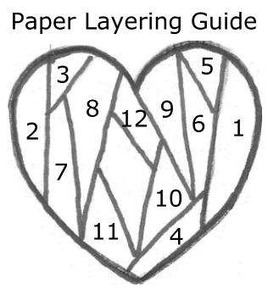
Heart Paper Quilting Template:
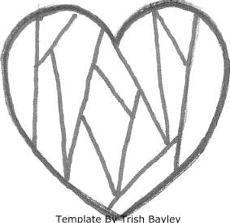

Square Paper Quilting Template
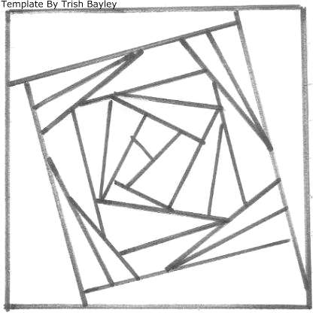
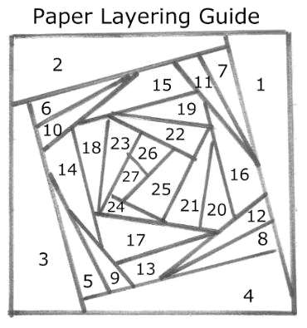

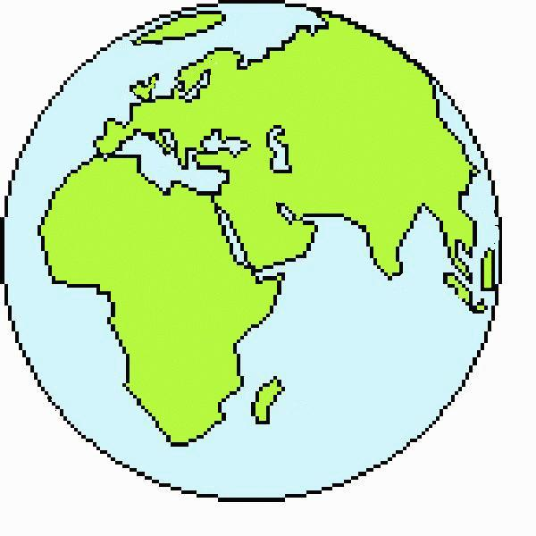
Celebrate Earth Day - Every Day
Earth Day is celebrated on April 22. This is obviously a topic for any time. Be good to the Earth.
A new look at junk, or change the world, one bit a a time...

Things to discuss when it comes to saving resources...
Recycling is when an object can be shredded, melted or otherwise processed and then turned into new raw material -- for instance, aluminium cans can be melted down to make more cans, glass can make more glass, cardboard and paper make more cardboard and paper, plastic bags and containers can be turned into other plastic products. This takes some energy (very little for aluminium), but it is a good choice.
Reusing is when you find a use for an existing item - like decorating a bag and using it as a gift bag instead of buying wrapping paper; putting leftovers into a clean container from some other food; turning a used box into storage; decorating a can to hold pencils; saving packing peanuts and boxes and using them the next time you need to ship something or give a gift.
It is important to 'reuse' items wisely -- reusing packing peanuts to pack an item is by far the best way to use them. Recycling them, if it is available, would be the next best thing. Turning them into an art project would be the least effective, and eventually they will end up in the landfill. Now many of us love art projects, and would be using materials to make crafts _anyway_, and so using an item that would otherwise be discarded may still be a sensible choice, it depends on the project.
Giving things in good condition that you no longer need to charity is another good way to reuse things like outgrown clothing or toys. Reusing is often the best way to save resources. This is something to consider year-round, not just around the winter holidays.
Shop Wisely to save resources. Can the container be easily recycled or reused? Will a larger container reduce the amount of packaging and perhaps cost less per serving? Is everything that can be recycled being recycled?
Save resources (and money) by asking yourself if the item is something you really need, and if it is well suited for the task, and if it will last. Not only can this save you money, it can save you space and work, too. Five toys that are loved an played with are more fun than 10 toys that are broken or are boring to play with. And it's quicker to pick up 5 toys and put them away than to pick up 10. Sometimes my kids and I imagine what it would be like if we bought everything we 'liked'..... and we realize that there wouldn't be any room left for us in the house.... and that really doesn't sound like that much fun, even to my kids.

Plant a Tree Perhaps you could do this at your meeting place or at a nursery, old folks home or community centre?

The Earth Day Groceries Project

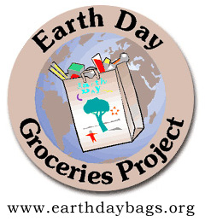
is a cost-free environmental awareness project in which students decorate paper grocery bags with environmental messages for Earth Day. One of the oldest and largest educational projects on the Internet, the Earth Day Groceries Project is managed online by Mark Ahlness, a third grade teacher at Arbor Heights Elementary School in Seattle, Washington. Why not make a groceries bag and decorate it with the earth day logo and add your own environmental message. Give it to someone to use and re use

Earth Day Necklace
Make a fashion statement and celebrate your love for the earth!
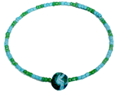
You need:
- Wire big enough to go round your neckt
- E-Beads
- Dark Green and Light Blue Sculpty / fimo
- Needle Nose Pliers
Instructions
Pinch a few small pieces of dark green and light blue sculpty together. Roll them into a ball about 1/2" in diameter. Now it should resemble the earth. Push a toothpick through it to make a hole. Bake according to package directions.
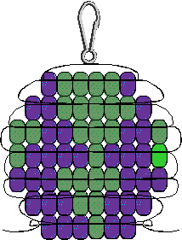
String e-beads on wire necklace filling half way. Add your earth bead. Fill the remaining half of the wire with e-beads. When finished, use a needle nose pliers to bend the other end to keep beads in place.
Earth Pony Bead Pattern
You need:
- 25 Green Pony Beads
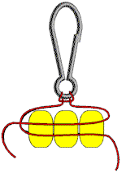
- 33 Blue Pony Beads
- 2 Yards Satin Cord
- 1 Lanyard Hook
Basic Instructions:
Fold your ribbon in half to find the centre. Use a half hitch to secure it to lanyard hook. Lace beads using the pattern above right as a guide.

USE “RUBBISH” TO MAKE A GIFT FOR SOMEONE OR EVEN YOURSELF!
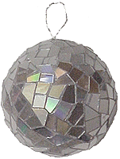
Recycled Disco Ball
You Need:
- 6 to 8 CDs you don't need
- 5" Styrofoam Ball
- Tacky Glue or Low Temp Glue Gun
- Wire for Hanging
- Kitchen Shears
Instructions:
Cut CDs into irregular 1/2" pieces. Some pieces will splinter. Discard the splintered pieces.
Wrap wire around Styrofoam ball in two directions. Bring lose wire ends together and form into a loop.
Glue CD pieces all around Styrofoam ball. Hang from wire.

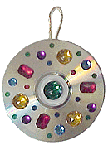
CD Ornaments
Save those free CDs and fill your Christmas tree with pretty, reflective ornaments.
You Need:
- Two CDs you don't need
- Gold Cord
- Tacky Glue or Low Temp Glue Gun
- Gemstones
Instructions:
Glue two CDs back-to-back, sandwiching a loop of cord between them for hanging. Decorate with gemstones and glitter.

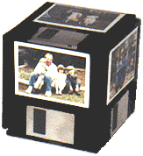
Floppy Disk
Photo Cube
!
You Need:
- 6 Old 3½" Floppy Disks
- Blank Index Stock
- 6 Photos You Can Cut
- Low Temp Glue Gun
- Double Stick Tape
Instructions:
Lay one disk face down on your workspace. Use a low temp glue to attach one disk to each side and a disk on the top.
Cut six pieces of index to 2-1/8" x 2-3/4". Use double stick tape to attach one to each floppy. Cut photos to 1-7/8" x 2-1/2" Use double stick tape to attach photos in the centre of rectangle index leaving a white border around each picture.

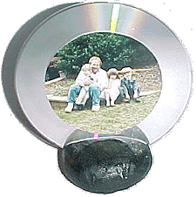
CD Photo Frame
You Need:
- Old Compact Disk
- Flour/Salt Dough
- Photo
- Scissors
- Double Stick Tape
- Adhesive Backed Felt
- Tacky Glue
- Paint
- Scrap of Cardboard
Instructions: Use Flour/Salt Dough to mould a base for your photo frame. Make sure that it is at least 1" deep and 2" around. Make it any shape you want. Use cardboard or a table knife to make a slot in your base. Go at least halfway down through base and wiggle it back and forth a little to widen. Bake or air dry. Paint. Cut photo into a 3" circle. Attach it to CD with double face tape. Cover the back of the CD with sticky back felt. Use tacky glue to secure in into slot in base.

Plastic Grocery Bag Dispenser
Why not make the tube-like bags that you use to store and dispense plastic grocery/other bags. They are not difficult or expensive to make.
This project is rated EASY to do.
What You Need
- Old long sleeved shirt
- Needle and thread
- Ribbon
How To Make It
- Take the sleeves out of old long sleeved shirts that you don't want any more.
- Turn down the end that came from the shirt to where it is even all the way around, stitch down.
- Tack a piece of ribbon on each side of the top to hang it by and dispense the bags from the cuff end. The bigger shirt sizes probably would work better for this.

Perhaps you could make and sell them to raise money for a local or national environmental project?
PUZZLE TIME, HAVE A GO AT ONE OF THE PUZZZLES THEN TRY AND MAKE YOUR OWN
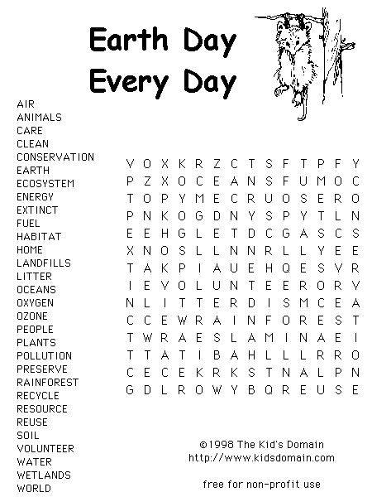

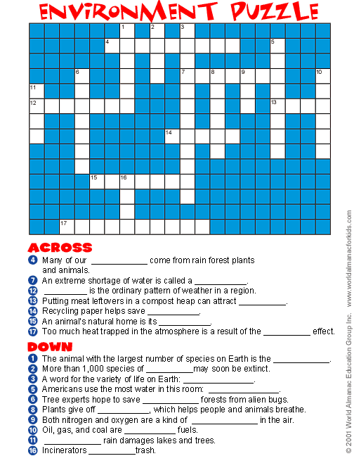
Answer

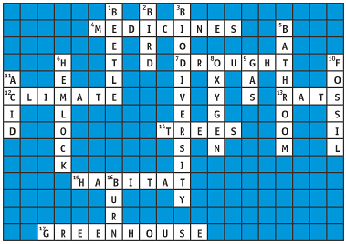

Perhaps you could make up your own word search, cross word or puzzle and get the rest of the guides to try it out?

How You Can Help the Environment
From Linda Book's World of Music for Kids (www.lindabook.com).

Here's what you can do to help the environment:
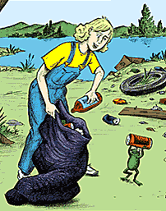
Here are some things you can do:
- Save energy by turning off the light when you leave your room.
- Save trees, which are used to make paper, by using a lunch box, rather than a paper bag each day.
- Pick up litter that you see in your neighborhood and recycle whatever can be recycled - aluminum cans, glass, paper, cardboard, plastic things.
- Ride your bike or walk, when you can, rather than ride in a car.
- Turn off the water while you are brushing your teeth.
- Use less water in your bath or shower.
- Use both sides of a piece of paper when drawing, coloring or writing.
Here are some things your family can do together:
- Use paper shopping bags, rather than plastic, and reuse them at the supermarket. Keep a supply in your car, so you have them with you when you stop at the shops.
- Pay attention to the packaging of the products you buy and buy things that come in containers that can be recycled or reused.
- When possible, bring fruits and vegetables home unwrapped, rather than in plastic bags.
- Recycle aluminum, glass, and newspapers, cardboard and plastic containers.
- Use water-saving devices on toilets, showerheads and taps.
- Carr share whenever possible. When you can, walk, ride a bike, or use public transportation.
- Plant trees in your yard.
- In the winter, keep your thermostat lower and wear a sweater.
Using the list record how many ways you have helped the environment in a week at home, school and at guides.
Recycled Water??
Investigate how water is recycled in a small environment and to learn on a small scale how water is cycled on earth.
You will need
- Soil
- Container -- 2-liter plastic bottle works best.
- 1 or 2 plants depending on size of container.
- Gravel or stone
- Water
- Scissors or knife
The amount of water on the earth is the same today as in the days of the dinosaurs. Everything we do to our water affects its quality. In the activity you will see how water is recycled. Think about the affects that humans have on this cycle.
Here’s how
- Cut the 2 liter bottle in two pieces at the top of the hard plastic base.
- Remove the softer plastic from inside the hard plastic bottom, if possible.
- Place a layer of stones on the bottom of the clear plastic and add three to four inches of soil.
- Put the plant in the container, making sure that the soil is firm around the roots.
- Add one to two tablespoons of water depending on how moist the soil is.
- Place the top of the bottle securely on the base. Keep the cap on the bottle. Place in a sunny window.
- If the water cycle is working, water droplets called condensation will form over time inside the dome. When enough condensation forms, it will rain and water the plants.
Think about the fact that rain contains more than just water, it also includes pollutants picked up from the air. Some of these pollutants form acids and cause acid rain, which can stunt tree growth and kill fish and other aquatic organisms.
As an extra experiment, fill another bottle 1/4 full with water colored with food coloring, screw the cover on, and place the water in a sunny window. What do you expect the color of the condensation to be? Colored or Clear?
(I will be clear because when water evaporates, any dissolved substances are left behind.)


Water water everywhere and not a drop to drink

Here in the UK we have toilets and safe clean water flowing from taps in our homes. But life is very different for many people around the world who do not have these basic services. Water and sanitation affect everyone throughout the world and WaterAid is committed to raising awareness of water-related issues.
Why not visit its web site at www.Wateraid.org.uk to see how you can help them.

What did you do when you got up this morning?
- Brush your teeth?
- Have a wash?
- Have a drink?
One of the first things you did probably involved using water.
WaterAid helps these people by working with them to build safe water and toilets. These pages will show you more about the people, countries and projects that WaterAid is involved with.

THE EFFECT ON CHILDREN
Children throughout the world suffer greatly because they don’t have access to safe water and sanitation. Their health, education and family relationships are affected.
In many countries children, particularly girls, are responsible for the collection of water. Girls as young as 10 years old may take the main responsibility for drawing and carrying the family's water.
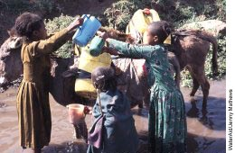
The size of the water container may vary with the size of the child, but each litre of water carried weighs 1kg and may need to be carried up to three or four miles. Carrying such heavy weights is damaging in the long term for adult women, and for girls there are even more serious implications given their physical immaturity. In particular, there can be damage to the head, neck and spine. In extreme cases deformity of the spine can lead to problems in pregnancy and childbirth.
Effect on education
Collecting water is not only physically stressful but extremely time consuming. One of the most serious effects is that girls are often not able to attend school. Many children who do manage to go to school have very low attendance figures and often drop out. Both boys and girls are needed by poor families to help either farming or in doing domestic tasks at home. They have little time to play
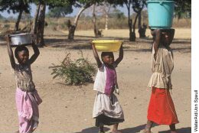
The lack of adequate sanitation facilities in schools also prevents girls from attending school, particularly when they are menstruating. Of the 113 million children currently not enrolled in school worldwide, 60% are girls. Girls' attendance at school is increased through improved sanitation. For example, in Bangladesh, a school sanitation programme has increased the enrolment of girls by 11% every year since it began in 1990.
Health matters
Children are most vulnerable to the diseases that result from a lack of water, dirty water and poor sanitation. In developing countries each child has an average of ten attacks of diarrhoea before the age of five. Malnourished children are more vulnerable to disease, and prone to diarrhoea, pneumonia, measles and malaria. These four diseases, plus malnutrition, account for seven out of ten childhood deaths in developing countries. For example in Zambia, one in five children dies before their fifth birthday. In contrast in the UK fewer than 1% of children die before they reach the age of five. Diarrhoea is the second most serious killer of children under five worldwide (after pneumonia) but in most cases it can be prevented or treated.
Children's ill health places an increased burden of care on the women and girls who look after them, adding to their already heavy workload. This and the time spent collecting water can prevent women from earning money which can in turn mean they are unable to afford to send their children to school.
A lack of water also means that children cannot wash often enough and suffer from diseases as a result. These include skin diseases like scabies and eye infections such as trachoma, the largest cause of preventable blindness in the developing world.
In the Kongwa District of Tanzania a trachoma research project found over 90% of school children were infected with the diseases. After treatment the disease nearly disappeared but in a few months it had returned. Their conclusion was that treatment was not a long-term solution: educating to regularly wash their face, hands and eyes was the best preventative measure. The problem was education and lack of water.
Providing children with clean and accessible water and toilet facilities changes their lives. Their health improves; they have more time with their families and more regular and varied meals. They have time to go to school and gain an education; sometimes they have time to simply play.
Why not visit their web site and se how you can help this charity, perhaps you could make and sell recycled gifts?
Links
Cool Planet
Oxfam provide information and ideas about our planet and what we can do to help.
www.oxfam.org.uk/coolplanet/index.htm
Earth Day Games
Fun environmental games available on line.
www.kidsdomain.com/games/earthday.html
Eco-Kids
An American site all about waste and recycling with an eco-quiz and fun activities to do at home.
www.futuresolutionsinc.com/Kids/kidz.html
exZOOberance
A website with information and pictures about almost every animal on the planet!
www.exzooberance.com
Ollie Recycles
Extend your knowledge of sustainability and its related issues, in a fun and entertaining way.
www.ollierecycles.com
Water Aid
Sections for different age groups to access information and games about global water issues.
www.wateraid.org.uk/site/learn_zone/
Wild over Water – WOW
Games and activities linked to waterways, plus the chance to produce a homepage.
www.wow4water.net
Wildlife Watch
Wildlife Watch is the UK’s leading environmental action club for kids, providing an exciting way to explore your surroundings and get closer to the wildlife you share it with.
www.wildlifewatch.org.uk
Young People’s Trust for the Environment
A charity dedicated to promoting understanding of the environment, with loads of fact sheets written specially for young people.
www.yptenc.org.uk

