Go4It :
Get Traditional

This is a Go For It pack written specially for 193B Edinburgh Guides in November 2001.

Contents  - Autumn Festivals  - Film canister rockets  - Spring festival  - Chinese couplets  - Christmas  - More Christmas  - Easter  - Games  - Local traditions – pinata  - Local traditions – Divali  - Guide traditions  - Other ideas | Notes for patrols:  - Try not to pick 4 activities the same – like 4 games or 4 crafts  - You don’t have to do things exactly as it says here – use your own ideas as much as you like  - Don’t forget to record what you do  - Make sure everyone has fun

Harvest – you could try flower arranging, maybe for your church. Or take food to an elderly person. If you don’t know anyone suitable you could collect food to donate to a homeless charity or even pet food to donate to an animal shelter.

Halloween
- make turnip or pumpkin lanterns
- try bobbing for apples
- peel an apple keeping the peel in one piece – the shape reveals the name of the man you’ll marry!

Bonfire Night –
Remember, remember,
The fifth of November,
Gunpowder treason and plot.
We see no reason
Why gunpowder treason
Should ever be forgot!

The Plot was foiled in the night between the 4th and 5th of November 1605. Already on the 5th, agitated Londoners who knew little more than that their King had been saved, joyfully lit bonfires in thanksgiving. And we still do it!
- Try making your own guy
- Make a rocket by following the instructions on the next page.

Film Canister Rockets
How to make Film Canister Rockets………………………..

- Get a film canister, make sure the top goes inside the main bit!!
- Using paper and glue etc. make your rocket round the main part of the film canister. Use your imagination and make them really funky!!
- Fill up your film canister rocket about 2/3’s full with water.
- Get a plate, and a quarter of an alka seltzer tablet or half a teaspoon of baking powder.
- Go OUTSIDE and put the alka seltzer or baking powder in the water put the lid on, rocket on the plate, and STAND BACK.

Why do you think it works?
Don’t forget to clear up afterwards.

The oldest and most important festival in China is the Spring Festival, more commonly known in the West as Chinese New Year. The date of the holiday varies from late January to mid February.
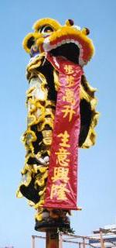
- Try a Spring Festival tradition like lion dancing.

Decorations are an important feature of the celebrations for the Chinese New Year. One of the main forms of decoration are the 'Red Couplets', which are Chinese good luck sayings written on red paper, often with gold trimmings and usually made up of four Chinese characters which ask for luck in terms of long life, wealth etc.
Red is not only a lucky colour for the Chinese, but also frightens off the monster 'Nian' who arrives at this time of year and destroys crops and homes.
Some New Year couplets are intended to be pasted or pinned in special places such as the kitchen or doors, while some can be placed anywhere. The couplets are usually taken down after the New Year celebrations, thought some people keep them up all year long in the hope of keeping good luck.
- Make a good luck couplet for your house (instructions on the next page)

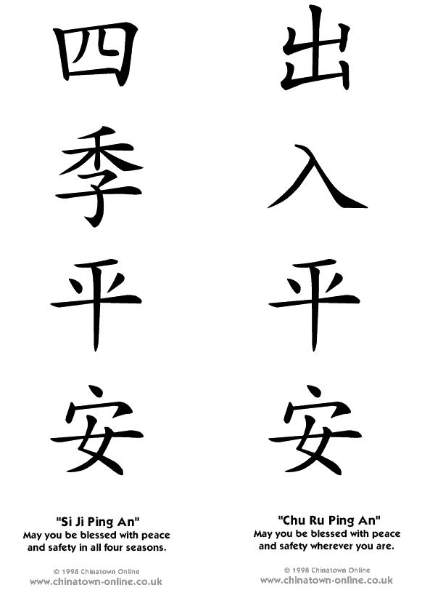

Chinese Couplets
Copy the symbols below onto a red piece of A4 paper. Cut the paper lengthways & hang one side each side of your door to bring you luck!
Try a few Christmas traditions, even if it’s the middle of summer! Use some of these or your own favourites!
mulled wine
Here’s a recipe for a non-alcoholic version of mulled wine, if you’ve got a hob or cooker that you can use:
Simmer 5 cloves, 3 teaspoons ground cinnamon, half a teaspoon ground allspice, half a teaspoon grated nutmeg, 30g sugar and pared rinds of 2 lemons in 200ml of water for about 20 minutes. Strain into a large pan and add the juice of 2 lemons, 500ml orange juice and one litre of apple juice. Heat slowly without boiling. Makes about 12 drinks.
While it’s cooking you could prepare your carols to sing as you offer some “wine” to the rest of the guides!

- Make or borrow a Christmas tree & decorate it. You could make your own decorations.

Decorate a real tree outside as a bird’s Christmas tree. Try these ideas for decorations…
- string threaded with popped corn or conkers or peanuts in their shells
- Fir cone feeders: Collect large fir cones. Thread fine string through the sections and tie to make hanging loops. Cover the cones with peanut butter and roll them in oats.
- Collect small foil bun or pie plates and fill them with kitchen scraps – stale cheese, bacon rind, stale cake, potato – and bind together with fat from meat and the grill pan. Leave to set hard then take off the foil container and put the cakes on the ground.

Have fun in the snow!
It’s not snowing? No problem!
- have a snowball fight with newspaper “snowballs”
- use mashed potato to make a snowman
- use an old piece of carpet or blanket as a sledge & try it out in the hall! Don’t forget to thread some rope through it so you can get your friends to pull you through the “snow”!
- Make cardboard skis, attach them to your feet with string & have a race!

Have a Christmas Quiz – here’s one to start you off. Can you identify the carols from their initials?
- OCAYF  - OIRDC  - GRYMG  - SN  - LDLDOTDR | 6. OLTOB  - GKWLO  - WTKOOA  - DDMOH  - AIAM

(Solutions are on the back cover if you get really stuck!)

Make some Christmas crackers
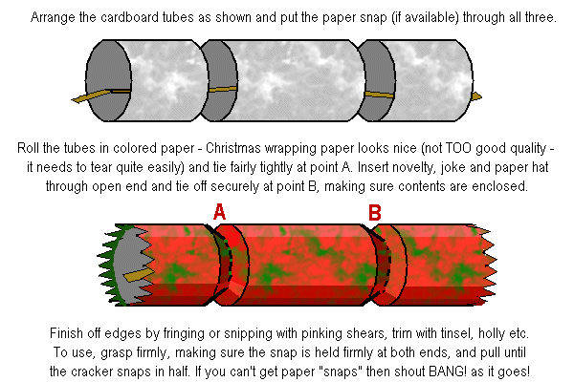
The custom of giving eggs at Easter time has been traced back to Egyptians, Persians, Gauls, Greeks and Romans, to whom the egg was a symbol of life.
In medieval times a festival of egg-throwing was held in church, during which the priest would throw a hard-boiled egg to one of the choir boys. It was then tossed from one choir boy to the next and whoever held the egg when the clock struck 12 was the winner and retained the egg.
- hold an Easter egg hunt – in the hall or outdoors. Maybe you could organise one for the unit?
- find out how to make chocolate Easter eggs and try it!
- Have an egg throwing contest – you’ll need some real eggs (not cooked). Go outside, somewhere it doesn’t matter if you drop eggs! Get a partner & stand really close together. Gently throw an egg to your partner. If you manage ok, move a bit further back and try again. How far can you throw an egg??
- Try egg blowing, and decorate the eggs. You could fill them with cotton wool & lavender give them as presents.
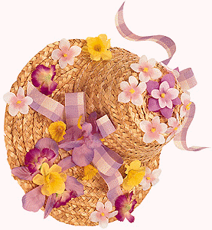
Easter Bonnets are a throw back to the days when the people denied themselves the pleasure of wearing fine clothes for the duration of Lent. By tradition, it was obligatory (or at least lucky) for churchgoers to wear some bright new piece of clothing - at least an Easter bonnet, if not a complete new outfit.
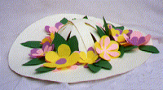
- Have an Easter bonnet competition. Make them from anything you like – try paper, or silk flowers & an old straw hat.
Have a go at some traditional games – maybe some you’ve played before. Try at least one new one. Here’s some ideas:

- marbles (does anyone have any marbles? The first person rolls their marble on the floor then everyone else tries to hit it by rolling their own marbles. If you hit the first person’s marble then you win it – who has the most left after 5 or 10 games?)

- jacks or five stones (take 5 small pebbles or other objects and spread them on a table or the floor. Then take a small ball & throw it in the air. How many jacks can you pick up before catching the ball?)
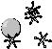

- skittles (you could use ready-made ones or make them out of pop bottles with something like rice in, to weight them down)

- skipping (either individually or with a long rope. If you don’t have a long rope see if your guider has one, or maybe you could borrow one from the brownies? How many rhymes do you know?)
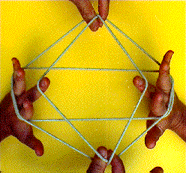

- Cat’s cradle (who can demonstrate this string game?)

- clapping games (do you know any? do you know someone who could teach you some?)


- dominoes (there are loads of domino games – there are usually some ideas with a set of dominoes)

- jack straws (if you don’t have a set you can use twigs or skewers or even drinking straws)

Piñata
Piñatas are clay jugs filled with sweets or small gifts. Originally they came from Italy but now they’re very traditional in Mexico whenever there’s a celebration. A piñata is hung from the ceiling & children are blindfolded & take turns trying to break it with a stick. Try making your own then you can break it and eat all the sweets! This activity could be spread over 2 weeks.
- Cover your working surface with newspaper
You will need:
An apron per person
¾ kilo plain flour
1 tsp salt
water
newspaper
scissors
mixing bowl & spoon
glue & crepe paper
string
wrapped sweets
balloon
- Put the flour and salt in a big bowl then add the water slowly, stirring until it looks like thick cream
- Tear lots of newspaper into strips & sort into writing and pictures.
- Cover all over, using paper with writing on. Overlap the pieces a little but leave the knot of the balloon uncovered.
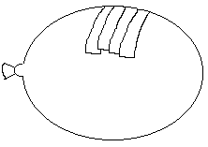
- Add four more layers, alternating between picture and printed layers so you know how many you’ve done.
Get someone to take it home & hang it somewhere warm to dry for 3 or 4 days. Then at the 2nd meeting you:
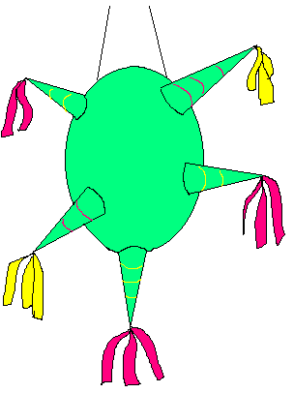
- Burst the balloon inside and remove it.
- Make a small hole at the other end & thread the string through to hang it from.
- Decorate the outside with crepe paper to make a star or an animal.
- Fill carefully with sweets and hang it up.
Then have fun trying to get the sweets!

DIVALI – Festival of Lights

The Festival of Lights is the most exciting holiday of the year for Indian children. Before Divali (Dee-VAL-ly) children spend all day making diva lamps. They pour mustard oil into little clay lamps and cut wicks. On Divali the family visits friends and exchanges gifts. At sunset the divas are lighted. The lights guide Lakshmi (the Hindu Goddess of Wealth and Good Fortune) back down to earth on wings of a heavenly swan and leaves wealth and good fortune at each house as she blesses. -UNICEF’s Festival Book

Find out about other “light” festivals

Make a MEDEL DIVA

Making the lamp

Colour appropriately (leave section A blank)
- Cut along all dotted lines
- Colour reverse side
- Fold “flame” upwards
- Glue section A and stick under B

Making the stand
Follow instructions 1, 2 and 5
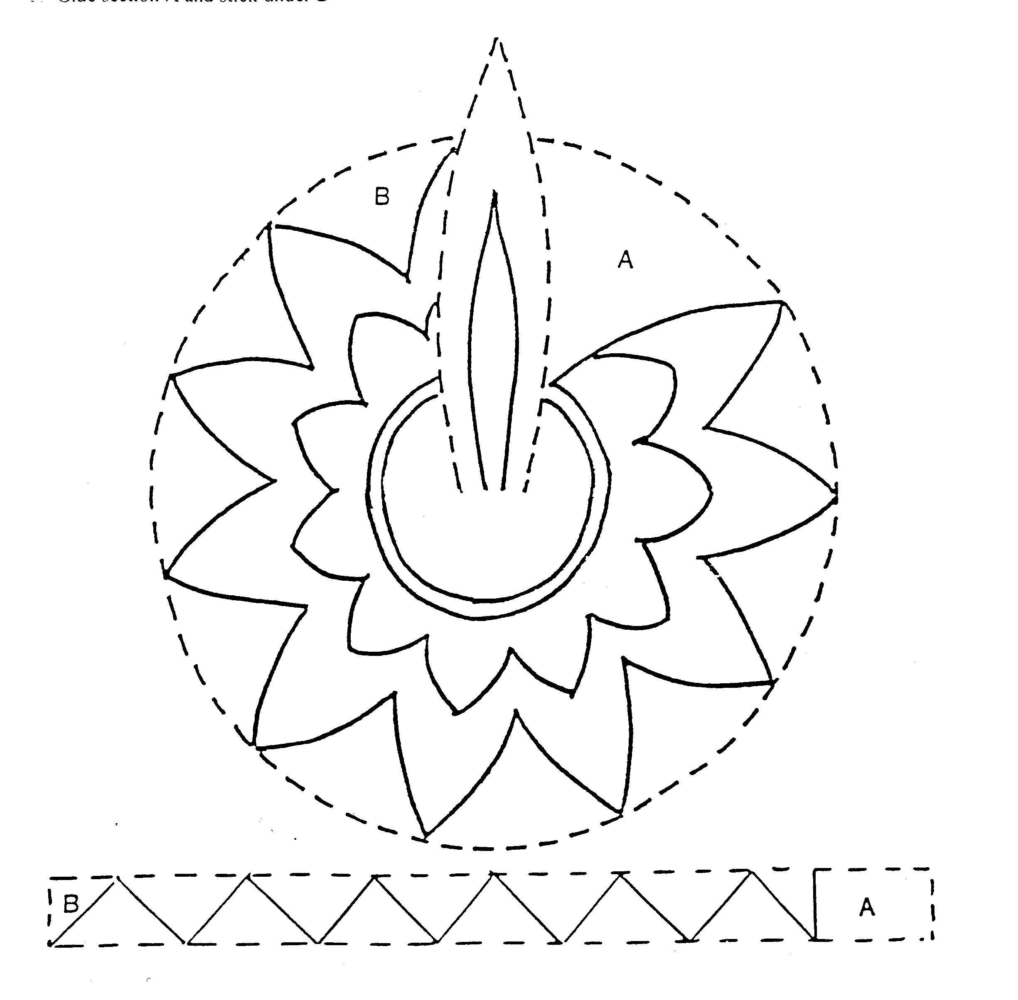
Guides started in 1910 so it’s had time to get a lot of traditions! Why not try some of them out with your patrol?
Try your hand at bandaging. Could you use a crepe bandage to strap up a sprained ankle? Or a triangular bandage to make a sling?
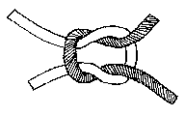
How are you at knots? Make something from just pieces of wood and string – like a pair or stilts or a patrol notice board. The only limit is your imagination! Learn any knots you need or improvise your own.

Get hold of the first scout handbook, Scouting for Boys, or the first guide handbook, “How Girls Can Help Build Up The Empire” and find some activities in there. Your guider might have a copy.
Use tracking signs to lay a trail – take a piece of wood like a broom handle and use a sharp knife to carefully carve a symbol on the end. Then use it like a walking stick and you’ll leave a trail of your own “footprints” if you walk on soft ground. If you are stuck with pavements try using arrows or a particular “footprint” marked in chalk.

Campfire singing: learn some traditional guide and scout songs, and perform them or teach them to your unit. You probably already know “Campfire’s burning” and “Tzena” but what about “Swinging Along” or “Join Hands in Friendship”?
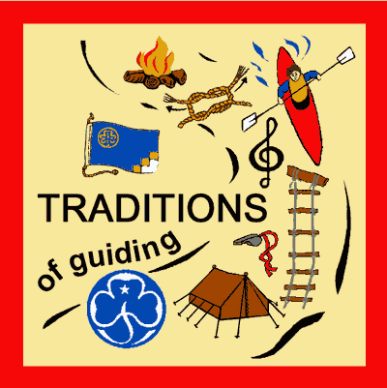

If you like the look of some of these ideas you could go for the “Traditions of Guiding” badge.

Bring a desk lamp and try a hand shadow show on the wall!
Have a go at country dancing – have any of you had lessons? Could you teach the others?
It doesn’t have to be from your own area – anything from Flamenco to line dancing!

Learn some old songs – you could sing “It’s a Long Way to Tipperary”, “Pack up your Troubles” or “Minnie the Moocher”.

Try making some traditional food, like pancakes – don’t forget the sugar and lemon! Or do you know someone (maybe one of your mums?) who could teach you how to cook a local dish? You could meet at their house if they were willing. Don’t forget to check with your guider if you want to meet outside the usual place.

Back cover

Answers to Christmas Quiz:
- Oh Come All Ye Faithful
- Once In Royal Davids City
- God Rest Ye Merry Gentleman
- Silent Night
- Little Donkey Little Donkey On The Dusty Road
- Oh Little Town Of Bethlehem
- Good King Wencleslas Looked Out
- We Three Kings Of Orient Are
- Ding Dong Merrily On High
- Away In A Manger



If you enjoyed doing this pack you
could look at the “culture” badge.

Some of these activity ideas have come from:
The Singing Snowmen http://www.geocities.com/singingsnowmen/crackers.html
The Best of GuidingUK http://www.guidinguk.com
Chinatown OnLine http://www.chinatown-online.co.uk

