BRIDGEWATER DIVISION BADEN POWELL NARROW BOATING WEEK END



28th September to 30th September 2007

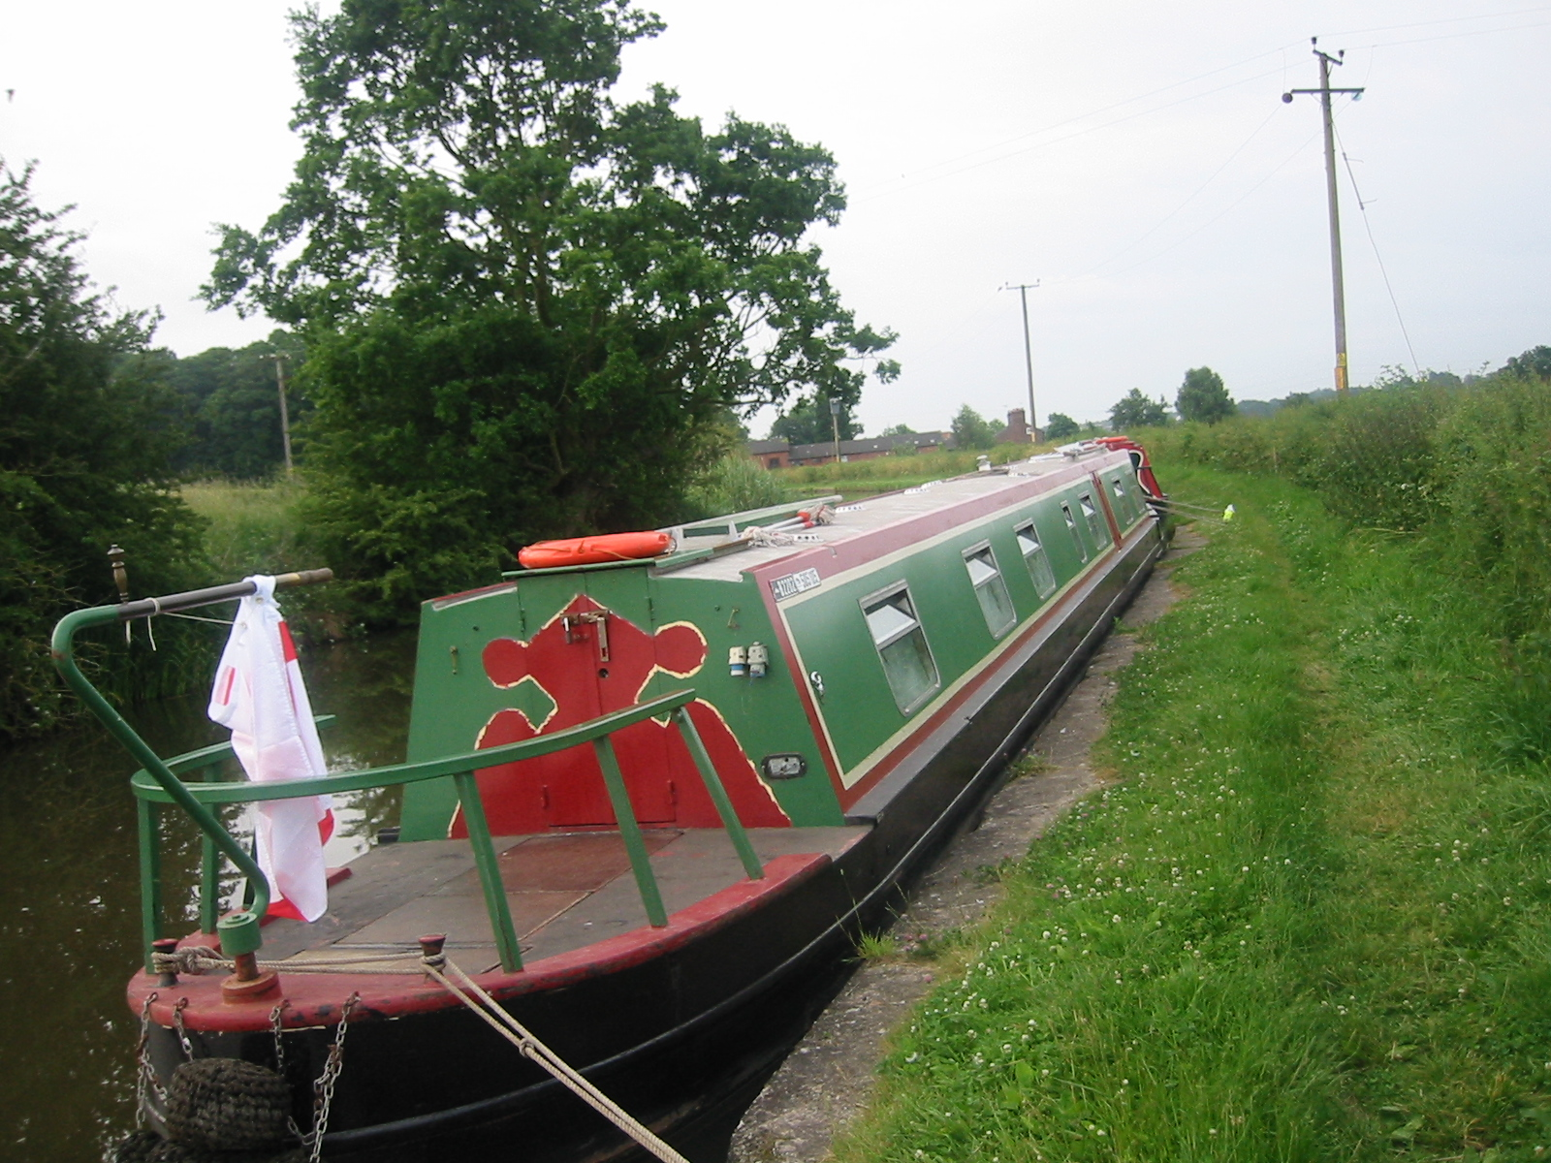

You have chosen to undertake this Adventure for this weekend.
There may be people on this narrow boat that you do not know but by the end of the weekend, you certainly will! Make friends, settle in and form your own patrols of 2 plus. Decide between you in which order that you will complete the following challenges which will give you a taster of canalling …… Relax, take your time and enjoy your cruise!
F O R E W O R D

A residential event on a narrow boat is a great experience for Guides! The girls (and leaders!) appreciate the opportunity to learn different skills, such as operating locks and steering, and enjoy seeing the scenery pass by at a slower pace to usual. They learn the obvious skills, such as working as a team and co-operating, as well as the less obvious: how to cope with living in very close proximity to each other! By undertaking this Go For It!, the Guides will have a greater understanding of canal culture, and have good memories of their time aboard.
Jane Mason, London and South East England Region Boating Adviser.

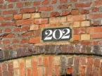Plan the Route

Each group needs to plan our route with an adult available to guide as required. (Nicholson’s Map Guide available.) Adult leader will give a destination. You need to work out how many lock miles from morning to lunch, lunch to tea etc.

The Skipper needs to know how many bridges we may go under, their numbers, locks, and anything else you think may be necessary for us to know, including how long it will take us to travel from A-B etc.

Your boat is not allowed to travel at more than 4 mph on a canal. You need to allow 15 minutes for passing through each lock. Eg 1 mile = ¼ hr = 1 lock. For any journey you add the locks to the miles and the answer is lock miles. You can do 4 lock miles an hour.

Work out how long your proposed trip will take. Cruising on canals for 6 hrs each day means that you could do 24 lock miles a day.

Canal terms

Research the books available to find the definitions of the terms printed below. (Dusty Miller’s Tips, British Waterways Handbook for Boaters, observing ongoing situations.)

Aground | Astern | Berth | Bow | BWB Key
Fender | Galley | Gongoozler | Helmsperson | Lock Miles
Lock Crew | Mooring Pin | Paddle | Pound | Port
Prop | Pump Out | Rudder | Screw | Starboard
Stemmed Up | Stake | Skipper | Throttle | Tiller
Winding Hole | Windlass

Answers will be given on Saturday evening.

Knots
You need to know how to tie the boat up when you moor. Practice the following knots.
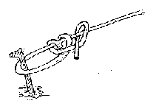TAUTLINE HITCH
Used when you need to be able to adjust the tension or length of a tied rope.

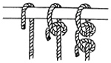TWO HALF HITCHES
This reliable knot is quickly tied and is the hitch most often used in mooring. To tie:
- Pass the end of a rope around a post or other object.
- Wrap the short end of rope under and over the long part of rope, pushing the end down thru the loop. This is a half hitch.
- Repeat on the long rope, below first half hitch, and draw tight.

FRIENDSHIP KNOT (Decorative)

  1st cross the 2 ends of the neckers |   Then make a bight with the end that went over, and tuck it back under the other end. |   Now pass the other  End behind the bight |   Finally tuck the end down the bight

Finished friendship knot - looks smarter in a Halved necker, and if you fold the bights

Exercise
Devise an exercise routine suitable to use on a narrow boat. You can get quite stiff sitting and sleeping in the small space of a canal boat.

Water Safety Code
What is it and who is it for and how does it apply to you as a user? Could you suggest any other rules? Read the leaflet enclosed in your wallet.

First Aid
You may suffer from hypothermia, sunburn, dehydration, heatstroke, cuts and burns on a narrow boat. Discuss how you might/would treat a casualty with a helmsperson/guider on board.

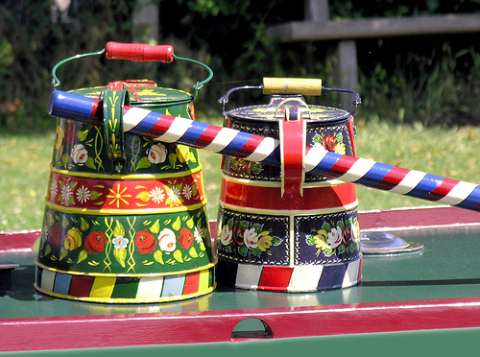Traditional Craft

- Barge painting. Wooden Spoon – Traditional style is to use roses and castles. Attached are the instructions for roses.

- Scoubidous. Fancy knots for brooches – pens – key rings – Guide Association Knot Book or Scoubidous books.

Cooking
Prepare a 2 course meal using a cooker for all people on board – no microwave or electric kettle available because of the precious need to conserve electricity for other things.

Help will be needed to prepare the Indian Banquet celebration meal for Saturday evening. The cook for this will be arriving on Saturday morning. Please greet her in the usual Indian tradition.
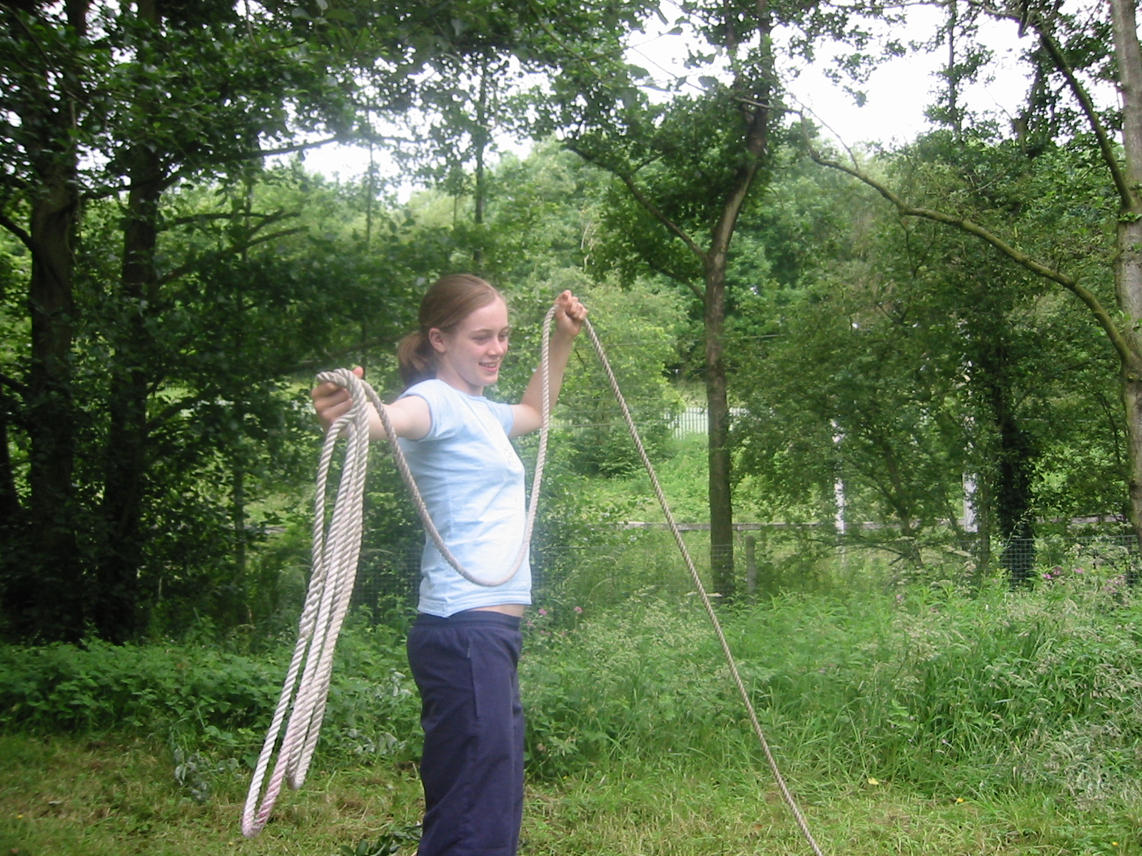Rope Throwing
Practice throwing a rope to someone else: NB The rope must not touch the water
- in front of you – from the boat to the canal bank side
- above you – upwards as if you are on the boat eg in a lock and throwing to someone else on a bridge or canal bank side
- below you – ditto
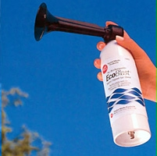Horn or Whistle Signals from the Boater’s Handbook – the first 5 are rarely used!
1 short blast = I am turning to the right
2 short blasts = I am turning to the left
3 short blasts = I am in reverse
4 short blasts (followed by 1 or 2 or 3 of above) = I am about to alter course
5 short blasts = I have run aground
1 LONG blast – sound every 20 seconds when approaching blind spots, a lock or moveable bridge and requiring to be opened and when entering a tunnel

Look Out Duty

On a 70 feet long boat especially, the helms person stands at the back of the boat steering and it’s extremely difficult to see what is at the front of the boat and what traffic is coming up. Therefore we have people at the front – 2 preferably for company and we use hand signals for the helms person to be aware of. You need to sit outside the cabin at the front and be aware all the time of the canal conditions.

(a) A flat hand, palm facing the stern, pointing straight up = stop boat coming, slow down

(b) A thumb pointing upwards with fingers clenched inside hand – going round bends especially = carry on at normal speed; everything is OK, no traffic.

Can you suggest another hand signal? It would need to be clearly seen and understood.

Wild Life on the Water
British waterways would like you to take note of any of the following wild life you spot over this weekend. It doesn’t matter how many times you see the same type of bird or animal as long as you can record where you saw it and approx what time and what the weather was like.
 I SPY …… with my little eye
Did you see anything unusual not named here?
Where did you see them?
Please be as accurate as to where you saw them.

BIRDS –Have you seen a
  http://www.waterscapes.com  KINGFISHER | WHERE/DATE | 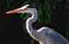  http://www.waterscapes.com  HERON | WHERE/DATE
  http://www.waterscapes.com  SWAN | WHERE/DATE | 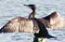  http://www.waterscapes.com  CORMORANT | WHERE/DATE
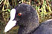  http://www.waterscapes.com  COOT | WHERE/DATE |   http://www.waterscapes.com  MALLARD | WHERE/DATE
  http://www.waterscapes.com  MOORHEN | WHERE/DATE | 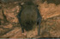  http://www.waterscapes.com  BAT | WHERE/DATE
INSECTS |  | INSECTS
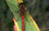  http://www.waterscapes.com  DRAGONFLY | WHERE/DATE | 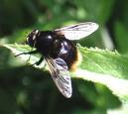  http://images.search.yahoo.com  BUMBLEBEE | WHERE/DATE

COMPETITION
Your Kingfisher pictures are wanted!!

Send you Kingfisher photos to editor@waterscape.com and the best will win £100 as soon as possible after the weekend. Please let me know if you intend to send a photo of a Kingfisher as Waterscape are aware that you will all be looking out and the closing date is the same weekend but they will extend the closing date … just for us!

Please note – Kingfishers are protected from being disturbed on or near an active nest.
Please take care not to go too close to a nest as this may cause parents to abandon eggs or chicks.

Combined efforts of Ally Whittaker & Karen Macintyre, Guiders with 7th Appleton Hill Cliffe Guides, Bridgewater Division, Cheshire Forest May 2005
Improved and updated by Ally Whittaker June 2007 ally@allywhittaker.co.uk
Proof reading check by Paula Syred, Ranger Guider, Cambs East & owner Fox Narrowboats Ltd, www.foxnarrowboats.com

