



CONTENTS

Fighting Fit
Water Babies
Get Down And Dirty
Couch Potatoes!
A Four-legged Friend
Faster than a speeding bullet…..
Bat ‘n Ball
Sport as an Art Form….
Try Something New
Having a “Wheely” good time”
Indoor Sports
Baby it’s cold outside!

Created for 1st Keyingham Guides in response to their pleas for the return of the Sportswoman badge!

Fighting Fit

Before you take part in any sports you need to be FIT. Do you think you’re fit?

We’re not talking about weight here – at your age you shouldn’t be too concerned about how much you weigh – but if you know you could be a bit fitter, start to do something about it NOW.

Think of ways in which you can improve your fitness by changing simple things you do every day.
Can you walk to school (or part way anyway) instead of having a lift in the car?
Use the stairs instead of the escalator or lift when you go shopping
Eat healthily! Fruit instead of crisps and chocolate – and at school dinners too!
With your patrol, devise a simple exercise routine you could do every day. Teach it to the other patrols in your unit. Are you going to exercise to music? Then don’t forget to arrange who’s going to provide it!
WATER BABIES!!

If you can’t swim, now’s the time to learn! You can’t enjoy yourself in the water until you CAN swim.
Find out where your nearest swimming pool or leisure centre is and phone to enquire about swimming lessons.
You don’t need to swim to Olympic standard, but you do need to be confident both in and on the water.

Think about how you could organise one of the following :

A swimming gala, either for your unit, District or even Division! What races would you include? What about “fun” events for the not-so-competitive?

A mini-regatta : is there anywhere you know of where you could SAFELY hold a water-sports event? What safety cover would you need – who could you ask to find out? If you CAN hold one, what events would you include? Make sensible plans for a swimming gala or regatta.

Once you can swim, you can learn to
- Kayak
- Canoe
- Sail
- Surf
- Windsurf
- Raft
- Water-ski and/or Scuba dive

…. If you want to!


How about an “Indoor” or “Mini Regatta” – in a bath or paddling pool!

You can make model boats in lots of ways :
- Rafts out of lolly sticks with paper sails
- Folded paper (origami) sailing boats (see next page)
- Paddle-wheel boats (see next page)
- Sail boats out of cardboard boxes, sardine tins etc.
However you make your boats, race them across a paddling pool or bath of water. How are you going to provide the “wind?”

If you have a suitable river, stream or pond, you could float your boats on that –
WARNING : ADULT SUPERVISION ESSENTIAL NEAR WATER.
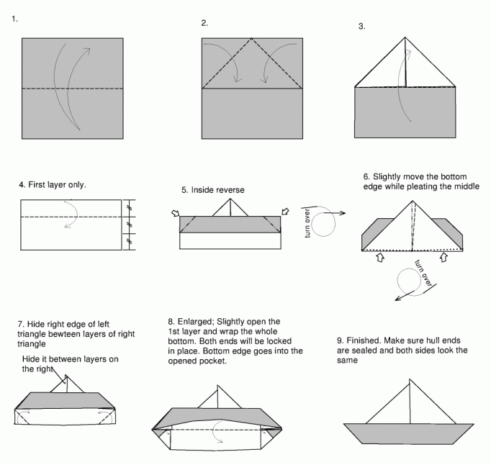

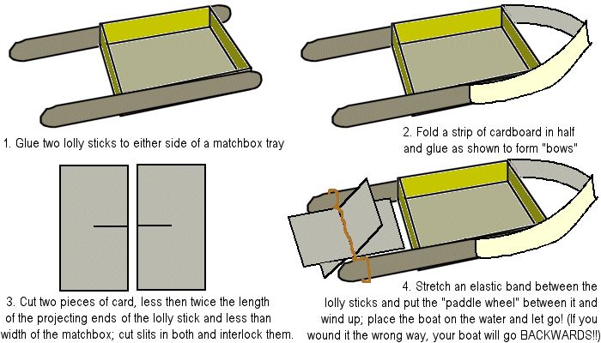
Get Down And Dirty!
How are you in the wet and the mud? Think about what you need to wear for an outdoor game in wet weather. Discuss it as a patrol and make a list of what you’d need.

Assault courses are great fun! If there is one near you, have a go on it. Don’t chicken out of crawling though wet muddy tunnels etc.!

How could you construct an INDOOR assault course in your meeting room or hall? Make sure everything is safe and stable before you try it out. (CLUE : you don’t necessary have to climb ON things….)

What about a Night-Line course? Mark out a course through some waste land if possible – under trees, through puddles, over fences – with a clothes line tied to branches, railings etc. then take it in turns
to be blindfolded and led through the course. No peeping! (It would be a good idea to get your Guider to check the course before you try it out.)
If there’s nowhere outside, do it indoors……
Arrange an abseiling or climbing wall session : contact the Venture Scouts who will probably know where you can go and who can instruct you – you can’t do it on your own!
Couch Potatoes!

There’s more to sport than taking part ….. you can watch sport as well.

Use a TV guide (TV Times, Radio Times, etc.,) and see just how many hours of sport there is on TV in a week. You might need to divide your list up into separate sports in order to keep track of it!

     

Watch a sports event and see just how much time is taken up talking about the event compared with how much time is spent actually on the sport!

Sports magazines and the sports pages of newspapers : read up about your favourite sport or sportsman/sportswoman.
Compile a scrapbook of press cuttings, photos and magazine articles .
A Four-legged Friend

At some time in their lives, most girls want to learn to ride!

Is there a stable or riding school nearby? Perhaps you can arrange to go there as a patrol one weekend and see if you enjoy riding.

You can make a start by reading books and magazines about horses and riding, and make a scrapbook of pictures of horses and riders.
If you can’t manage a real horse – make a Hobby-horse by stuffing an old sock to make a head, decorate it with eyes, nostrils and a mane, and fasten it to a broomstick.
Now arrange a “Hobby-horse gymkhana!!”

It isn’t only horses that are used in sport! What about greyhounds – or even racing pigeons!

Can you arrange for a dog trainer or pigeon-fancier to come and talk to your unit?
Faster Than A Speeding Bullet...

Running is one of the oldest sports.
You can organise sessions using running as your theme, either indoors and outdoors.

Try these different types of races :
Sprint - run fast for short distances
Distance – run not so fast, for a longer distance (round a field, round the Hall in which you meet, etc.)
Relay – team races, one person has to “tag” the next one, or pass an object to her, before the next runner can set off.
Obstacle – use your imagination! The runners have to cross over/under/round simple obstacles in the course of the race, or perform simple feats (e.g. throw beanbag into a bucket, climb through a hoop)

If you can borrow a stopwatch, you can time each other rather than having to actually race against each other.

Challenge another Patrol to compete against your Patrol, or select a “champion” to represent each Patrol and have a Unit competition.
Bat ‘n Ball

How many ball sports can you think of?
Which ones can you play with JUST a ball?

The most obvious ones are
Football
Netball
Volleyball
Basketball
but can you think of any others?

Organise some ball-only games – use a ball which won’t damage the place (or the players) if you’re playing indoors!

What about bat-and-ball games (or stick-and-ball games)?
Hockey
Cricket
Rounders
Baseball
Tennis

Adapt one or more of these games for indoor play – try using a rolled-up newspaper, or even your hand, as a bat and use a soft ball.

Sport as an Art Form
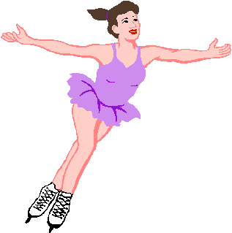
Some sports combine athleticism with artistic expression:
Gymnastics
Figure-skating
Synchronised swimming

Can you think of any others?

Gymnastics : devise a routine you can perform in your hall or meeting place. Practice until it is good enough to put on as a display for the rest of you unit.

Skating : is there an ice rink anywhere near, that you could arrange to visit? This is something you could do as a unit, but your patrol could make all the arrangements and bookings etc.

Synchronised swimming is even harder than it looks! Perhaps you could improvise a “dry” synchro routine to entertain your friends!

Make sure you get the hairstyles, make-up and costumes right, and don’t forget the music!
Try Something New….

Don’t think you’re the sporty type? Not everyone is super-fit, or even wants to be!

Try something which requires skill rather than muscle. Or maybe you ARE the sporty type and would like to try something really unusual?

How about :
Archery?
Dragon-Boating?
Trampolining?

Ask your Guider about organising a “Taster” session for something new.

* * * * * * * * * * * * * * * *
Think about what sports you enjoy watching – do you think you’d enjoy them even more if you could take part? Ask at your local sports centre for details of what courses they offer. You’d be surprised!

Having a “Wheely” Good Time!
If you can’t already, learn to
Roller-skate
Ride a bike
Skateboard

If you already CAN, try something a bit more ambitious, and see if you can borrow a snakeboard or a unicycle! (If anyone runs Circus Skills classes in your area, they will probably be able to help.)

Read the Highway Code, especially the sections for cyclists.
Then organise a bike ride with your Patrol – you will need to discuss this with your Guider AND get your parents’ permission, and depending on your ages you may need to take an adult with you. PLAN WELL, STAY SAFE, and HAVE FUN!!

INDOOR SPORTS

... and games!

Organise a tournament involving some or all of these games and pastimes :
- Jacks
- Marbles
- Tiddley Winks
- Conkers
- Darts

Organise the playing order and make trophies or medals to present to the winners!

Beetle Drives are great fun too. If you don’t know how to play, find out, and organise a Beetle Drive for your Unit.

Invent your own indoor games! Think of the sort of games you like to play at Guides and make up your own variations.
Work out the rules between you and when you have agreed on them, teach your new game to the rest of your unit.

Baby It’s Cold Outside!

Just because winter’s coming doesn’t mean you can’t do sports or play games outside!

If the snow has come, how about these?

Sledging / tobogganing – using proper sledges if you have them, or improvise with trays or even plastic fertiliser sacks (thin bags will wear through!)
Snowboarding
Skiing
A snowball fight!
Build a snowman!

If it really IS too cold to go out, check out the suggestions on the Indoor Sports card OR – devise an “indoor” version of the winter sports listed above :

Toboggan races – pull each other on plastic sacks (careful – check the floor for splinters first!)
Snowball fights – make snowballs out of crumpled newspaper.
Ice Floe race – across the floor using just two sheets of newspaper per patrol…….

If you have enjoyed this GFI, you may like to do the following Interest Badges :


Agility
Team Player
Team Leader

Hobbies

Healthy Lifestyles

You may find these websites helpful :

The Guide Association www.guides.org.uk
The Best of GuidingUK www.guidinguk.com
The Sports Council www.sportengland.org

