Go 4 It!
Get Practical

Notes for patrols:


- Try to have a go at varied activities

- Don’t forget to keep a record of everything you do!

- Most importantly… make sure everyone takes part and has fun!

Notes for Guiders:

As ever, it is your responsibility to ensure guides undertake a varied programme which covers the 5 zones. You should also keep an eye on safety when patrols are running their own activities.

If you have any comments or suggestions on this Go For It, please submit them to GuidingUK so other Guiders can have the benefit of your experience! If you don’t have access to GuidingUK, go to http://groups.yahoo.com/group/guidinguk/ to find out more, or email slbhill@yahoo.com with your comments.

Credits
Fire information (including extinguishers)
http://www.wsfb.co.uk/ (West Sussex Fire Brigade)

Pin star
http://www.pitara.com/activities/craft/online.asp?story=112

Clipart, ideas and all sorts of stuff!
www.guidinguk.com

This Go For It was produced by members of the GuidingUK mailing list. Edited by Sandra Hill, 193B Edinburgh Guides.
ON YOUR BIKE!
- Hold a “take good care of your bike” night for your patrol or even your unit. Get someone to bring in a bike and give it a good check over. You might need someone to show you how…
- oil the chain… what else should you oil?
- check for and repair a puncture
- check all gears work.
- check there’s enough tread on the tyres
- what about the brakes – do they work ok (how would you test this?) and how much material is there on the brake blocks?
- check for anything loose or dangerous

- do you have a reflector – and is it clean enough to work? (The law says you must have a red rear reflector, and if your bike was made since 1985 it must also have amber pedal reflectors)
- do you have lights? Do they work?
- bell – do you have one? Do you need one?

If you can do all this you could try fixing the chain or adjusting the gears.
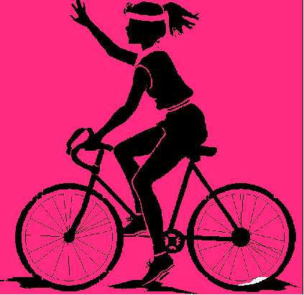
Riding!

Where do you ride? Are there enough cycle paths?
- Contact your local council and ask for more!
- Go on a ride with your patrol.

What clothing do you wear for cycling? What should you wear??
- Get one member of your patrol to dress in dark clothes, one in light, one in fluorescent and one in reflective clothes. Then see how far away you can see them in the dark. Which are best in daylight?

Do you wear a helmet?
Find out how to make sure it fits, and how to wear it properly – it won’t do you any good perched on the back of your head!

Try making or taking a Highway Code quiz!
HIGHWAY CODE QUIZ

1. If you’re walking down a road with no footpath, which side of the road should you walk on?
- the right
- the left
- whichever side has less traffic

2. If you have a young child or a pet with you, which side should they be?
- on your left
- on your right
- the side away from the traffic

3. You are going on holiday by car and the car breaks down on the motorway. While you are waiting for the breakdown people which of the following should you do:
a) stay in the car with windows locked
b) stand behind the car to warn other traffic
c) watch the approaching traffic
d) sit on the bank behind the barrier

4. If you are riding a horse on the road, what does the law say you must wear?
a) bright clothes

b) a helmet
c) boots

5. Where must you not ride a horse:
a) on a pavement
b) on a residential road
c) on a bridleway
d) on a main road

6. On a bike, which are better…
a) flashing lights
b) constant lights

7. You are riding your bike down the road when you come to an amber traffic light. what should you do?
a) Carry on through, traffic lights don’t apply to cyclists.
b) Stop unless it would cause an accident
c) Get off your bike
Answers on the back page
d) Go as fast as you can to get through before it goes red.

8. Which of the following are against the law:
a) Cycling on the pavement
b) Leaving your bike on the pavement, causing an obstruction
c) Carrying a passenger on a normal bike
d) Holding on to a moving car
TRAVEL

ON FOOT

- Learn how to use a compass – if your patrol leader doesn’t know, maybe your Guider will show you if you ask nicely!

- Know where the compass directions are – practise by doing the treasure hunt on the next page!

Can you use a street map? Or an Ordnance Survey map?
- Make a game of Pelmanism (card matching) with OS map symbols.

- Discover different ways of finding north without a compass – for example by the sun or stars.

- Go for a penny hike in your local area (take a penny, and every time you get to a junction toss the coin – if it lands heads go right, if it’s tails go left… what will you do for straight on?). When you get back, get everyone to draw a sketch map of where you went. Are they all the same? Check with your Guider before going out.

- Be streetwise and keep safe. Could you get a policeman to come into the unit and teach you how to do this? Or do you know someone else who could help out?

Learn some self-defence!

- Borrow a wheelchair and push one of your patrol round the neighbourhood in it. (Or take turns to be pushed). How easy is it to push? Is there anything you can do to make it more comfortable for the person in the chair? What’s the gentlest way to go up or down a kerb? If you can’t get hold of a wheelchair use a pushchair with a doll or just a box in it instead – how many times does it bounce out?? What does this tell you about your steering or the state of the pavements? Check with your Guider before going out.
- TRAVEL – ON FOOT:

Treasure hunt

Divide your patrol into 2 groups & each group set up a “treasure hunt” for the other:

- Draw a map of “treasure island” on squared paper. Don’t forget to include things like jungles, swamps, rivers and beaches.
- Label the squares across the bottom A, B, C, D and so on, and the ones up the side 1, 2, 3, etc. Then any square is easy to find by its “grid reference” – eg. K5 on the map below is in the lake.
- Decide which of these squares will contain the treasure.
- Set a “trail”. First tell the hunters where to start (by giving them a grid reference – maybe of the beach where they would have landed), then give directions like “follow the river for 3 squares north east” until they get to the treasure.
- Don’t make the directions too easy!
- Swap maps & see if you can find the hidden treasure.

- If you’re really good at compass directions you could try using bearings instead … could you get your Guider to show you how?
- Do a “real” treasure hunt outside – using compasses, or maps with directions or grid references.
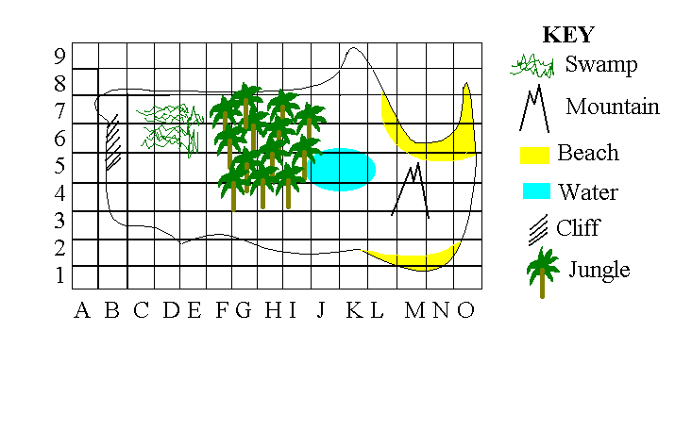

Travel – By Public Transport

Learn to read a timetable. Get hold of some bus or train (or ferry, plane…) timetables – you can pick this up at most big stations. Can you plan a trip using them? For example, use the one below to tell someone who’s at Stafford at 1.30pm when and how they can get to Preston.

Birmingham | 1151 |  | 1234 | 1248 |  |  |  | 1334 |  | 1351 | 1357
Wolverhampton | 1208 |  | 1252 | 1307 |  |  |  | 1352 |  | 1408 | 1414
Stafford | 1225 | 1243 | 1307 | 1324 | 1341 |  |  | 1407 |  | 1426 | 1432
Crewe | 1251 | 1305 | - | 1353 | 1407 |  |  | 1432 |  | 1452 | 1459
Liverpool | 1333 | 1350 | - | 1438 | 1450 |  | 1432 |  | 1532 | 1532 | 1541
Manchester | - |  | 1417 |  |  |  |  | 1522
Preston | - |  |  |  |  | 1505 | 1530 | 1608 | 1630
Glasgow | - |  |  |  |  | 1751
Edinburgh | - |  |  |  |  |  |  | 1922

- Make up your own journeys using several timetables.
- Plan a long journey, say from your home to Paris or New York!
- Get hold of some timetables from a travel agent or the internet to help you work out your trip.
- How will you switch modes (eg. how will you get from the airport to the railway station)?
- What will you do to avoid getting bored?
- How will you keep comfy?

- Plan a local journey and carry it out, by public transport if possible. You could just go shopping or swimming, or maybe you could visit a museum or theme park… whatever you like. Make sure you check transport timetables, opening times of where you’re going, costs and so on.
- Make a leaflet of contact numbers for public transport and put it somewhere useful

- Make a poster of bus and train services from your town – and where they will take you

BY CAR

Obviously you’re too young to drive, but there’s lots you can do when it comes to travelling by car… have a go at some of the things listed, or find a driving school which will let you have a go at driving a car! Sometimes they do this at fetes and such like.

If there was an accident, would you know what to do? Two of the most important things are to put on the handbrake and turn off the ignition – can you get someone to show you how?

Learn how to
- check the tyre pressures  - pump up the tyres | - change a wheel  - jump start a car
- check the oil, water and battery levels
- push a car!! (to help the driver push start it – maybe you could practise by pushing something smaller & have a race!)

*********************
DECORATE

- Hang some curtains
- If your hall needs repainting, find out if you can do it
- Is there somewhere local you could paint a mural?
- Find out how to wallpaper a room
- Make a decoration or a poster for your bedroom, for a friend or for your family.

How will you put pictures or posters on the wall?
- Blu-tak is one popular option, especially for posters, but how much damage does it do to the walls? Test this out:
- Get hold of some wallpaper scraps. If nobody has any you can pick up “testers” at DIY shops. Get different sorts if possible – shiny, embossed, woodchip and so on.
- Stick on bits of blu-tak then put the paper out of the way for a while.
- Several weeks later, remove the blu-tak. Did it leave a mark? Did it damage the paper?

Would it be better to leave pin or nail holes?

- Practise hammering in nails so you’ll be an expert when you want to hang pictures in your room!
- To produce something at the same time as practising, try a string picture like the one below… pick your own shape instead of a star if you prefer.

This beautiful design board is perfect for your bedroom wall and it’s also simple to make.
The things you need:
- Pin board or piece of wood

- Small size nails
- Hammer
- Different coloured threads
- Black cloth
- pencil
Step 1: Take a soft board and cover it with a black cloth. You can take any size you want.
Step 2: With the help of a light coloured pencil draw out the pattern. Try to keep it simple if you are doing it for the first time.


Step 3: Now hammer small sized nails on the pattern you have created. The nails should be placed at a distance of no more than 2cm from each other.
Step 4: Start from one end of the pattern. Tie a knot in one of the nails and weave the thread across the star then back to the nail next to the one you started with. Fill the pattern with the threads.
Though it looks complicated, once you get down to making the pattern, it's fun all the way. This attractive design board makes an excellent gift for birthdays and anniversaries.


IN CONTACT

- Do you know how to use a payphone? Did you know you now need 20p for a public phone box? Get out there and practise!
- Find out how to make a reverse charges call. How much does it cost the person you call?

- Find out how to make an emergency call.
- Could you give clear directions?
- Practise using the phonetic alphabet to spell place names etc. Practise by spelling names across the hall to each other when the rest of the unit is playing a noisy game.
- Play Chinese whispers to remind yourself why sometimes we need to spell things or speak extra-clearly!

A | Alpha | B | Bravo | C | Charlie | D | Delta | E | Echo | F | Foxtrot
G | Golf | H | Hotel | I | India | J | Juliet | K | Kilo | L | Lima
M | Mike | N | November | O | Oscar | P | Papa | Q | Quebec | R | Romeo
S | Sierra | T | Tango | U | Uniform | V | Victor | W | Whisky | X | X-Ray
Y | Yankee | Z | Zulu
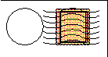
Letters! Can you address a letter properly? Where would you find out a postcode? How would you find out how to post a parcel and how much it would cost?

Mobile phones
People are sometimes attacked for their phones – what can you do to avoid this?
Even if you’ve got a mobile, what would you do in an emergency if you ran out of credit or battery power, or there was no signal? Make sure you know how to use a payphone, just in case!

Internet
- Read the Guide Association’s Internet Safety Guidelines. Are they sensible rules? Do you keep to them when you’re online?
Things to make

- Make a beanbag, or a huge pile of beanbags for games with your unit!

- Learn to knit basic squares & make enough between you for a blanket to give to charity or to keep as a spare for camp. Or you could make something else from squares – even a soft toy!
- Make a teddy bear

- Use a jigsaw to cut a shape – what could you make with this new found skill?

- Make up a story for a 3yr old & record it.

- Find out if your local newspaper makes recordings for blind people… if they don’t, maybe you could offer!

- Put together a piece of “flat pack” furniture

- Make a bat box or a bird table.

- Make food for birds – you could use the recipes below if you like.

bird puddings
Put 1kg wholemeal flour and 225g soft marg in a mixing bowl. Rub the fat into the flour then stir in enough water to make a thick, sticky mix. Put balls into bun tins & bake for about 10 mins at 200C, 400F, Gas Mk6. Cool. Use needle & strong thread to make hanging loops & hang from trees.

scrap cakes
Collect small foil bun or pie plates and fill them with kitchen scraps – stale cheese, bacon rind, stale cake, potato – and bind together with fat from meat and the grill pan. Leave to set hard then take off the foil container and put the cakes on the ground for ground feeding birds.

DRESS SMART

- Make a trendy shoulder bag to put all your guide badges on and carry your G-File in.

- Could you fix your clothes if you split a seam or lost a button? Find out how and practise.

- Make a hair scrunchie – just take a strip of material, sew it in to a tube and thread some elastic through. Sew together the ends of the elastic and then the ends of the tube and there you go!

- Do you know how to wash your own clothes? What do all the symbols mean? How would you get rid of stains? Practise ironing.

- Put up a washing line – at your house or at camp. Do you know how to make one that doesn’t need clothes pegs?

- Design an outfit – from scratch or using clothes you already have.
- What will guide uniform look like in 50 or 100 years time? Make it if you can, otherwise just design it.

- Put together a kit list for camp or guide holiday – which clothes are suitable, which aren’t?
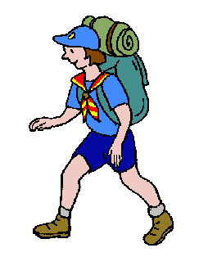
Shoes –
- how many do you have? How many do you need??
- which are suitable for what?
- bring all your shoes in and have a mega-clean!
- hold a shoe-cleaning event to raise money for your favourite charity.

- Hold a guiding fashion show – through the ages, round the world, or one specially for your unit: 2 girls for each sort of event you do showing clothes which are or aren’t suitable for a particular activity (welly boots for canoeing, sandals for a muddy camp…)
FIRE!

In a typical house fire, the temperature at floor level is around 20ºC whilst at 1.5 metres it is 120ºC. The temperature at an average adult's head height will be higher than boiling water.

- Practise moving along the floor!

In a recent survey of 500 fatal domestic fires, 421 of the people who had died either did not have a smoke alarm, or had one that did not work. Smoke alarms should be fixed to the ceiling at least 30cm (12 inches) away from any wall or light fitting and as close to the centre of the room, hallway or landing as possible. Does your home have a smoke alarm? Does your hall? Do the batteries work?
- Get one fitted
- Find out how to check and change the batteries

IF YOU DISCOVER A FIRE!
Get everyone out as quickly as possible
Close all doors behind you
Call the Fire Brigade
Do not go back into the house
until the fire officer has told you it is safe to do so

- Arrange a fire drill for your guide unit.
- Draw a map to show all the fire exits and extinguishers in your hall. Would you know which extinguisher to use? Can you get to try using one as a practice? (NOT one which might be needed!)
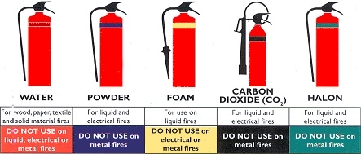
- Make an emergency plan for your home or meeting place
- Talk to your local fire station and see if they can show you round, and teach you how to put out fires. Maybe your whole unit could go?
It’s ELECTRIC!
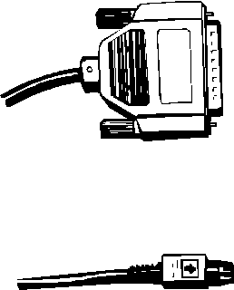
- Wire up a pc or tv & video. Can you tell the difference between power and aerial leads?

- Read the electricity or gas meter at your house or meeting place

- Wire the plug (if it’s not sealed) on a stereo or CD player – and treat yourself to some music once you’re sure it’s right!

- Find out how to change a fuse

- Change a lightbulb. What different fittings are there? Test out some energy efficient lightbulbs… where do you think they should be used?
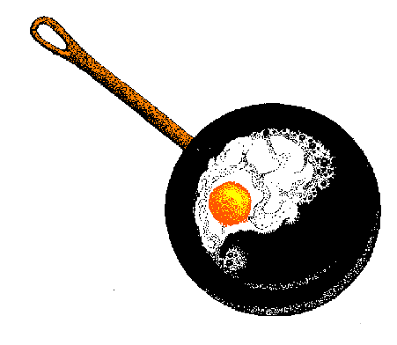
- What would you do if there was a power cut? Could you keep busy in the dark for a whole evening? Are there candles or torches in your house? Could you cook a warm meal without power?

- Where could you turn off the electricity (or gas or water) in your house? When would you need to?
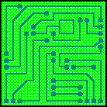

- Could you have a go at soldering? It’s really easy but you’d need someone to show you how. To practise the same sort of skills, see if you can get hold of some electric pyrography irons.

Get to work!

- At what ages can you work? Does it depend on the sort of job? What are the rules? (What should be the rules?)


- Create a job advertisement and interview people for it. Candidates could get dressed in smart clothes and it could be as real as possible. The job might be a guiding one (eg. patrol leader), or a job in a shop or office. Don’t forget to ask why they want the job, and why you should choose them!
EMERGENCY!
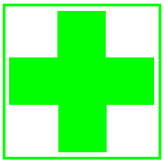
Learn or practise some First Aid, for example…

- Check the pulse, respiration and temperature of everyone in your patrol

- What’s the best way to bandage a sprained ankle? Practise it!

- Can you put on an arm sling? Make sure everyone in your patrol can. What would you do if you didn’t have a triangular bandage… try as many ways of improvising as you can.

Could you…
- entertain a bored / ill child for an hour
- cook a hot meal for the whole family
- pack a small case for someone going in to hospital
Practise what you’d do for one or more of these.
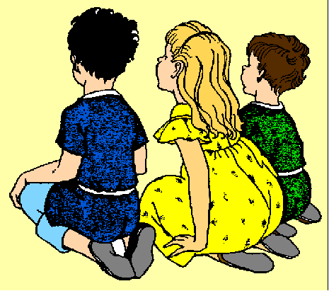

Find out what to do if you
- smell gas
- discover a fire
- find a lost child
- find a lost animal
- have a burst pipe when there’s nobody else at home.

- Your house has been flooded and soon the whole area will be under water! You’ve got 5 minutes to pick up things to take with you, and you might never be able to come back… what will you take? Did you think about food and shelter? What about memories (like photos or letters)? What about your pets?? You must be able to carry everything you take… how do you think real refugees feel?

- Have a go at the lifeboat game where your patrol can only take a limited number of things to survive on a desert island. Can you agree what 10 things you think you’ll need?
OTHER IDEAS

- Light a fire without matches (using glass, a magnifying glass or even “rubbing 2 sticks together”)

- Your county commissioner’s on the phone… the speaker for the AGM has let her down at the last minute – could you come along and do a 5 minute talk about Guides? What would you say? Practise it with your patrol or unit.

- Find out how to estimate distances – by sight or by measuring using your body! For the second one you’ll need to measure your handspan, pace, etc. Go on a walk and count paces to work out how far you walked. Can you think of a good way to keep track of how many paces you’ve walked?

Learn some useful knots so you could:

- tie up a parcel
- improvise a dog’s lead
- tie a bandage


What would you do if people at school tried to pressure you into smoking? How could you say no? Who would you tell? Role play some situations in your patrol.

- How much do you think your favourite meal costs? Get the list of ingredients and price the meal by visiting a supermarket – how close were you?

- Grow a pot of bulbs or herbs, or try growing beansprouts or cress

- Have a look at the personal safety badge and try some of the clauses

HIGHWAY CODE ANSWERS

1. If you’re walking down a road with no footpath, which side of the road should you walk on?
- the right – that way you can see the traffic on your side of the road as it approaches.

2. If you have a young child or a pet with you, which side should they be?
c) the side away from the traffic

3. You are going on holiday by car and the car breaks down on the motorway. While you are waiting for the breakdown people which of the following should you do:
c) watch the approaching traffic
- sit on the bank behind the barrier
The biggest danger is that an oncoming vehicle might lose control & run into your car. Never lock yourself in the car on the motorway.

4. If you are riding a horse on the road, what does the law say you must wear?
b) a helmet
But the others make sense too!

5. Where must you not ride a horse:
a) on a pavement

6. On a bike, which are better…
b) constant lights
The law says you must have “normal” constant lights. Flashing lights can be useful too, but they shouldn’t be used on their own.

7. You are riding your bike down the road when you come to an amber traffic light. what should you do?
- Stop unless it would cause an accident
If you are on the road then the lights apply to you just the same as cars.

8. Which of the following are against the law:
a) Cycling on the pavement
b) Leaving your bike on the pavement, causing an obstruction
c) Carrying a passenger on a normal bike
d) Holding on to a moving car
Yes - all of them are actually against the law!

