Go 4 It and
Express Yourself

Discover your artistic side with this new GFI from BoGUK (the Best of Guiding UK)
Please note : this is NOT an official Guide Association GFI but one of the GFIs drawn up for
members of the GuidingUK e-group. It is intended to supplement the official GFIs, not replace them.

Created for - and trialled on! – 1st Keyingham Guides January 2002

Contents
Introduction
I wish I could draw….
Pretty as a picture!
Going Potty
All stuck up….
Nimble Thimble
Watch the Birdie!
Writer’s Cramp
Computer Art
Make Sweet Music
Trip the Light Fantastic
Drama Queen?
Introduction
This GFI aims to do just what the title says – get you to express yourselves!! No need to be a shrinking violet – this is going to give your Patrol the chance to show off and shine. Even the shyest ones among you will be able to help – remember, you have to work together as a Patrol to earn a GFI.

The ideas here are all from different aspects of the arts – both performing arts such as dance, music and drama, and creative arts such as drawing and painting, crafts, writing etc. There are lots of ideas for you to choose from: just remember to choose a varied selection and don’t concentrate on just one aspect or topic.

These ideas are meant to get you thinking – so if they help you think of something else besides what’s in this GFI then – Go 4 It and express yourself!!!
I wish I could draw…….

How many times have you said that? What you mean is, you wish you could draw better than you can already, because EVERONE can draw, it’s just that some people are more confident at it than others. What you have to do is draw (or paint) pictures to YOUR satisfaction, and not worry about pleasing everyone else (although it is nice if someone says they like your pictures too.)

Some ideas for pictures :
Portraits – of your family, friends and pets
Landscapes – holiday memories, actual views, imaginary scenery, dream scenes
Illustrate a favourite scene from a book
Still-life – copy anything from a bowl of fruit or vase of flowers to the contents of your pencil box!
Abstract pictures and patterns

You might find it helps to sketch your picture or design in very lightly with a pencil. If you are copying a picture, draw a grid on tracing paper and lay it over the picture and draw a similar grid on your paper. Then copy each square of the grid for your picture.
Pretty as a picture!!
Try making pictures in different ways : the most obvious are pencils, pastels, crayons and paint (watercolours, acrylics, poster paints, etc.) but you don’t have to use brushes – use your fingers, print with dish-washing sponges or potatoes cut in to shapes.
You can also make pictures by cutting and sticking – pictures made by sticking things onto a background sheet are called collage . You can make collages with all sorts of things – coloured paper (and different types of paper), fabric, pasta shapes, shells – the list is endless, just use your imagination!


Try making a silhouette picture of all the members of your Patrol. Sit each girl in front of a sheet of paper and shine a torch so that her shadow falls on the paper (make sure she sits in profile) and draw around her shadow. Transfer the outline shape to black paper, cut it out and stick it onto white paper or card.
Going Potty?

Fancy having a go at something more three-dimensional? What about trying your hand at pottery or sculpture, using
Clay or Fimo
Plasticene
Plaster of Paris
Papier Mache

Make a papier-mache piggy bank : all you need is a balloon, lots of newspaper, wallpaper paste and “cups” from an egg-box for the legs and snout.
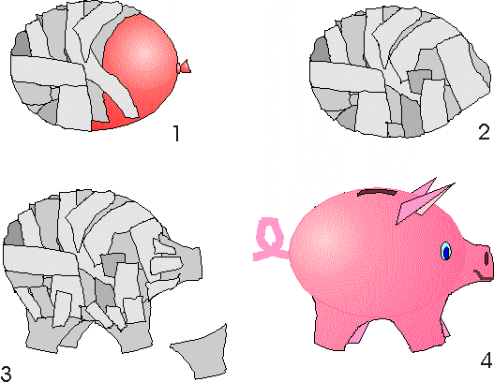

Why not try a completely new craft? What about
Quilling (making pictures and designs with coiled strips of paper)
Origami (Japanese paper folding)
Beadwork and jewellery making
Decoupage (3-D pictures using cut-outs – usually from bought kits, or even wrapping paper with a re[eating pattern & sticky fixer pads))
Basketwork and weaving
Macramé (decorative knot work.)
These are all very different, and there are lots more crafts besides these.
Try to find someone to teach you (maybe they could come and show your whole unit?) or look for books on your chosen subject in your school or public library. And of course, you can always do an Internet search if you have access to the Internet!
Try this simple Origami doll.

If you like making this sort of thing, there are lots of books of origami designs, and lots of Internet websites you can visit - try this one for starters : http://users.erols.com/sychen1/pprfld.html

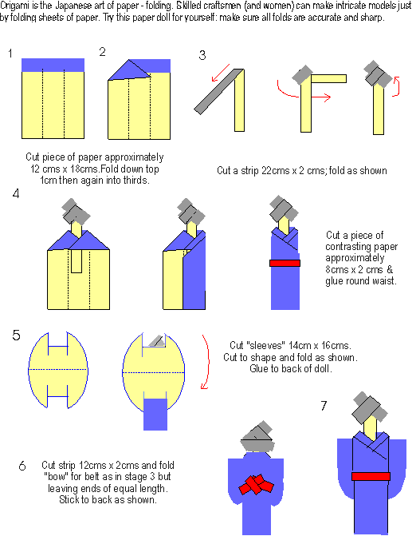

Nimble Thimble
Sewing / dressmaking : make an article sewn either by hand or machine – it could be something to wear, something useful, or something decorative (or a combination!)
Embroidery – decorate a ready-made item with your own design, using various stitches and threads
Cross-stitch and tapestry work – either pre-printed or from a chart, or make your own design
Appliqué – a picture or item (e.g. a cushion) made up of shapes cut out of different fabrics and stitched on and decorated with threads, beads etc.

You can also work with textiles in other ways :

Can you borrow or make a simple weaving loom? Ask your Guider to help if necessary!!

Can you knit? If not – why not learn?
If you can knit, you will probably enjoy learning to crochet; if you can’t knit – crochet is easier (there’s only one stitch to drop at any one time!!)
Watch The Birdie!
Photography is FUN,. And it needn’t be expensive.

First of all you need to have (or borrow) a camera.
You could use an ordinary 35mm camera, a disposable camera or even a digital camera if you have or can borrow one. Disposables are cheap to buy (you can get supermarket or chain store own-brands for around £5) if you don’t already have a camera, and come complete with film. You will still have to take into account the cost of developing the film. If you have a digital camera to use, then you will print the photos through a PC.

When you have got yourselves fixed up with a camera, the next thing is – what to photograph?
You could take photos of ;
Your Guide Unit meeting
Your Patrol at work – and play!
The Hall or room where you meet
The area around your Guide meeting place (ask permission before leaving the room!)

Decide how to display your photos – in an album? Make them into posters? A collage? Think up an original way to show them to your Unit!
- Writers’ Cramp
Try your hand at writing …
- Poetry
- A play
- Stories (fiction)
- Descriptive pieces
- Your own autobiography

You can …work individually or as a group effort.
You can …write by hand
You can …type on a typewriter or computer
You can….present your work in a booklet
You can … make it into a decorative wall display


Is your handwriting as neat as it could be?
Would you like to learn calligraphy?
Try copying the alphabet at the bottom of this page and use it to copy out a poem, rhyme or proverb you like, then decorate it and frame it for a wall-hanging.

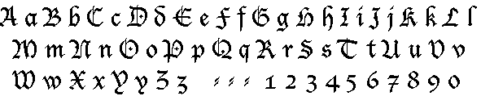
Computer Art

To have a go at Computer Art you will need access to a computer during your Patrol time! It would also be helpful to also have a colour printer, although this isn’t essential as you can save your work and print it out later.

Learn to use one of the special art programs called a “Graphics Program” or “Paint Package” – what you use will depend on what’s installed on the computer.

When you have learned the basics, try your hand at creating one of the following :
A cover for your patrol notebook or register
A birthday card to send to your friends
A Thinking Day card
A picture to decorate the wall of your meeting place
… or anything else you can think of!
Make Sweet Music

Can anyone in your patrol play a musical instrument?

If a few of you can, why not get together and work on a piece you can perform as a group. You could even put on a concert when you have practiced enough – try to make the programme varied, with solos, duets and group pieces. If not all of you are going to play the music, the rest of the patrol could make (and sell) tickets, programmes and posters, and arrange and serve refreshments etc.

                 
Just because you can’t play a conventional musical instrument doesn’t mean you can’t make music – you can
- Play comb and paper
- Make drums out of large tins, upturned bins etc.
- Make a “guitar” by stretching elastic bands across the hole in an empty tissue box and twanging them!
or have a really good sing-song!
Tripping
The Light Fantastic
Everyone loves to dance! If you have dancing lessons that’s wonderful, but if you don’t, it doesn’t matter – just get out there and have fun!

Just some of the types of dancing you can try :
Tap dancing
Line dancing
Morris dancing
Square dancing
Country dancing
Ballroom dancing

Do you know anyone who can come to Guides to teach you some dances? The rest of your Unit would probably like to join in!

There are National Dances from all over the world – are you lucky enough to know someone who can show you some of the dances from their culture?
Don’t forget about arranging to provide music to dance to!

Drama Queens
There are LOTS of things you can do as a patrol in the field of Drama – most people do drama at school, but you can do exactly what YOU want to do at Guides!

You can……
Write a sketch or short play on any subject you like, and perform it for the rest of your unit. You can have fun with costumes, scenery and props!
Try your hand at mime – you won’t have to worry about learning lines!
What about a musical? If your play is just a private showing for you and your unit you can use popular songs to liven up your performance.
You can even get your whole unit involved and invite all your friends and families when you are confident enough.

And you could even make a video of your performance so you can watch yourselves and see just how good you are!

If you have enjoyed this GFI, you might also like to do some (or all) of the following badges :

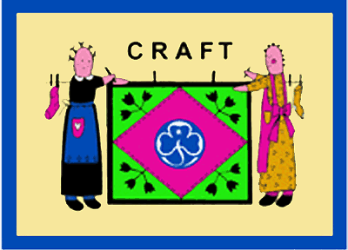
Craft Badge

Film Lover Badge
Music Group Badge
Hobbies Badge

You can find lots of ideas on the Internet – check out The Best of Guiding UK – http://www.guidinguk.com



Some of the craft ideas in this GFI are taken, with permission, from
Holderness Rangers’ Resource Pages
http://www.holdernessrangers.org.uk



