Go For It!

WATER

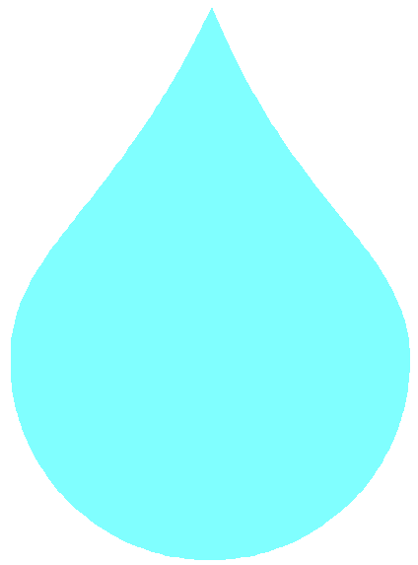

CONTENTS:
- Introduction
- Bubbles
- Soap 1 – The Test
- Soap 2 – A Soap Boat
- Think About It!
- Anyone for a Drink?

Food, Glorious Food
- Keep it Safe
- Save a Life
- Get Wet!
- Make a jet boat
- Move It! (Obstacle course & Fill the Bucket)
- Water marking
- Fire! (2 shorter activities)
- Build a submarine
- Rafting

Acknowledgement: Many of the activities in this booklet came from “It’s Not What you do, it’s the way that you do it!” compiled & written by Rush Black & Pauline McKie, copyright Staffordshire Guides and from “A Breath of Fresh Air”, a Girl Guides publication.
Introduction

This is a “Go For It” produced by Sandra Hill specially for 193B Edinburgh guides. The activities are all based round water, although many of them can be done at a unit meeting.

Notes for patrols – don’t forget:
- read the instructions first – don’t rely on the list of what you need
- think about what else you might need – particularly towels for drying yourselves, or cloths for mopping the floor!
- keep a record of which activities you do and how they went
- assess after each activity how it went, and what you could change, either about the activity or about how you planned it
- try to have a go at different sorts of activities – don’t spend all your time making boats
- make sure everyone has fun!
Bubbles!

Try making your own bubble mixture for HUGE bubbles!

You will need:
- 3 glasses of water
- 1 glass of clear washing up liquid
- 2 glasses of glycerine (available from chemist or homebaking shops)
- wire coathangers

Mix all the ingredients and shake gently and put into a washing up bowl. Bend the coathanger into a large circle. Dip the wire into the bubble mix and blow.

Soon you will be blowing enormous bubbles.

Try bending the wire into different shapes to blow through.

Who can blow the largest bubble? Or the one that lasts the longest?

You could try “normal” bubble mix too. How else can you make bubbles? Try blowing through straws into the bubble mix.

What other ideas have you got?

SOAP!

How effective is soap? How clean are your hands? How can soap propel a boat?? Find the answers here…

SOAP 1 - THE TEST

You will need:
- magnifying glass
- warm and cold water
- hand washing bowls
- flannel, sponge, nailbrush
- various types of soap
- towels

Use a magnifier to look carefully at the hand you use for writing. How clean is it really? On an outline of your hand shade in the grubbier areas, eg. nails, the folds in your skin etc.

Experiment with what gets your hand clean – cold water only, warm water only, warm water with soap, cold water with liquid soap, warm water with a sponge, a flannel and cold water, a nail brush, soap and no water… which works best?

Maybe you could try different types of dirt – paint, felt tip pen, dust, mud, etc. Don’t forget you’ll need to agree a set number or rubs or brushes when cleaning to get a fair test!

SOAP 2 – A SOAP POWERED BOAT

You will need:
- pieces of card
- small bits of soap
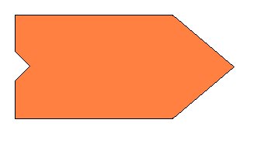

Cut out a boat shape from the card, making a notch in the middle of the back of the boat. Place a tiny piece of soap in the notch. Fill a bowl with water and once the water has settled put the boat on the water and watch it move.

Try having races.

The boat moves because the soap weakens the surface tension behind the boat. The stronger tension pulls the boat forward.

- Try altering the position of the soap.
- Add paper clips to make a rudder
- Use a drop of washing up liquid behind the boat instead of soap – what happens?
- Try using balls of modelling clay as cargo… how much can your boat carry?
- Could a soap powered boat carry people?

Think about it!
If 100 people did all the water carrying that is done in the third world in a year, and they spent 24 hours per day doing it… it would take them 100,000 years!

Some people have to spend almost all their time walking to the nearest source of water and then carrying it back to use for drinking, cooking and cleaning. And even then it may not be clean.
Think about these facts and any others you can find, and look at the “Go the Distance” sheet. How would you cope if it was you? What can you do to help?

Anyone for a drink?

How much do you drink in a day? What’s your favourite drink? Does it have water in it? Are there any drinks that don’t? After all, if cows drink water, there must be water in milk, and even cola is made with water.

Have a taste test of different types of water – tap water, mineral water, flavoured water, fizzy water, soda water…

Food, glorious food

Have you ever tried dried foods? There’s a huge variety available from camping shops, and you may be surprised how many there are in your kitchen cupboard – soup, gravy, angel delight, packet mix sauces, milkshake powder… Try a few. How important is it to add the right amount of water?

Keep it safe!

Every year people are drowned because they didn’t follow basic safety rules. How often do you go near water, and are you water wise?

What sort of water
do you think most
people drown in?
The sea?
Rivers?
Swimming pools?
The bath?

Don’t forget that you don’t have to be going swimming to drown – many people fall in accidentally. What can you do to avoid that? What can you do if it happens? (See the activities on “Be a Lifesaver” for some ideas).
What safety rules are there? Find out about the blue cross code.

Make a poster for water safety at the beach, by a lake, at the swimming pool or in the home and garden.

Save a life


If somebody was in danger of drowning, would you know what to do? Would you have already noticed where the rescue equipment was? Could you throw a lifeline or a buoyant aid (a lifebelt or inflatable ball) accurately enough that the person could reach it? Practice now to make sure!

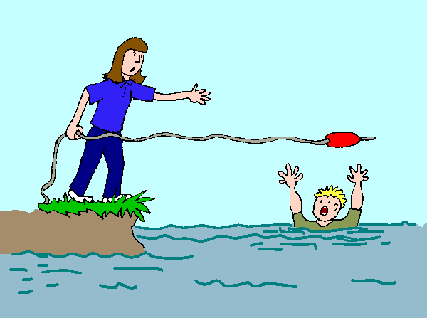

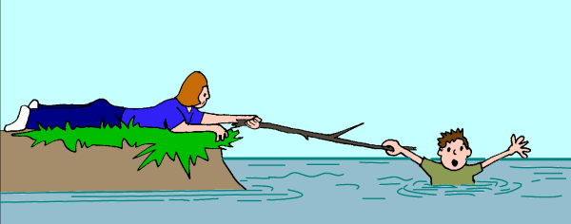

Get Wet!

ONLY DO THESE IF THE WEATHER IS DRY & WARM!

WATER CHUTES: This requires warm weather, a natural slope, a nearby tap with a hose attached and a supply of polythene sheets and bags. The slope should be covered with polythene sheet wide enough for one person to slide down and pegged down securely. Water should be run down the polythene when anyone is sliding. It is less uncomfortable if the participants get inside strong polythene bags (for example garden sacks). Put on your swimsuit & slide!
- Try your hand at windsurfing
- take your patrol swimming
- go for a paddle if the weather’s good, a welly walk if it isn’t
- visit the seaside
- find a local water sports centre & see what they offer. Maybe you could try sailing or
kayaking

WATER BOMBS:

Follow the instructions on the next page, but don’t use them indoors or if the weather’s cold! On a sunny day you could use them like snowballs. Don’t forget to clear up afterwards.

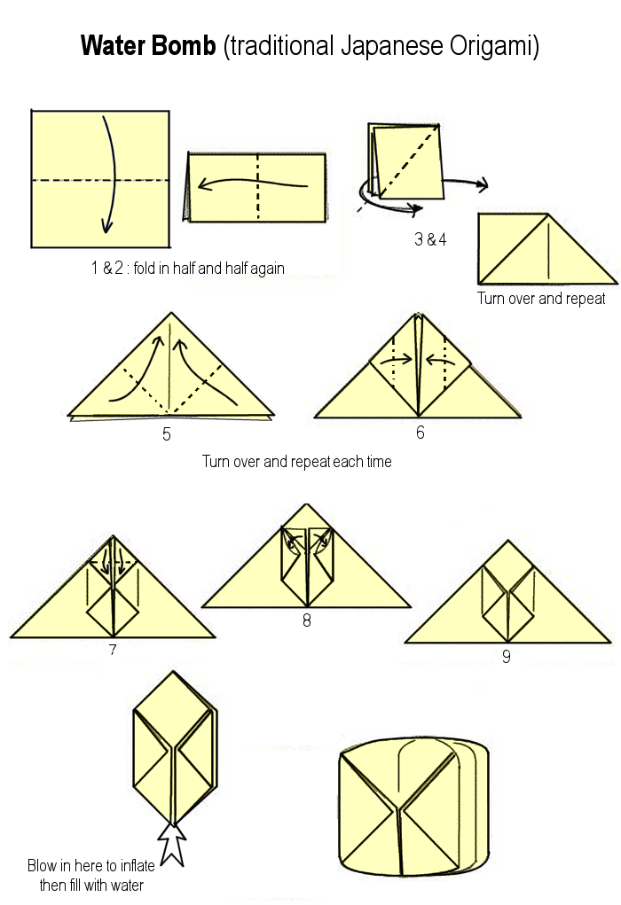

Make a Jet Boat

You will need:
- metal tin (eg. talcum powder tin) with tight fitting lid
- something sharp to make a hole in the tin
- strong wire (an old wire coathanger will do)
- heavy-duty foil tray
- hot water
- some hexi-blocks (used for backwoods cooking)
- oven gloves
- large metal bowl of water to float the boat

Punch a small hole near one edge of the base of the tin. Half fill the tin with hot water and using the wire, mount the tin on strong wire legs with the hole at the top. Put a hexi-block (broken up) into the foil tray and stand the tin in the dish over it. Light the block CAREFULLY, which then heats the water until steam comes out of the hole, propelling the boat.
WARNING: EVERYTHING WILL GET VERY HOT!
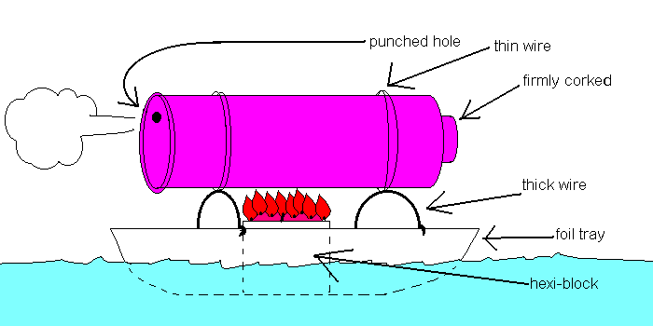

Move It!

These activities might be better done out of doors. Don’t forget to bring towels, and if you do them indoors bring a mop or some cloths to dry the floor afterwards.

MOVE IT 1: OBSTACLE COURSE

Thread a mug onto a long piece of string which starts at a full bucket of water and then traces an awkward route through, under, over or round various obstacles to a measuring jug. Who can get the most water through the course? Who can get at least ¾ of the water through in the quickest time?
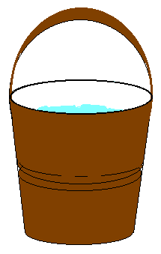

MOVE IT 2: FILL THE BUCKET

Each guide or pair of guides has an empty jug or bowl of a similar size, and a plastic cup. Each guide puts her jug in a corner of the room. In the middle of the room is a bucket full of water. Have a competition to see who can fill their jug first, or see who’s got the most water at the end of a fixed time (say 10 minutes). You can get water from the bucket in the middle or from other peoples jugs, but you mustn’t move any of the containers except your cup!

Water Marking

You will need:
- writing paper
- bowl of water
- toothpick or empty ballpoint pen
- mirror

Soak an ordinary piece of writing paper in water until the paper feels soggy.

Lay the wet paper flat on the surface of a mirror. Write on the soggy paper with a pointed instrument (such as a toothpick or an empty ballpoint pen) and allow the paper to dry.

When the paper has dried it will seem blank, but if you hold the paper up to the light you can see your own watermark.

Try sending secret messages, or use it to personalise writing paper.

How does it work?

By pressing on the wet paper with a pointed instrument you have disturbed the previously ordered lines of the fibres which make up the paper, and when the paper dries this new order which you have made remains, thus producing your own watermark.

Fire!
CANDLE WITHOUT WAX
You will need:
- shallow container with a flat base
- short piece of string
- small piece of plasticene
- water
- cooking oil
- matches

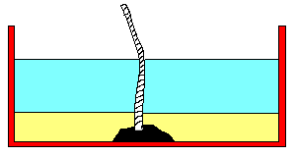

Fix a piece of string to the bottom of the container with a small piece of plasticene, letting the string stick up 5 cm or so like a wick.
Pour water gently around the wick, about 5mm deep. Float a centimetre of cooking oil on top of the string. The result should now look like the illustration
Light the string, which will act like a wick, and you have made a useful night light.

HOLLOW CANDLE
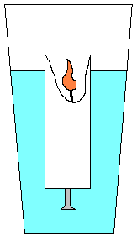
You will need:
Fix a nail or screw into the bottom of a candle so that it will float upright in a
- candle
- screw or nail
- glass of water
- matches
glass of water with just a small amount of the candle showing above the water.
Light the candle. As the candle burns you will find it burns hollow – the wax on the outside is being cooled by the water so it cannot melt.

Build a submarine
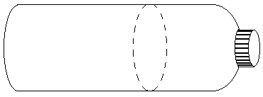

You will need:
- 2 plastic bottles with tops
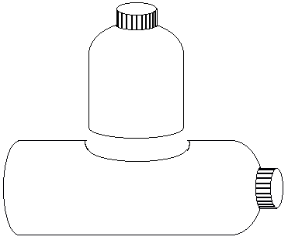
- 2 extra bottle tops
- 2 plastic drinking straws
- a length of plastic tubing
- some plasticene
- glue

Cut the top off one of the bottles a short distance from the end (see picture), keeping the bottle top in place. Lay the second bottle on its side and cut a hole to fit the piece you have cut off the first bottle. Push the piece into place and seal the joint with glue. This is the conning tower.
Cut a second hole in the opposite side of the bottle, underneath the conning tower. Make 2 more holes, one in front of the conning tower and one behind; glue the straws into these holes. The 2 bottle tops act as stabilisers, fill them with modelling clay and fix them on opposite sides of the bottle level with the conning tower. Finally fit the plastic tube to the front nozzle.
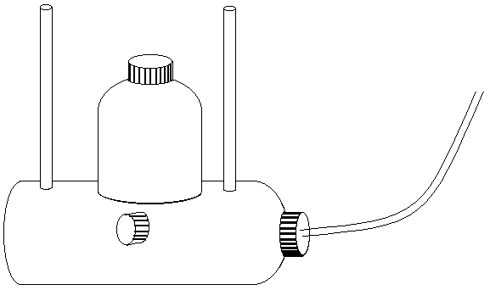
Try the submarine in a bath or sink. It will sink slowly by itself, and rise when air is blown into the tube.
Why does this work?

Rafting

Find somewhere to take your patrol rafting. If this isn’t possible, or you don’t want to, try making miniature rafts and hold your own raft race. Set some limits, for example “your raft must be between 5 and 15 cm in each direction, and it must have a sail”. You could pair up, work individually or all help make all the rafts. Don’t forget to work out how you’re going to propel them – maybe with a hairdryer, if they have sails. Or you could make rafts to carry a nightlight, or see who’s will carry the biggest weight.

Here’s a few ideas for how to make your miniature raft:

- Use some polystyrene packaging as a base, a wooden skewer as a mast and a piece of paper as a sail.

- Use 2 empty drinks bottles for buoyancy and make the base and mast out of garden canes or barbecue skewers. Use a carrier bag as a sail and fix it all together with elastic bands
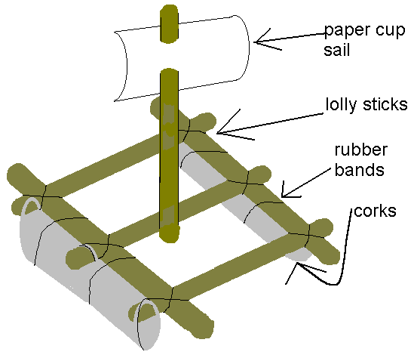

- Use lollipop sticks fixed with elastic bands or thread to make a base and a mast. Use corks as buoyancy and half a plastic or paper cup as a sail.

