Get cooking!

Do you have cooking facilities at your meeting place? If not, could you spend an evening at one of your homes? Make sure you ask the host Guide’s parents as well as your Guider first!

If you can’t cook, make a salad with locally or UK-grown ingredients such as potatoes, watercress, British cheeses, eggs, cabbage, radish…

Try a traditional recipe from the area where you live, or from another part of the UK. You could try the recipes below and hold a traditional High Tea, or here are some different ideas…

 | - haggis and clapshot  - scotch broth or cock-a-leekie soup  - cranachan or whimwham  - drop scones (Scotch pancakes) |  | - stuffed herring  - Welsh cakes (recipe below)  - Bara brith | 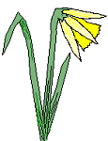
 | - Bubble and squeak or toad in the hole  - Spotted dick or bakewell tart  - shrewsbury biscuits | - Potato and parsley soup  - Irish stew  - Boxty bread, Barm brack or soda bread |  | 

Welsh cakes
Ingredients:  500g flour  125g marg  125g lard  1 egg  2 tbsp milk  125g currants  pinch of salt  1 heaped tspn mixed spice  caster sugar | What to do  - Rub fat into flour  - Add dry ingredients, egg & milk  - Roll dough to 1cm thick  - Cut with pastry cutters  - Cook on a greased griddle or in heavy frying pan for about 3 minutes each side.  - Dredge with caster sugar and eat hot.  Don’t forget to wash up and leave everything clean!

Shortbread petticoat tails
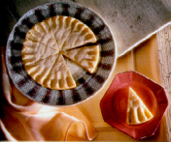
Ingredients (makes 1 round)
100g butter, softened
50g caster sugar, plus extra for dredging
150g plain flour
50g ground rice

- Cream the butter and sugar until pale and fluffy.
- Gradually stir in the flour and ground rice. Draw the mixture together and press into an 18cm round sandwich tin
- Prick well all over, pinch up the edges with a finger and thumb. Mark into 8 triangles with a sharp knife. Bake at 170ºC (gas mark 3) for about 40 minutes, until a pale straw colour.
- Leave in the tin for 5 minutes, cut into 8 triangles, then dredge with caster sugar. Remove from the tin when cold.

Gingerbread men
Ingredients: (makes about 16 gingerbread men)
350g plain flour

1 tsp bicarbonate of soda
2 tsp ground ginger
100g butter, diced
175g soft light brown sugar
4 tbsp golden syrup
1 egg, beaten
currants, to decorate.

1. Sift the flour, bicarbonate of soda and ginger into a mixing bowl. Rub in the butter until the mixture is like breadcrumbs, then stir in the sugar. Beat the syrup into the egg then stir into the flour mixture. Mix together to make a smooth dough.
2. Knead the dough until smooth, then roll out on a floured surface to about 0.5 cm thick. Cut out “man” shapes. Re-roll and cut the trimmings until there is no dough left. Place the gingerbread men on greased baking sheets and decorate them with currants for eyes and buttons.
3. Bake at 190ºC (gas mark 5) for 12 to 15 minutes, until golden brown. Leave on the baking sheets to cool slightly then transfer carefully to wire racks and leave to cool completely.
Soda Bread
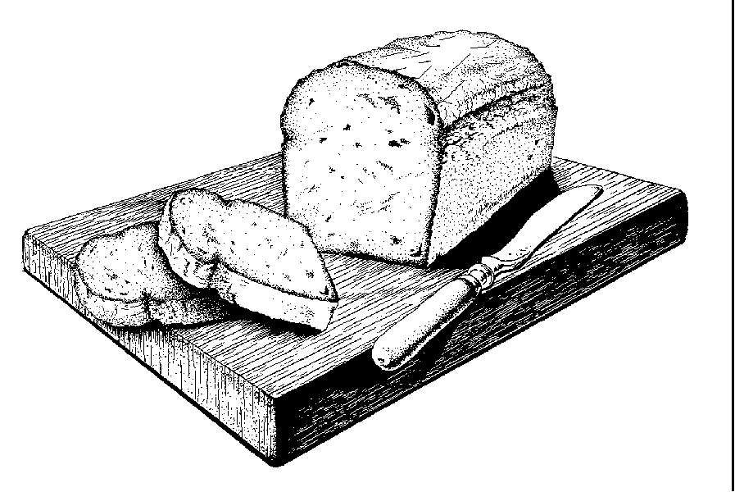

Ingredients (makes one large loaf)
450g plain wholemeal flour
100g plain flour
50g rolled oats

1 tsp bicarbonate of soda
1 tsp salt
about 450 ml (3/4 pint) buttermilk

- Put the flours, oats, bicarbonate of soda and salt into a large bowl and mix together. Add enough buttermilk to mix to a soft dough.
- Knead very lightly then shape into a large round and place on a greased baking sheet. Cut a deep cross in the top. Bake at 230ºC (gas mark 8) for 15 minutes then reduce the oven temperature to 200ºC (mark 6) and bake for a further 20-25 minutes or until the loaf sounds hollow when tapped on the bottom.
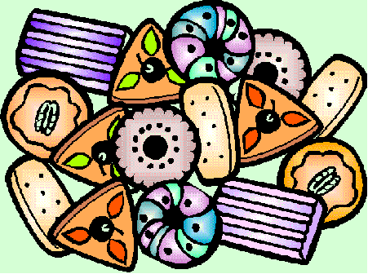
- Eat while still warm.


Scones
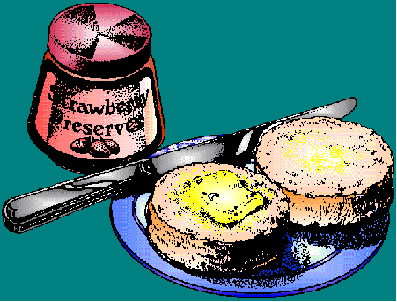
Ingredients (makes about 20 small scones)
150g self raising flour
50g butter
75g grated cheese and 1 tbsp chives
salt and pepper
milk to mix

- Rub butter in to flour. Add salt and pepper. Stir in cheese (and chives, if liked) and mix to a soft dough with milk.
- Knead lightly on a floured board. Roll out 1cm thick and cut into rounds.
- Put on a greased baking sheet and bake for 10-15 minutes at 220ºC
- Best eaten buttered while still warm.

For fruit scones replace the cheese, chives, salt and pepper with 25g caster sugar and 50g sultanas.

Industries

Pottery
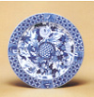
The area of the Midlands round Stoke on Trent was so well-known for producing pottery that even today the area is called the Potteries. Probably the most famous is Wedgwood - "father of British potteries".
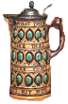
- Have a look at the website for the Wedgwood museum: www.wedgwoodmuseum.org.uk
- Visit a pottery factory, museum or workshop
- Find out about the pottery industry – what was it like to be a potter?
- Make a pot. You could use a modelling clay like Fimo.
- Have a go at painting a plate – there are craft workshops that will help you with this or buy some cheap white plates and experiment!

- Make a relief brooch in the style of the Wedgwood blue and white figures

Fishing
In many parts of the UK, fishing was a huge industry. In some places it still is. Most of the fishing industry is in the sea but a lot of amateur anglers fish in the rivers.
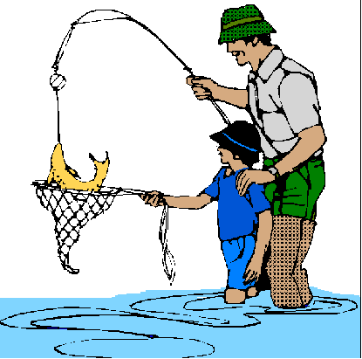
- Get someone to take you fishing!
- Visit a fisheries museum
- Find out about line fishing and how to “cast”
- Try out some fish recipes
- Raise some money for the Lifeboats

Others
- What are the biggest industries where you live?
- Could you visit a place involved in one of them?
- Or have a go at one?

Get artistic!

- Dress dolls in Welsh, Scottish or Irish national dress
- Design a national dress for the UK as a whole.


- Make a bookmark using a traditional Celtic or Pictish design. There are a few ideas here or use your own.

- If you don’t fancy drawing your own get someone to photocopy one of the jigsaws on the next page and have a go at that instead. Who’s the quickest jigsaw puzzler in your patrol??


Have a go at a traditional craft

Could you find someone to teach you? Here’s a few ideas…

- spinning  - weaving  - basket weaving | - smocking  - lacemaking  - corn dollies | - patchwork  - embroidery  - barge painting!

If you can’t find anyone to teach you, have a go at the corn dollies or paper woven basket on the following pages.

Other ideas
- Make a mobile of saintly symbols – you could have a dragon with St George’s cross on, an origami fish with a saltire (St Andrew’s flag), a curling snake for St Patrick and a leek for St David.
- Investigate other UK symbols like the Manx cat and make something using these symbols.
- Find out about the War of the Roses and then model some roses either out of fondant icing or bread (take a slice of processed bread, slice off the crusts, mash up the slice and knead it until it looks doughy, colour it red or blue and model it into roses!)
- build your own “iron” bridge out of straws. Try to produce one like the “real” iron bridge which is interlocked in every part and has no bolted or riveted joints

Corn dollies
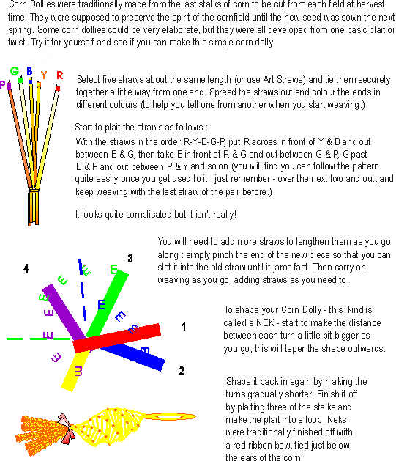
Flowered Basket
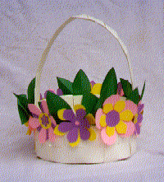
You will need:
- 18" x 24" heavy paper or thin card
- pink, yellow, purple and green A4 paper if you want your basket filled with flowers
- glue
- scissors


Instructions:
Cut card into approximately a 16" circle with a 7" circle drawn in the middle. The inner circle will be the basket bottom. Trim area around this into 1" radiating strips.
Bend radiating strips up at dotted lines to begin to form basket side.
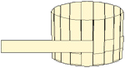
Cut about eight 1" x 24" strips out of the same paper. Beginning close to the bottom of basket, weave one of these strips in and out of the radiating strips all the way around the basket. Cut off or add extra pieces to complete first woven level. Secure ends with glue. Weave two or three more levels.

Fold or cut excess radiating strips even with the top level.
To make the handle, wrap one of the precut strips (we'll call this the core) with another precut strip as shown:

Secure ends with glue. Continue with additional strips until the handle core is covered. Trim ends. Glue to inside of basket.
If you like, you can glue paper flowers around the basket. Glue on leaves, tucking them under flower petals.

What could you fill your basket with?
Back to nature
The UK has a lot of wildlife – why not discover some of it?
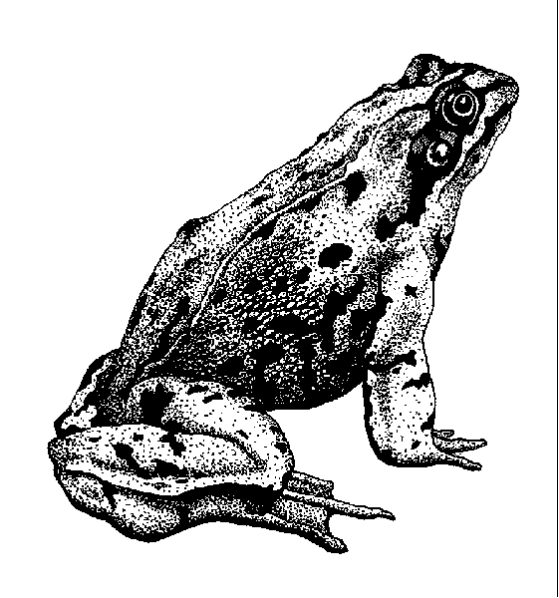

- Go on a hedgerow or woodland walk and see how many animals you can spot. Don’t forget to be as quiet as you can, and don’t disturb any animals. You might find it useful to take some identification books. Here’s a few animal tracks to look out for:
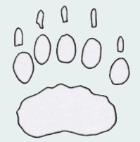
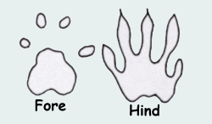
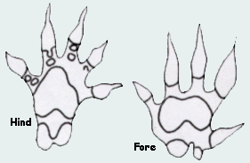

Badger squirrel hedgehog domestic cat
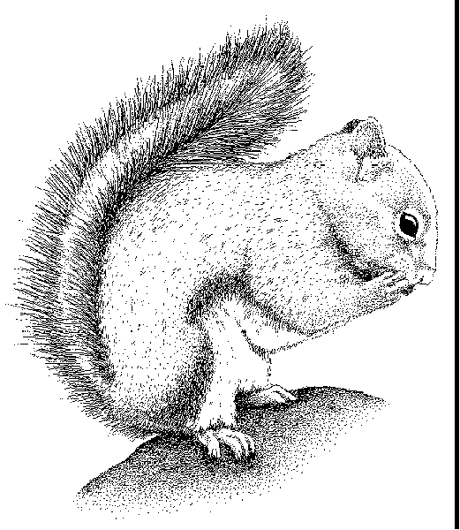
If you find some of these tracks you could make a cast of one of them. If you want a quick and easy cast, just push plasticene into the track & then remove it carefully. If you want a more permanent one you could use plaster of paris:
you will need:
- something to make a wall round the print, eg. strips of cardboard held together with paper clips.
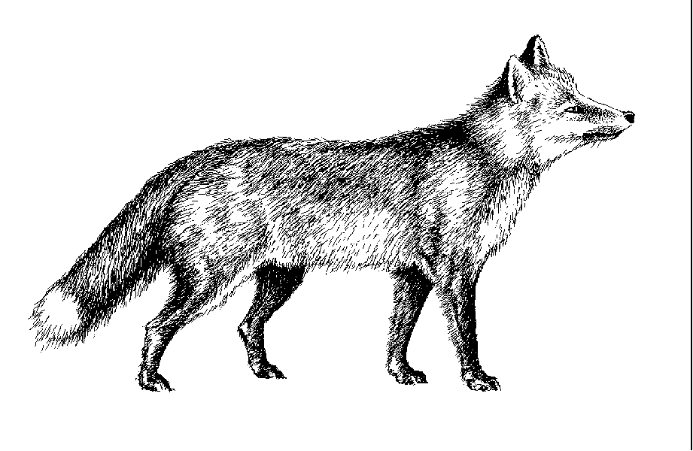
- fine casting powder (plaster of paris)
- an ice cream container to mix the plaster
- some water
- a stick or ruler.
- Push your cardboard wall vertically into the soil round the print. Make sure that there is at least 2cm between the print and the wall and there is room inside the wall for a depth of 3cm of plaster. Fix your wall together with paper clips.
- Make up the plaster, following the instructions on the packet.
- Carefully pour enough plaster into your mould so that the plaster is at least 2 cm. deep. The cast will be too fragile if less plaster is used. Leave the cast to set.
- Setting will take 15-20 mins. You can judge whether the plaster is setting by touching the surface gently. When the plaster is setting, the plaster becomes hot. When it is completely cold again then the cast should be ready.
Web of life
Do you know what a food chain is? Here’s an example: Earthworms live on decaying leaves, shrews eat earthworms and tawny owls (not the brownie guider variety!) eat shrews. This can be written as:
decaying leaves → earthworm → shrew → tawny owl

A food web is just the same only it links more plants and creatures. Can you fit the animals into the woodland web below?
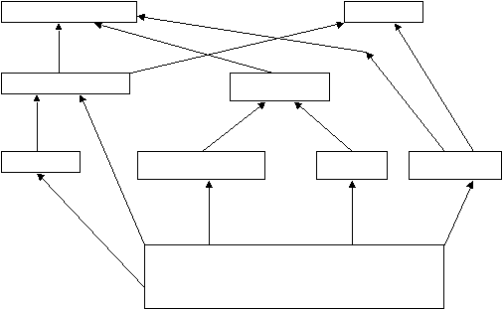
Moth caterpillars: Tawny owls: Squirrels: Aphids: Trees (leaves, flowers, fruits, bark): Beetles: Bank voles: Foxes: Sparrows:

- Bring a food web to life!
- Each person in the patrol chooses an animal or a plant that you might find in a hedgerow. (Or a wood, or the sea – just make sure you’re all in the same place!)
- Then attach each “animal” to everything it eats or is eaten by using pieces of wool
- use chairs if there aren’t enough people
- Maybe you could do this with the whole unit? Work out a big enough web first!
- You could even do the whole web, right back to the sun which provides energy for the plants. You could ask your guider to be the sun!
Festivals and Feasts
Celebrate a British or local festival. If it’s the wrong time of year, don’t worry – just pretend! Here’s some to start you off.

Halloween
- make turnip or pumpkin lanterns
- try bobbing for apples
- peel an apple keeping the peel in one piece – the shape reveals the name of the man you’ll marry!
Harvest – you could try flower arranging, maybe for your church. Or take food to an elderly person. If you don’t know anyone suitable you could collect food to donate to a homeless charity or even pet food to donate to an animal shelter.

Bonfire Night
Remember, remember,
The fifth of November,
Gunpowder treason and plot.
We see no reason
Why gunpowder treason
Should ever be forgot!

The Plot was foiled in the night between the 4th and 5th of November 1605. Already on the 5th, agitated Londoners who knew little more than that their King had been saved, joyfully lit bonfires in thanksgiving. And we still do it!
- Try making your own guy
- Make a rocket by following the instructions on the next page.

Others
Find out about the Eisteddfod or Highland Games and hold a mini version for your unit!
Film Canister Rockets
- Get a film canister, make sure the top goes inside the main bit!
- Using paper and glue etc. make your rocket round the main part of the film canister. Use your imagination and make them really funky!
- Fill up your film canister rocket about 2/3 full with water.
- Get a plate, and a quarter of an alka seltzer tablet or half a teaspoon of baking powder.
- Go OUTSIDE and put the alka seltzer or baking powder in the water put the lid on, rocket on the plate, and STAND BACK.

Why do you think it works?
Don’t forget to clear up afterwards.

Easter
- Hold an Easter egg hunt – in the hall or outdoors. Maybe you could organise one for the unit?

Easter Bonnets are a throw back to the days when the people denied themselves the pleasure of wearing fine clothes for the duration of Lent. By tradition, it was obligatory (or at least lucky) for churchgoers to wear some bright new piece of clothing - at least an Easter bonnet, if not a complete new outfit.
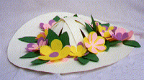
- Have an Easter bonnet competition. Make them from anything you like – try paper, or silk flowers & an old straw hat.
Games

Have a go at some traditional games – maybe some you’ve played before. Try at least one new one. Here’s some ideas:

- Marbles (does anyone have any marbles? The first person rolls their marble on the floor then everyone else tries to hit it by rolling their own marbles. If you hit the first person’s marble then you win it – who has the most left after 5 or 10 games?)

- Jacks or five stones (take 5 small pebbles or other objects and spread them on a table or the floor. Then take a small ball & throw it in the air. How many jacks can you pick up before catching the ball?)
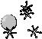

- Skittles (you could use ready-made ones or make them out of pop bottles with something like rice in, to weight them down)

- Skipping (either individually or with a long rope. If you don’t have a long rope see if your guider has one, or maybe you could borrow one from the brownies? How many rhymes do you know?)
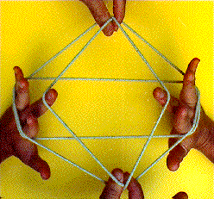

- Cat’s cradle (who can demonstrate this string game?)

- Clapping games (do you know any? do you know someone who could teach you some?)


- Dominoes (there are loads of domino games – there are usually some ideas with a set of dominoes)

Jack straws (if you don’t have a set you can use twigs or skewers or even drinking straws)


CREDITS – thankyou to…

Corn dolly, graphics and much, much more!
http://traditions-uk.freeservers.com/

http://www.guidinguk.com
Both recommended as your first stop for further information!

Well dressing
CONTENTS

- Patron Saints
- Flags and heraldry
- English local customs
- Limericks, Golf
- Address to a haggis
- Love Spoons, fish and
chips
- Dance
- Music
- More music
- Get cooking
- Recipes
- More recipes
- Pottery, fishing
- Get artistic!
- Corn dollies
- Woven flower basket
- Celtic jigsaws
- Back to Nature
- Web of Life
- Festivals and Feasts
- Games
- Credits and Contents!
lynne@lynne-neil.freeserve.co.uk, guidinguk

Cheese rolling
Verna Hayes, GuidingUK
http://www.stilton.org/

Love spoons
http://www.wales-calling.com/culture.htm

music from
http://www.traditionalmusic.co.uk
Di Edwards, GuidingUK
& lyrics from
http://www.chaos.org.uk/~pdh/string/songbook.htm

Dance
Hornpipe Loris Cooper, GuidingUK

Heraldry
http://www.digiserve.com/heraldry/

Animal info and tracks
http://www.wildkids.org.uk/teens/frameset.htm

Celtic patterns
http://www.celtic-clipart.co.uk/

Celtic jigsaws
Mary Andrews, GuidingUK

Flower basket:
http://familycrafts.about.com/

Iron bridge, bread flowers
Umi Tang, GuidingUK

