Go 4 It!
United Kingdom

At the top of each activity is a symbol to represent which country it is about:

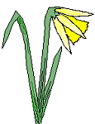


England | Scotland | Wales | Ireland

If an activity is relevant to more than one country then the Union flag is at the top. Try to do at least one activity from your own country and one from a different part of the UK.


This pack contains recipes and crafts to try as well as plays to perform, games to play and so on. Try to do at least 2 different sorts of activity – don’t spend all your time eating or playing games!

Make sure everyone gets to join in and have fun

- Don’t forget to evaluate your activities afterwards – what was good? What could you improve next time? If you’ve got any suggestions then get your Guider to send them to the GuidingUK list so they can be passed on to other Guides!

- Before trying any activities make sure you know what you’re going to need for it & who is going to bring what.

Patron Saints

Each of the four countries of the UK has a patron saint. Find out which country has which saint! When are their days celebrated, and how? Take part in local celebrations for one of them, or hold your own.

Make up a play for the story of one of the Saints, for example St George or St Patrick:
Here’s one version of the story of St George, taken from the Catholic Encyclopaedia:
At the town of Silene, in Libya, there was a dragon, who was appeased by being fed two sheep a day; when these failed, the townsfolk offered by lot one of their young people. One day the lot fell on the King's daughter, who was led out to the sacrifice, dressed in her wedding gown. George appeared and transfixed the dragon with his spear and then using the Princess's girdle led the bemused dragon into the town, where it was beheaded."

Saint Patrick was born in Scotland and was kidnapped and sold in Ireland as a slave. He became fluent in the Irish language before making his escape to the continent. Eventually he was ordained as a deacon, then priest and finally as a bishop. Pope Celestine then sent him back to Ireland to preach the gospel.
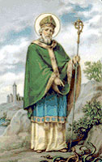

Patrick is most known the world over for having driven the snakes from Ireland (although this is probably a myth). Different tales tell of his standing upon a hill, using a wooden staff to drive the serpents into the sea, banishing them forever from the shores of Ireland. One legend says that one old serpent resisted, but the saint overcame it by cunning. He is said to have made a box and invited the reptile to enter. The snake insisted the box was too small and the discussion became very heated. Finally the snake entered the box to prove he was right, whereupon St. Patrick slammed the lid and cast the box into the sea.
Flags & heraldry
- Find out how the flags of England, Scotland and Northern Ireland fit together to form the Union Flag.
- Find out the difference between a Union Flag and a Union Jack.
- Make a set of paper or cloth flags to demonstrate the idea to brownies.

Do you know why the Welsh flag isn’t included?
It’s because the union flag was first brought into use (without the Irish flag) when England and Wales (which were already joined by a treaty) formed a union with Scotland.

- design your own Heraldic coat of arms
- or what about a patrol shield?
- make a big shield from wood or card to display in your patrol corner!
- design your own Scottish tartan instead

You might like to include your patrol emblem, guide or personal favourite colours and symbols to represent what you like doing, or your local area. Here are the meanings of some of the traditional colours and symbols:

Background Colours
Blue - Loyalty and truth.
Or, yellow or gold - Generosity.
Red - Military fortitude and magnanimity.
Black (sable)- Constancy, sometimes grief.
Argent, white or silver - Peace and sincerity.
Green (vert)- Hope, joy and sometimes loyalty in love.

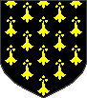 | Symbols (called charges)  Wheel - Fortune.  Snake - Wisdom.  Horse Shoe - Good luck.  Lion - Deathless courage.  Heart - Charity, sincerity.  Swan - A lover of poetry and harmony.  Trunk of a Tree - An object of veneration.  Dolphin - Charity and a kind affection towards children.  Falcon or Hawk - One eager in pursuit of an object much desired.  Rhinoceros - Great ferocity when aroused.  Elephant - Courage and strength.  Lamb - Gentleness and patience under suffering.  Panther - a beautiful woman
English local traditions
Find out about a local tradition – for example York or Lincoln mystery plays, Olney pancake race … Have a go at one of them! Here are two…

Cheese rolling

- find out about cheese rolling
- hold a cheese rolling race!

Rules: Teams of 4 roll a cheese shaped piece of wood along the street, competing with the other team/s to get to roll the “cheese”. Each team member must roll the cheese at least once. Whichever team rolls it over the finish line is the winner!

This version leads to fewer injuries than the downhill cheese rolling practiced in Gloucestershire! You could use wood, or ask a friendly carpet shop for a cardboard roll from inside the carpets – be careful cutting a “slice”!

Well dressing
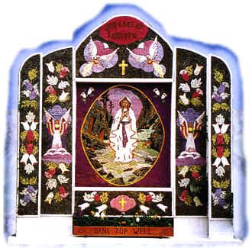
In Derbyshire each year many villages do well dressings, which are basically a mosaic picture done on clay using natural materials. Have a go at it! If you don’t have access to a real well you could do your own miniature versions:
- Fill a jam jar lid with damp clay (or plasticine).
- Draw a design on it with a cocktail stick.
- Complete the outlining by putting peppercorns along the marked lines.
- Fill in the spaces with natural ingredients of different colours.

- Maybe you could each make one on the same theme
- Use dried materials such as lavender, seeds and flower heads or fresh flower petals or leaves
- The petals or leaves should be all laid on facing in the same direction in rows, and each row should overlap the one below.

Limericks!
The limerick was made popular by the English poet Edward Lear in his Book of Nonsense, published in 1846 but it has much earlier origins. It is believed that limericks originally came from a song with the chorus “Will you come up to Limerick?” which was brought back from France by returning members of the Irish Brigade in the 18th century.
- Find Limerick on a map
A young lady of fair Aberdeen,
Drank gallons of boiling caffeine.
Kept needing the loo
Oh! What a to do!
Inspired, dug a handy latrine.

- Get hold of Lear’s “Book of Nonsense” or another book of silly poetry & prepare a poetry reading for the unit. No giggling allowed (from the readers!)
- Learn some poems by heart
- Write a Limerick!

Golf
You may know that golf originated in Scotland but did you know that it was once banned there? In 1456 King James II thought golf was taking too much time away from the men’s archery practice, and decreed that the football and golf no longer be played. When James IV signed a peace treaty with England in 1502 the ban was unofficially lifted.


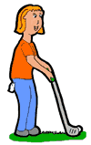
- Visit a putting green, pitch and putt course or driving range and try it out
- Use a walking stick or a broom handle and an indoor practice golf ball or a pingpong ball and improvise your own course, indoors or out. Make use of what you’ve got – stairs, furniture, whatever! Ask your guider (beforehand!) if you can let the whole unit have a go on your course.
Hold a traditional Burns’ supper (usually this is held on 26 January but you can have yours whenever you like). Or if you can’t face the food, rehearse a proper address to a haggis:


Fair fa' your honest, sonsie face,  Great chieftain o the puddin'-race!  Aboon them a' ye tak your place,  Painch, tripe, or thairm:  Weel are ye wordy of a grace  As lang's my arm.  The groaning trencher there ye fill,  Your hurdies like a distant hill,  Your pin wad help to mend a mill  In time o need,  While thro your pores the dews distil  Like amber bead.  His knife see rustic Labour dight,  An cut you up wi ready slight,  Trenching your gushing entrails bright,  Like onie ditch;  And then, O what a glorious sight,  Warm-reekin, rich!  Then, horn for horn, they stretch an strive:  Deil tak the hindmost, on they drive,  Till a' their weel-swall'd kytes belyve  Are bent like drums;  The auld Guidman, maist like to rive,  'Bethankit' hums. | Is there that owre his French ragout,  Or olio that wad staw a sow,  Or fricassee wad mak her spew  Wi perfect sconner,  Looks down wi sneering, scornfu view  On sic a dinner?  Poor devil! see him owre his trash,  As feckless as a wither'd rash,  His spindle shank a guid whip-lash,  His nieve a nit:  Thro bloody flood or field to dash,  O how unfit!  But mark the Rustic, haggis-fed,  The trembling earth resounds his tread,  Clap in his walie nieve a blade,  He'll make it whissle;  An legs an arms, an heads will sned,  Like taps o thrissle.  Ye Pow'rs, wha mak mankind your care,  And dish them out their bill o fare,  Auld Scotland wants nae skinking ware  That jaups in luggies:  But, if ye wish her gratefu prayer,  Gie her a Haggis!

There is an explanation of some of the Scots words on www.rabbie-burns.com/thepoems/address.htm or find out yourself what it all means!
Love spoons
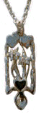
A love spoon is a wooden spoon, often very complex, carved from a single piece of wood by a young man and presented to his sweetheart as a token of his affection. Although the earliest surviving one dates from 1667, the custom was widespread in Wales before that date.

The spoon may be plain or intricately decorated with various symbols - birds, hearts, wheels, balls - each representing good luck, the blessing of children, wealth, health, etc.
The custom of young men carving love spoons has, perhaps understandably, died out, but they are today a popular souvenir of Wales.

- Make your own love spoon!
- If you don’t want to carve one you could take a wooden spoon (from any kitchen shop) and decorate it however you like.
- If you want to try some easier carving, try whittling a teaspoon.
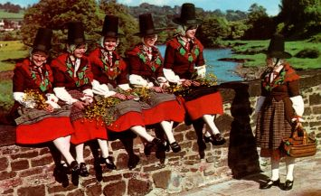
!

Make sure you’re careful with knives, and
check with your guider first about safety.

Fish and chips!

The UK is world famous for its Chippies! How many are there near you?

- You could go out during the meeting and try some chips from each local chippy. Give them points for taste, texture and freshness – which is the best? Make a fancy certificate to present to “The best chippy in your town”!
- Fish and chips is a fairly balanced meal but if we ate it all the time it wouldn’t do us much good. Work off some of the calories … maybe by going for a jog on the way there (not the way back – indigestion isn’t fun!)
- Alternatively you could try a comparison of other foods found locally

Don’t forget to decide beforehand how you are going to pay for the chips.
Dance
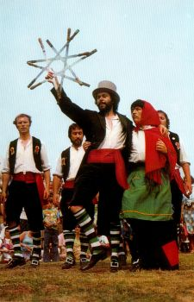
Find someone to teach you some national or local dances,
for example:
- Maypole  - Morris  - Highland fling | - Scottish country  - Clog  - Hornpipe

Here are a few of the moves for Cotswold Morris – they’re very similar for many forms of country dancing. But these ones let you wave sticks about!
- Make up your own dance sequence.
- Maybe you could teach it to the rest of the unit?
- 'rounds' - dance around in a circle clockwise one following the other, then go back anti clockwise.
- 'back to back' is what you probably know as a dozi doh
- 'hey' is a figure of eight up each side.
- 'sides' is where you change place with your partner, but keep facing her as you switch. (then clobber sticks and change back again!)
- forward and back - everyone faces up the set and goes forward 2 steps then back 2. All turn to back and repeat.
- 'corners' is where opposite corners change places, then the two middles.

Maypole dancing
First you’ll need a pole (up to 9 feet tall) that has coloured ribbons attached in multiples of 4. The ribbons should be a length of one-and-a-half times the height of the pole. Half of the dancers dance in an inner circle, nearer the pole, and the other half dance in an outer circle.

There are basically two kinds of dances: the closed plait, where the pattern of ribbons is wound around the pole, and the open plait, where the pattern is made by the outer ribbons winding over top of the inner ones. Here are two possible resulting patterns:
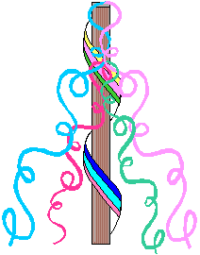
- The Barber's Pole forms a striped pattern, spiralling down the pole like the traditional barber's sign.
- The Single Trace is an open plait, so the inner ribbons are held against the pole while the outer ribbons weave a pattern over them.
Music
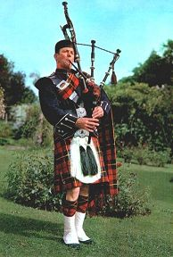
- try local instruments – harp, squeeze box…
- do you know someone who could demonstrate?
- get hold of some traditional or folk music CDs & see which instruments you like the sound of.

Get singing!

- Sing along to Land of Hope and Glory and Rule Britannia at the Last Night of the Proms. Learn the words first! Here’s the chorus of both and 2 verses of Rule Britannia, just to start you off.

- Do any of you play an instrument? You could play while the others sing – but remember this music is in C so if you play a B flat instrument like clarinet or trumpet you’ll need to transpose or it’ll sound wrong.
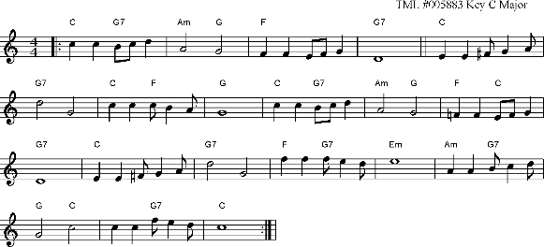

Land of Hope and Glory
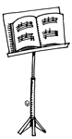
Chorus:
Land of Hope and Glory, Mother of the Free,
How shall we extol thee, who are born of thee?
Wider still and wider shall thy bounds be set;
God, who made thee mighty, make thee mightier yet,
God, who made thee mighty, make thee mightier yet.

Rule Britannia!
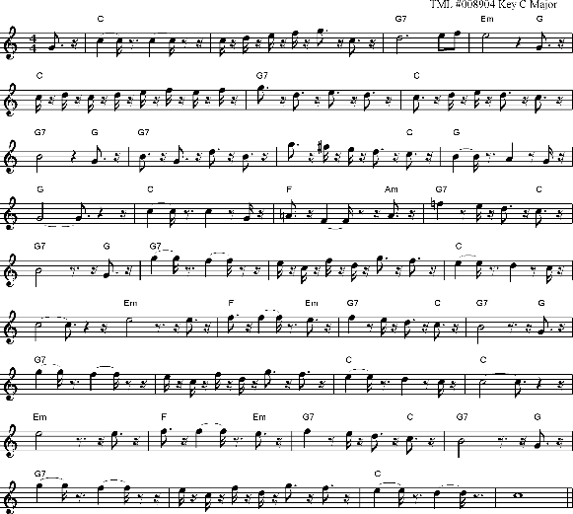

When Britain first, at heaven's command,
Arose from out the azure main;
This was the charter of the land,
And guardian Angels sung this strain:

Rule, Britannia, (Britannia) rule the waves;
Britons never (never, never) will be slaves.

The nations, not so blest as thee,
Must, in their turns, to tyrants fall:
While thou shalt flourish great and free,
The dread and envy of them all.

These are just two verses – how many are there?

