CONTENTS

- Trails  - Chariots  - Access all areas  - Fly away  - Steam power  - Out and about  - Round the world | - Obstacle course  - Moving about  - Pollution test  - Stilts  - Flying Saucers  - Build a hovercraft

This is a “Go For It” produced specially for 193B Edinburgh Guides. The activities are all based round movement.

Notes for patrols

- Read the instructions first – don’t just rely on the list of what you need
- Keep a record of which activities you do and how they went
- Assess after each activity how it went, and what you could change, either about the activity or about how you planned it
- Try to have a go at different sorts of activities
- Make sure everyone has fun!
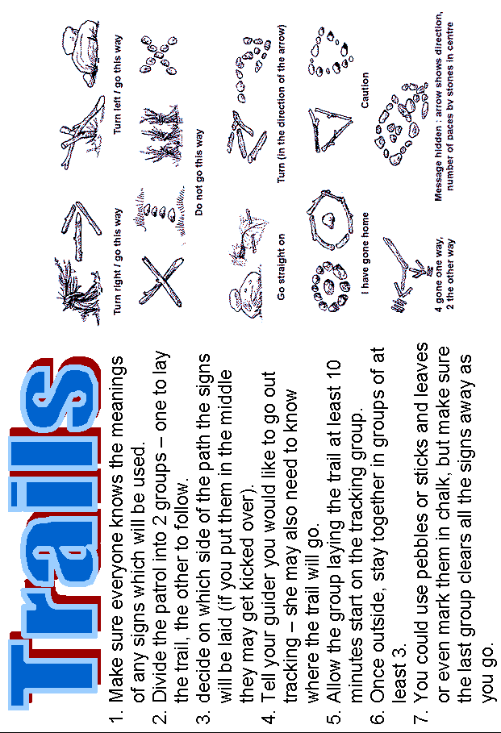

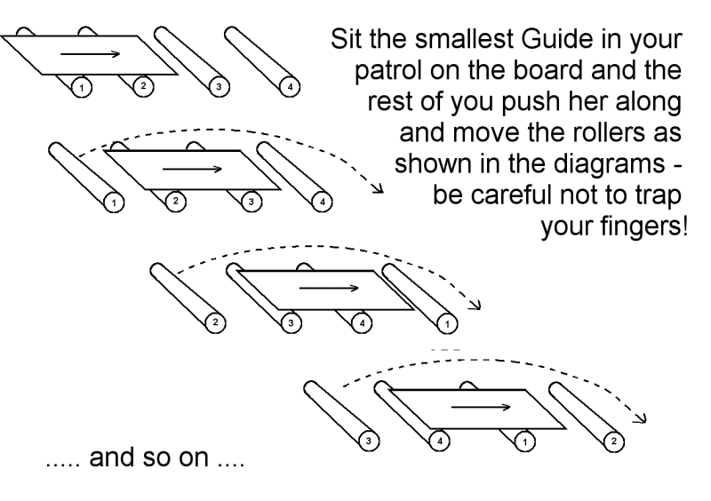

- You could make an A-frame chariot by lashing poles together.
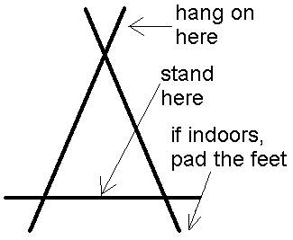
- Make two and have a race.
- Which design is fastest?
- Which is easiest to ride?
- Make sure everyone has a go at being a passenger and at helping to steer!

- How easy is your meeting place to get around? (Use the checklist opposite as a guide)
- How easy would it be if you walked with a stick or if you were in a wheelchair?
- What if you had a pram or pushchair with you?
- In a wheelchair, how many of the shops you use would be accessible?
- What about your school?

Other ideas:
- See if you can borrow a wheelchair or some crutches, and see what it’s like – try getting round the hall, using the stairs, getting into the toilets or reaching cupboards.

- Get someone who is or has been physically disabled to come and talk to you about any problems
they encountered.

- What would it be like if you were blind? Try blindfolding a member of your patrol and guiding her round the building. How does it feel to have to trust the person leading you?

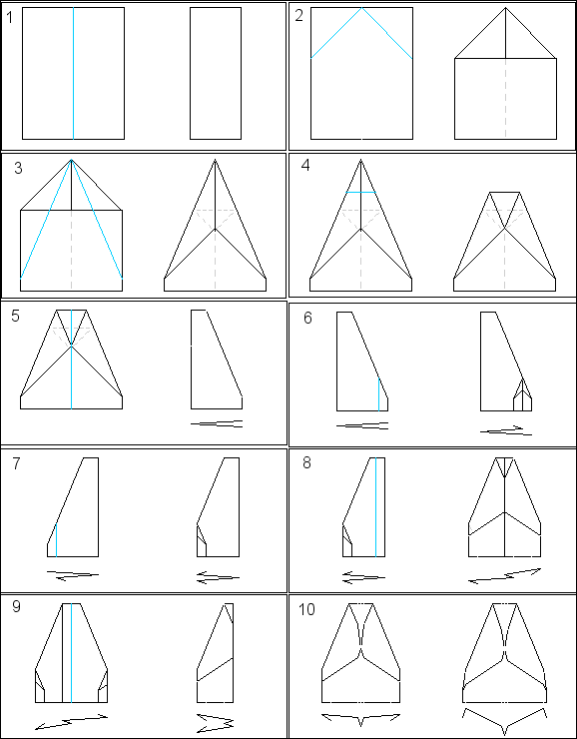
Build a paper aeroplane
Try the design below or the one on the next page. Sometimes it helps to put a piece of blu-tak or a paper clip on the nose or tail.
- Test different designs
- Have a competition
- Which goes furthest?
- Which flies most accurately?
- Try making a hang-glider from drinking straws and a plastic bag – how does that compare?

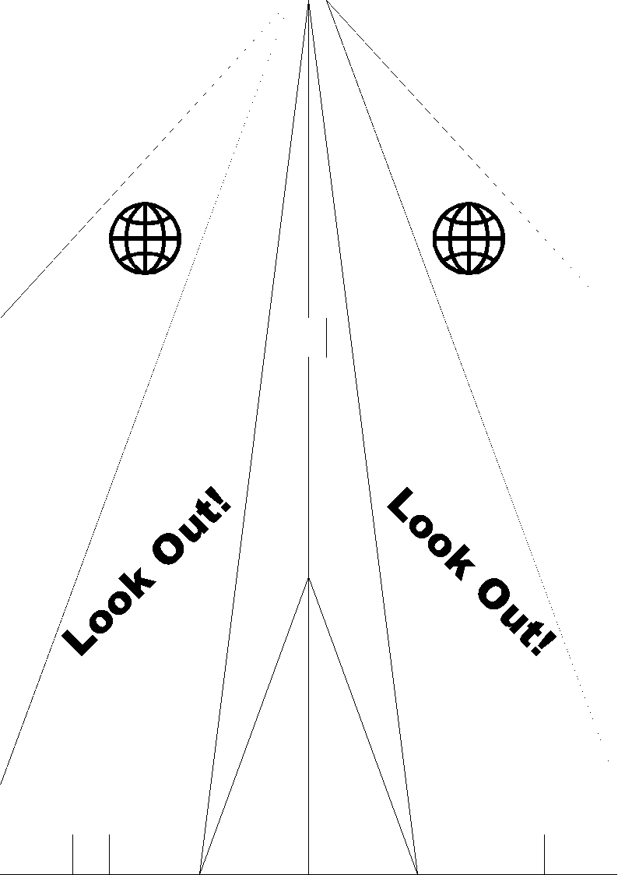

BOMB!
Take a tin with a tightly-fitting push-on lid, a candle, some aluminium foil, some plasticine, 4 matches, a knife and a very small quantity of water. Using only these items cause an explosion. If you can’t work out how to do it, ask your Guider – but she probably won’t tell you until you’ve had a few tries!

STEAM BOAT
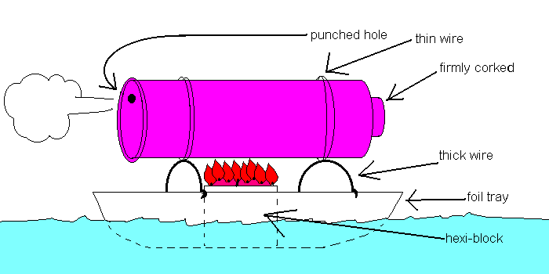

Punch a small hole near one edge of the base of a metal tin with a tight fitting lid. Half fill the tin with hot water and using thin wire, mount the tin on strong wire legs with the hole at the top. Put a hexi-block in a foil dish and stand the tin over it. Light the block, which then heats the water until steam comes out of the hole, propelling the boat.
WARNING: hexi-block burns very fiercely!

Go on a penny hike: take a penny, and whenever you get to a junction toss the coin – heads means turn left, tails means turn right. See where it takes you! But be careful to keep track of where you are so you can get back safely.

- How easy would it be to find your way to local places (shops, the meeting hall, playing fields, schools…) if you didn’t know the area? Where do you think there should be signposts?

- Draw a map showing important or interesting local places.

- Could you direct someone to the guide hall from anywhere within a mile?

- Practice drawing sketch maps to show the way from your home or guide meeting hall to places like the doctors surgery, vet or shops.

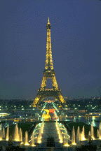
If you had two months, or a year and unlimited money where would you go?
What about if you had a limited amount of money, say £1000?

Get hold of some travel agent’s brochures and timetables, and plan your trip.

- How would you travel?
- Where would you stay?
- Who would go with you?
- What would you take?
- What would you bring back?
- How much would it cost?

InterRail through Europe?
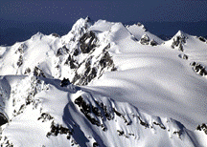
- Fly round the world?
- Hike over the Himalayas?
- Hitch hike across the USA?
- Cruise the Caribbean?
- Dive on the Barrier Reef

How many countries could you visit in a month? Or would you rather see more of one or two countries?
Is it really possible to “do” Europe in 5 days?

Make a poster or a diary of your trip – you could illustrate it with your own drawings, or use pictures from the brochures.

Design an obstacle course, then have a race.

Try some of the following:
- a scramble net to go under (eg. a groundsheet)
- a balancing bar (which might just be a line chalked on the ground, but lose points for putting a foot off)
- something to carry (like a cup of water – lose points for spilling any)
- challenges, like “hit a target with a ball before you can continue” or “do this bit on one leg”
- silly ways of moving (for example make some cardboard skis & use those for some or all of the course)
- do the race in pairs, one person carrying the other
You could make it big enough for several people to go at once, or use a stopwatch & time everyone.
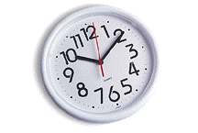

Or if you don’t feel the need for speed, you could score it like show jumping – give points for technique and not damaging any of the obstacles.
Another alternative is to set out a simple maze with furniture and string, and blindfold the person who is to go through it. They could be directed by whistle (one blast for left, two for right) or by someone calling out instructions. Make it harder by assigning one person to give directions & everyone else to shout & confuse them!



- How many journeys do you make by each mode in a year?
In a year, the average person makes 1051 journeys. 643 of these are made by car, 288 on foot and 79 by bus, coach or rail.
- Which way of travel is healthiest?
- Do you think you’re doing your bit for the environment?
- What could you do to reduce
traffic pollution?
- Test travel pollution in your area with
the activity on the next page.

People who walk or cycle are called “vulnerable road users” because they are more likely to be involved in an accident. Why do you think this is? Does it mean you should go everywhere by car?

AGE OF LEAVES: the tip of the branch will be the first year’s growth. somewhere below the tip will be a mark on the steam, this is called an age scar. The next leaves behind that are the second year’s growth, then there will be another age scar and so on.

You will need:
- sheets of filter paper
- card for recording results
- sticky tape
- scissors

One way to test for pollution is to check the amount of dust on leaves. Evergreens suffer more than deciduous trees because they don’t shed their leaves. Holly is a good plant to test, as it is easy to check the age of leaves as shown in the green box.

Test one leaf for each years growth as follows: Fold a sheet of filter paper in half and place the leaf inside. Firmly wipe along each side twice, so that the dust from each side transfers to the paper. Cut out the shape, stick it to the card and record which year’s growth it was. Repeat with a leaf from each year’s growth.

- Which side of the leaf collects more dust?
- Are the results different before and after rain?
- Which age of leaf collects the most dust?
- Does where the bush is growing make a difference?
- Where do you think most of the dust comes from?
- This test is for particle pollution. What other sorts of pollution are there?

Make some stilts and have a go at using them, or if you have some, hold a “stilt challenge”. You could combine this with the obstacle course ideas on the previous page!
Some ideas for making stilts:
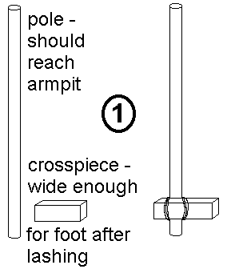

- Use a broomstick or gadget wood for the upright and anything you can think of for the crosspiece! Use square lashing to fix together.

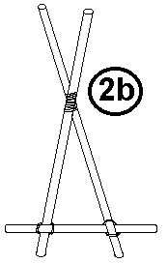
2. monopods
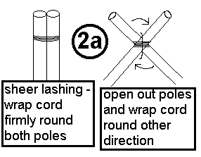
You will need 3
broomhandles
or similar and
some string.
Use shear
lashing at the
top (see 2a)
and square lashing at the bottom. Then put one foot each side & walk!

- Use two large tins (cleaned and with any sharp edges removed). Punch holes near the bottom, turn upside down and thread string through to hold them by.

- Who is the steadiest on their stilts?
- Who is fastest?

You will need:
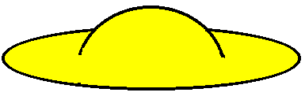
- clothes peg
- rubber band (about 8cm long)
- piece of stiff card, scissors
- drill (or get someone to drill the hole for you)

- Drill a hole through the handles of the peg using a 5/32” drill bit.
- Thread the rubber band through the holes so that the loops are equal on both sides – a sharp point such as a pair of compasses helps to push the band through.
- Take the 2 loops over and into the jaws of the peg, open them and let the loops spring back into the jaws.
- Pull one of the strands between the handles of the peg and create a firing loop.
- Cut out the flying saucer from card – draw round a 2p piece and cut out a notch as shown in the diagram.
- Put the disc into the jaws of the peg with the notch at one side, stretch the firing loop and hook it into the notch. When you press the handles of the peg together the flying saucer will take off and fly across the room!

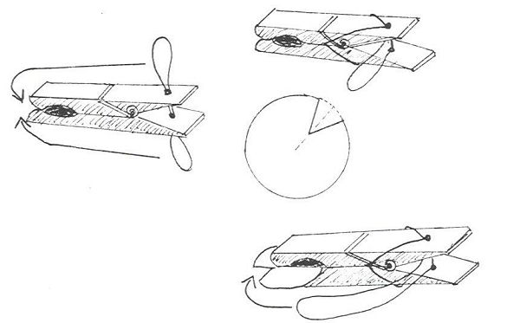

You won’t believe it till you try it!
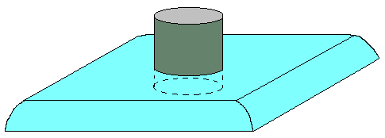
You will need:
- flat polystyrene tray (eg. a meat try from supermarket packaging)
- short length of cardboard tube
- pen
- sharp knife

Turn the tray upside down. Position the tube in the middle of the tray and draw round it to get a close fitting circle. Cut out the circle and fit the length of tube through. Blow hard down the tube and see what happens. Try different thicknesses of tube (eg. toilet role inner, camera film canister with the bottom cut off, drinking straw).

Balloon power!
Start by making a 1.5 cm hole in the middle of a polystyrene meat tray. Then take four strips of thin card about 12 cm long and tape them to the corners of the tray. These strips of cardboard will keep the balloon from falling over. Blow up a balloon, and whilst holding the balloon shut, feed the neck into the hole in the meat tray. Let go and watch the craft move!
