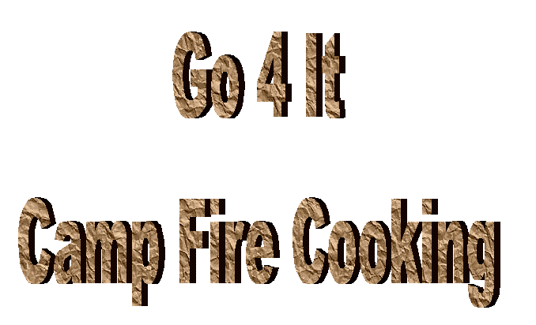

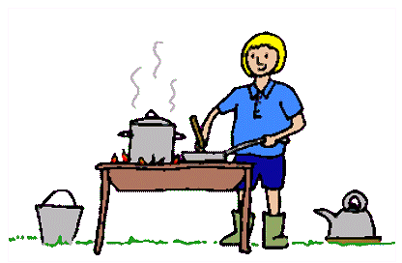

There’s more to cooking than meat and two veg. Camp fire cooking can be fun, if you do it properly – or a nightmare, if you don’t! There’s nothing worse than going home with the camp equivalent of Bombay Belly because you didn’t make sure that your food was cooked through properly, and I don’t mean singed around the edges and raw in the middle. So where do you begin to learn the basics of cooking on an open fire? It’s easier than you think.

Once you’ve mastered the technique of each sort of cooking, try experimenting with what food you can cook on it. You’ll be surprised what a candle can cook or what will cook in a cardboard box!

Candle Cookery

EQUIPMENT NEEDED:

Silver Foil Barbecue Skewers

Candles Coathangers & Pliers

Vegetable Oil Popcorn
Silver Foil Containers Chocolate Buttons
(pudding size ones are best for popcorn) Mint Sweeties
Bulldog clips Digestive Biscuits
Teaspoon Marshmallows

Matches

Popcorn in Foil
Light the candles.
- With a foil container - add half teaspoon of oil in to the container.
- Add a teaspoon of popcorn.
- With silver foil, cut out a piece of foil much larger than the container. Put a double fold in the middle (this is so the popcorn can expand when cooking).
- Cover the container with the silver foil and seal well over the edges.
- Using some initiative, pliers and a coathanger, or two bulldog clips, hold the container over the candle until the popcorn begins to pop.

Chocolate Mint Sweeties
Light the candles.
- Crush the mint sweets inside a plastic bag.
- Using a small foil container, melt the chocolate over the candle.
- When melted add the crushed mint sweets, mix and then leave to set.

S’More’s
Light the candles.
1. Skewer a marshmallow (or two) onto a barbecue skewer.
2. Hold over the candle until cooked to taste, then place them between two biscuits with a couple of chocolate buttons. Eat while still hot.

Buddy Burners

Before you start this section you must collect the following items. It may take some weeks before you get enough to do the whole activity, so pre-plan the collecting.

BUDDY BURNER
Needed:
Corrugated cardboard (you can strip the paper from off normal cardboard boxes)
String
Candle ends – lots of them
Empty tin, small tuna tin sized OR single portion Baked bean tin size
Heat source to melt wax
1 Gallon Tin
Basin

- Melt the wax using the basin over a saucepan of hot water over a source of heat, taking care as you do this.
- Cut and roll the cardboard so it fits in the can. Ensure that it is cut to fit BELOW the rim of the tin. You can use as many strips of cardboard as you need. It needs to be fairly well fitted, not too loose so that the cardboard unfolds and not too tight that you have to force it in to the tin.
- Cut the string about 5cm longer than the height of the tin. Roll the paper around the string and pack it into the tin. Pour in the melted wax so that it just covers all of the cardboard, leave to set and then cut off the excess string.
- This type of heat will last 1 1/2 - 2 hours.

HINT: If you use a full size baked bean tin or soup tin, you may find it difficult to burn underneath a vagabond stove, but they are ideal to use with the mini saucepans or frying pans.

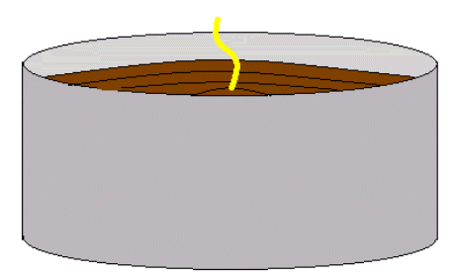
VAGABOND STOVES

MATERIALS
Candle
1 Large tin can (catering size baked bean tin)
Coat hanger
tin snips

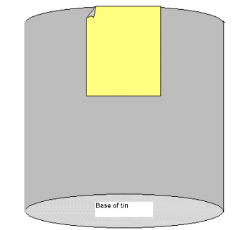
- Start with a one gallon tin can. Use a pair of tin snips to cut a door 3 inches high and 4 inches wide on one side of the can at the open end (rim edge). Leave the top of the door attached to use as a control vent. Pull the door open when cooking. WARNING – the edges of the door can be very sharp.

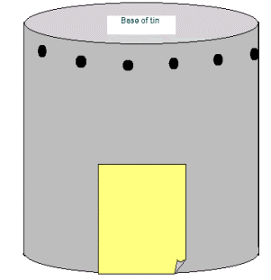

2. Turn the tin upside down. Punch holes with a punch-type can opener or hammer and very large nail in the side of the can near the top of the tin.
3. Punch a small hole in each side of the can near the top and attach a wire hanger handle to aid in removing the can from the heat source.
4. Two heat sources can be used with the tin can stove, a buddy burner or wood fire.

2 Trying removing both the lid and the base of the tin. Punch 8 holes evenly around the rim. Through these holes, thread sections of wire cut from wire coat hangers so that they cross the can in the middle and make a grill. Leave a loop of hanger to use for a handle, so you can lift the hot can. Use your tuna tin saucepan or frying pan to cook with – much easier to clean up afterwards! Try toasting bread over it!
SAUCEPAN/FRYING PAN

NEEDED:
Salmon or Sardine tin or small baked bean tin
Coat Hanger
Pliers

- Remove the outside label and give the tin a thoroughly good wash.
- Punch two holes on opposite sides of the rim.
- Using the coat hanger, attach a piece of wire long enough to be used as a handle.
- Light the buddy burner and use the tin over it as a saucepan or frying pan.
Try cooking a mini stew over the heat of the buddy burner (see recipe section).
Test yourself to the limit and cook a three course meal using a buddy burner. How about French toast starter, spaghetti bolognaise main course followed by pancake desert using a sweet filling? OR
Can you do something better?
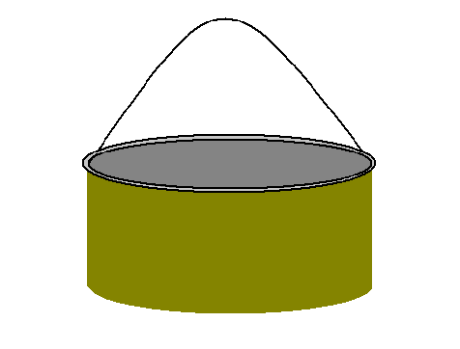

Cooking with a Buddy Burner and Vagabond Stove

Try cooking the following foods over the buddy burner & stove:-

- Pancakes
- Sausages
- Burgers
- Fried Eggs
- French Toast - cut 1 slice into 4 squares before dipping and frying.
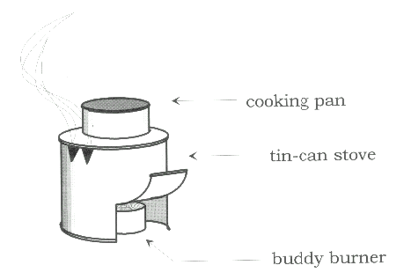
- Bananas

Place your buddy burner underneath the stove. Turn the door of the stove to face the wind before you start cooking.

Only use a teaspoon of pancake mixture to the top of the stove. Just make sure you apply just the right amount of oil to the top of your stove, or the pancakes will stick. Make sure you watch the pancake so it will not burn. Experiment by adding different ingredients to the pancakes while cooking. Things like chocolate chips, raisins, cinnamon sugar, honey, lemon juice etc.

When cooking eggy bread, cut the slice of bread into quarters before soaking in egg and cooking. The top of a catering can will only allow two quarters at a time to cook efficiently.

Allow four girls to a buddy burner so in order to allow each to cook one pancake then eat it, and once every girl has had their turn, start over again and keep this going until everyone has had their fill.

Slip open the banana, keeping it in the skin, add chocolate buttons and marshmallows. Wrap the banana in foil and place it on top of the stove.

Think you can Cook?

Well, you’ve tried the buddy burners and the vagabond stoves. Do you think you’re ready to cook on an open fire? Well before you can, you’ve got to make your fire.

INGREDIENTS FOR A FIRE

1. PUNK

No, I don’t mean a punk rocker. What is punk? Punk is the very first thing you need to start your cooking fire. Try gathering the following items before you begin. Which ones are the more successful at starting a fire?

1. A handful of sawdust
2. A couple of very dry and dead leaves
3. Lint from the tumble dryer (The fluffy stuff that collects around the door)
4. Some very small, very thin twigs, dead and very dry
5. Some cotton wool
6. A piece of paper
7. A piece of string and wool
- A small piece of cotton fabric
- Holly or sweet chestnut leaves
- Dead gorse
- Birchbark
- Fir cones

EXPERIMENT

Take a large catering sized clean, empty, tin. Turn it upside down. Using each of the above ingredients separately, place your punk on to the top of the tin. Set each ingredient alight using one match only. Which one is the most successful and takes the least amount of time to burn? Which one burns for the longest period of time.

WARNING – these items are likely to flare very quickly. Please tie up long hair or put hair inside a hat before you begin to light them.

2. KINDLING

Here’s a riddle. It’s larger than punk but smaller than wood, what is it? It’s Kindling!

Kindling is twigs, no thicker than a match, it’s used to place on top of the punk and enables the flames to get a good start before the main firewood can start to be added.

What makes good kindling? Any wood that is dead and preferably dry. It may be found on the forest floor or beneath the base of bushes and shrubs. How do you know if it is dead? Try breaking it in half. If it does not snap when you try to break it, it is not dead and should not be used. This is called ‘green’ wood and it will cause your fire to smoke rather than burn.

When you have a good pile of kindling wood, gather larger bits of wood. This too should be dry. Many official campsites have woodpiles with pallets on, which are fine if broken up, but be careful of nails.

The following is a list of kindling.

Holly
Birch
Beech
Larch
Fir
hawthorn

WARNING NEVER use Yew for a cooking fire as it is poisonous. Also avoid using elm and elder which gives off bitter smoke and very little heat.

3. WOOD

This means hard woods such as beech, ash, oak, holly, hawthorn, conifers, rhododendron, willow. It also means that it is thicker than a twig. Rhododendron wood makes very good charcoal. Conifers wood is soft and will often burn very quickly.

When collecting wood, try to collect a large amount of a variety of sizes, from finger thick size, arm thick size to large log size.

HOW TO BUILD A FIRE

Before you start to think about lighting a fire ask yourself two questions. First, have you got enough wood? Second, have you sorted the wood into a wood pile, with the smallest, thinnest at the beginning and the largest and thickest at the end? Doing this simplest of tasks will help get a fire going quickly ready for cooking.

There are lots of different ways to start laying a fire but the following are generally used by scouts and guides.

Pyramid
The first is a pyramid. This is formed by placing kindling round punk, with space left on the windward side for lighting.

Demonstrate three different types of fire building shapes.

If they are available, two thick logs should be placed either side of the fire, to contain the heat and prevent the grass burning from too much heat.

PREPARING YOURSELF
At this point, the first things you need to teach is not *the match*, but how to prepare *yourself* before the fire is laid and the match is struck, etc.
- Tie back long hair, put through a cap, whatever. No one is allowed in fire ring until this is done.
- Flapping sleeves should be rolled up, no long shirttails out, and NO NYLON ever in the fire ring.
- Have equipment nearby: 2 buckets of water, hoe, rake, etc.
- Know at least two different ways of laying a fire.
- Are you sure you know how to strike a match? If not, practice lighting a candle. Place a couple of sturdy pillar candles just inside the fire ring and let the girls take turns lighting the candle, blowing out the match, and tossing it into the laid fire.
- Now you are ready to light a fire.

Preparing the Ground
Be aware when choosing a site for your fireplace. Some simple rules apply.
- It should be at least 3 metres away from the nearest bush or tree
- The ground should be level
- There should be no overhanging branches which may catch fire should your fire grow too big.
- There should be sufficient space around your fire, once built, not to burn any surrounding grass.
- Should the ground underneath be wet, you can put a piece of tin foil down before you build the fire to give a dry base.

Getting it going
The Patrol should be divided up into action teams. At least one member of the patrol should be on firelighting duty. One member should be on wood pile duty – this girl should be ready to pass on the next size wood as the fire grows. She should not only be watching the fire as it takes but ready with the wood before the firelighter asks for it. The final group of guides should be collecting further wood. If it is not used with this fire it is stored ready for the next fire or the next meal.

1. If you have built your fire correctly, you should only need one match to light the fire. You light the fire by igniting the punk in the centre of your campfire. Don’t try and ignite the kindling before the punk.
- If there is a strong wind blowing, you may need to shield the small flame otherwise it may blow out; conversely you may need to blow or fan the flame gently to encourage it to blow. Only practice will teach you how much you need to use.
- Once the fire is going, build it up carefully using progressively larger logs. If you heap the rest of the wood on the fire at this point you will smother the flames and it will go out.
A fire should never be left unattended. Make sure someone is responsible for the fire at all times. A bucket of water and a fire blanket should be kept close by in case of any emergency. Make sure that all members of the patrol are aware of fire procedures, should any accident occur, such as grass, trees and tents catching fire.

Cooking on the fire
Once the fire has built up well, let the fire burn down until you have a good set of orange or white embers. The heat is hotter than flames and makes it perfect for cooking on - why not try some of the backwoods recipes?

You may need to add wood to the fire whilst you are cooking; this is not a problem. Move your pans to one end of the fire and build the other up, then let it burn back to embers and move the pans to that end and build up the other.

At the end of the day
Last thing at night (or after use if you are going away from your site), once the final water has been boiled for a hot drink, the fire should be allowed to burn out naturally if possible. By raking the embers regularly this should turn the wood from an orange glow into black (charcoal), although there is still plenty of heat there. If there is a large log left on the fire still glowing, but without flame, you should be able to leave it after it has been damped down slightly. Again in the morning, providing it hasn’t rained too heavily during the night, you should be able to get enough energy from it to start the mornings fire.

However, if the fire won't go out, sprinkle water on it to help. Not too much, though, as the charcoal left can be used to help get the fire going the next morning (after you have sifted it and carefully disposed of the ashes).

Finally, protect your wood pile from wet weather or heavy morning dew by covering it with an old groundsheet or piece of plastic sheeting.

Box Ovens - 1

Supplies:
- Cardboard box with flaps removed
- Heavy duty Aluminum foil
- Scissors
- Foil pie dishes
- Coat hangers
- Pliers

Cover the cardboard box inside and out COMPLETELY with aluminium foil, placing the shiny side out.
The bottom of the box will be the top of the oven.
To use the oven, place the pan with the food to be baked on a footed grill (or similar) over the lit charcoal. The grill should be raised about 10" above the charcoal. Set the oven over the food and charcoal. Prop up one end of the oven with a stone to allow the air circulation for the charcoal or cut air vents along the lower edge of the oven. Control the baking temperature of the oven by the number of pieces of charcoal used. Each piece of charcoal supplies 40 degrees of heat. Construct a removable oven top or oven door.
Bake bread, brownies, roast chicken, pizza, coffee cake etc. Works just like a regular oven. Suggested baking times - 30 minutes or less.
Try the oven over the coals of a campfire.

The copy paper Box Oven
The cardboard boxes that hold reams of paper, 10 reams of 8 1/2 by 11 inch paper, or 10 reams of 8 1/2 by 14 inch paper, will make very nice box ovens. Line the inside of the box and lid with aluminium foil. Use a sponge to dab some Elmer's glue around the inside and cover to hold the foil in place. Make a couple holes in the cover to let the combustion gases out, and make a few holes around the sides near the bottom, to let oxygen in.
Make a tray to hold the charcoal using one or two metal pie plates. You can either make feet for a single pie plate using nuts and bolts, or bolt two pie plates together bottom to bottom. Cut a couple coat hangers to make a rack to hold up the cooking pan. Poke the straight pieces of coat hanger through once side, and into the other. Two pieces will usually do fine..
Put several lit briquettes on the pie pan, put your cooking pan on the rack, and place the cover on top. The first time you use this box oven, check it a few times to make sure that enough oxygen is getting in, and enough gases are escaping, to keep the charcoal burning.
I have a big heavy cardboard box about 20" long by 15" wide and 15" deep. It needs to hold a 13x9x2 pan with a few inches all the way around. I cut mine so that it sits on its side and the door flap opens downward like a real home oven does. I ask the grocery guy to cut it open that way on 3 sides. You can also use a box with a top.
Line the inside with about 3 layers of HD foil shiny side towards inside of box (so you can see it). It is best to use long pieces that go from outside to inside and outside again. Then do the short side, long side etc. Crimp them really good on the outside.
You will need 9" square foil pans - one for each meal. These hold your coals, 4 empty soup cans with labels peeled and a rock or sand inside them to weight them down. They should all be the same height. These hold your cake cooling rack which is your oven shelf. If I need to cook lots I have a 3-tiered cookie cooling rack that I cook on. You also need a pan to cook in.
Box Ovens - 2
I like to use an oven thermometer to tell me temperature. Follow coal guidelines..I think it is 10 or 15 degrees per coal, that is something I always have to look up. I always make extra though !
Start coals, make food, put cans and rack in, put coals into foil pan when ready and put UNDER the cake rack on the oven bottom. I use a pan so that my oven does not burn and can reuse it with just lining it with more foil each time. You can also take pan in and out to add more coals as needed or take some out if too hot. Do NOT blow on coals or stir them with food in oven or add or subtract coals.
Preheat oven with door closed (set a rock against it) and then put food into oven and bake til done. 9x9 pans work best. Cakes and muffins are good, casseroles, anything you can bake at home. It might take a bit longer than conventional home oven, but that's what songs are for !

Box Ovens - 3
Take a large heavy-duty cardboard box - an apple crate works well. Line the inside with heavy-duty foil, shiny side out. Use duct tape to secure to side of box. Make sure it is as smooth as possible to fit over what you are cooking.
How to cook in a box oven:
Find a flat spot. Place 4 empty soda cans in a rectangle on the ground. Place a cookie sheet (that will fit when the box is inverted over it) on top of the cans and the pan that you are cooking in on top of that. Use an aluminium pie plate and place hot coals in pan and place between soda cans below cookie sheet. A charcoal briquette gives off about 40-50 degrees of heat ;so, for baking at 350 degrees, use about 9-10 briquettes). Invert box over the assembly and place a small stick on the ground for the box to sit on to serve as a vent. See the illustration (illustration below shows coals directly on the ground and also shows a viewing window fixed into the box oven both of which are options):

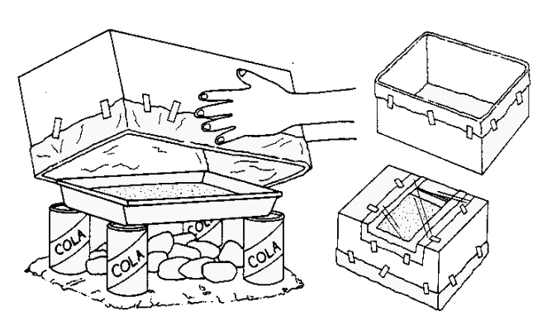

Pringles Oven
Once you have eaten or otherwise disposed of your Pringles (and cleaned the tube), cut a slit about 7 inches long lengthwise in the tube. Cut 2 shorter slits at each end of the long slit, so you have something like the letter I. Fold back the cut sections; the "wings" will be the solar reflectors. Now line the open space with some heavy plastic -- an oven bag works well. Do not use plastic or saran wrap as it will melt. That's basically it. Put some food (e.g., a hot dog or some marshmallows) on a skewer and run it through the tube, place it in some sunny area, and wait for it to cook.

FIRE STARTERS
If all else fails, the weather intervenes, you can’t get your fire started – then you need some help.

Dryer lint or cotton wool or sawdust
Cardboard egg cartons
Wax
String

- Melt some wax in an old tin. Use old candles or bits of wax crayons etc.
- Stuff a bit of dryer lint (highly flammable, by the way) into each egg holder, add a string ‘wick’.
- Add some wax - don't fill them to the top, about 2/3 full is good, but half way will do fine too!
- Let them cool, or put them in the freezer. Then when they are set, use a serrated bladed knife and 'saw' them into individual fire starters. The wet won't hurt them, they aren't toxic, won't hurt the environment, you are reusing old things and they WORK!!!

- dryer lint
- used toilet paper roll
- wax paper liner from cereal boxes
- Loosely stuff dryer lint into Toilet paper roll.
- Place in the cereal liner, roll up, twist ends to close.

These take seconds to make, cost nothing, and any age level can make them.

Here are a few other fire starters:
- A KISS: Wrap small candle stubs in waxed paper and twist the ends.
- THE FUZZ STICK: Cut into the sides of a dry stick to make curls attached to the stick. Use this stick as a central fire stick. Build a tent of twigs around it.
- WATERPROOF MATCHES: Dip matches in paraffin. Store in metal container.
- HUNTER'S MATCHES: Wrap each match ( or a few together) with string up to the head. Secure with a half hitch. Dip in paraffin wax.
- BRIQUETTES: Tie a briquette with string and dip in paraffin wax.
- PITCH: Use a small piece of wood to scrape pitch from a conifer tree. Place under tinder.

RECIPES

Edible Camp Fire
You need to provide various sweets and a good imagination to represent things needed for a camp fire.
Punk - chocolate flake bar crushed/coconut/chopped nuts
  - Kindling - 'matchmakers' broken up
  - Firewood - flake bars
  - Firebricks - marshmallows
  - Fire bucket - Cup of water /lemonade

The Guides can then make their campfire - and of course eat it when it's done!

Paper Bag Bacon And Eggs
Cut a strip of bacon in half and place side by side in a paper lunch bag.
Break an egg on top of bacon.
Fold top of bag over and push a stick through the fold.
Hold bag over coals.
When bacon stops sizzling, breakfast is ready!
Tear top off bag; salt and pepper to taste.

Ten Minute Casserole
1 6.5 oz. can of chicken (or tuna)
1 Cup Minute Rice
2 packets Cream of Mushroom Cup-a-Soup 1 and 2/3 cups boiling water.

Bring water to a boil.
Add chicken, soup and rice.
Stir to remove lumps.
Cover and remove from heat.
Let sit 10 minutes.
Stir again & dig in!!!

Ziploc Fudge
Zip-Loc Sandwich bag
4 Tablespoons powdered sugar
1 Tablespoon butter
2 teaspoons cream cheese
Few dashes of vanilla
1/2 to 1 Tablespoon cocoa

Squeeze air out of bag, zip, and "squash" ingredients together until well blended. Add "yummies" - M&M's, raisins, peanut butter, etc. - if desired. This is a single serving recipe.

Blackbirds
4oz Plain Flour
1/4 teaspoon salt
Slices of bread
1/2pt milk
Oil
1 Egg
Mix flour, salt, egg and milk together to make a batter. Cut slices of bread in half and dip them into batter. Warm the oil in the pan and fry the bread, turning once. Serve with blackcurrant jam
Mars Bar Krunchies
2 oz Margarine
3 Mars Bars
Rice Crispies

Melt margarine and Mars Bars over a gentle heat. When gooey remove from heat and add rice crispies stirring all the time. Press into shallow greased tin. Mark into squares and leave to set.
Muesli Bars
3oz Plain Chocolate
3 Tbsp Golden Syrup
1oz Butter
8oz Muesli
Cherries and Sultanas
Milk Chocolate to Cover
Melt plain chocolate with syrup and butter. Stir in muslei, cherries and sultanas. Mix thoroughly. Press into greased shallow tin. Melt milk chocolate and spread over mixture. Mark with fork and allow to set. Cut into squares.
Many of the games on this page are adapted from 'Take a Tent' Produced by Leeds County in 1986

Pineapple Upside Cake
Also, individual pineapple upside down cakes can be made using the same cooking method. Put a little margarine and brown sugar in the bottom, a slice of pineapple with a maraschino cherry in the centre and yellow cake mix on top. Cover with foil and cook on the grill.

Buddy Burner Grub
Put a little margarine or vegetable oil to coat the inside of the can. Crack an egg into the can, put 2 cocktail hot dog sausages inside and cover it with foil. Place it over a buddy burner until the egg is cooked. Can be eaten as is or put on an English muffin with a slice of cheese.

Fire and Food Games
Camp Ready Steady Cook
Give the Guides a list of food which can be usually be found in your QM stores on camp (any food which you can take and cook on camp easily!). Ask them to come up with menus for camp using these ingredients. You could give each patrol a different meal to work on (breakfast, lunch, dinner and desert). Write the ingredients on small coloured cards.
You may have to give advice to new campers who may not have cooked on camp before
You could try making their meals the following week!
Fresh Food
Have a set of large envelopes marked with the places where food is stored on camp. e.g. hanging larder in the shade, airtight jar, shelf off the ground, bucket of cold water.
Each patrol is given a set of small cards to 'post' in the envelopes which list foods found on camp (make sure you can differentiate each patrols answers)
Food Disposal
Label the large envelopes with the places where rubbish is disposed of (e.g. greasetrap, fire, pig bin,). Substitute the small cards with items of rubbish (e.g. sweet wrapper, potato peelings, teabags.

CAMP COOKERY CHALLENGE

Challenge 1
Each Patrol is to make a small camp fire.

They are given ingredients of foil, egg and a potato and told to cook it. They should do the following:

Scoop out a hollow in the centre of the spud.
Crack the egg into the centre of the spud, put the spud lid back on.
Carefully, wrap in foil - so as not to spill the egg, and place in the embers of the fire.

Challenge 2

Each Patrol is to be given two secret ingredients and told to cook them - without instructions! Leave the girls to cook what they wish from them.

Challenge 3

Each member of the Patrol is asked to bring an ingredient. It may be their favourite food item or their least favourite item, but only one item per girl. When the Patrol puts their food items together, they should be told to make either a complete meal or meals from the ingredients that they have brought.

Things like foil etc. should be provided for them by the Guider.

Raft Fire Challenge
Build a mini raft using twigs or barbecue skewers and the correct lashings to tie the twigs together. Fill a washing up bowl with water and put the raft on the water. Build a miniature fire on the raft. Can you start the camp fire using less than three matches?

WITH THANKS:

http://www.geocities.com/Heartland/Pointe/9385/ - Leaders Landing

http://www.guidezone.skl.com/jbvagst.htm - Guide Zone

Holderness Rangers' Guiding Resources http://www.holdernessrangers.org.uk

http://www.scoutbase.org.uk - UK HQ for Scouts on the net

