Easter Resources
Compiled by Mairi Scott 2002

Contents

Easter Songs 3

Easter Cooking 7

Easter Activities and games 8

Pokemon Easter cup holders 16

Easter crafts 17

Colouring in pages 31

Eater word searches 37

Easter cross words 39

Easter mazes 41

Web links 45

Easter Songs
Little Bunny Foo-Foo
Little Bunny Foo-Foo, (hold up two fingers)
Hopping through the forest, (bounce you hand up and down)
Picking up the field mice, (make a grabbing motion)
And bopping them on the head, (hold your fist, and hit your fist with your palm)
[spoken] Down came the fairy godmother, (symbol rain coming down)
[spoken] And SHE SAID:
Little Bunny Foo-Foo, (hold up one finger "no-no" motion)
I don't want to see you, (same as above)
Picking up the field mice, (make a grabbing motion)
And bopping them on the head, (hold your fist, and hit your fist with your palm)
[spoken]I'll give you three more chances, and then I will turn you into a goon!!!
(Sing again last line 2 more chances, then 1 more chance, then sing the following:)
Little Bunny Foo-Foo, (hold up two fingers)
Hopping through the forest, (bounce you hand up and down)
Picking up the field mice, (make a grabbing motion)
And bopping them on the head, (hold your fist, and hit your fist with your palm)
[spoken] Down came the fairy godmother, (symbol rain coming down)
[spoken] And SHE SAID:
Little Bunny Foo-Foo, (hold up one finger "no-no" motion)
I didn't want to see you, (same as above)
Picking up the field mice, (make a grabbing motion)
And bopping them on the head, (hold your fist, and hit your fist with your palm)
[spoken] I gave you three chances, now I will turn you into a goon!!!
[Spoken] And poof, she turned him into a goon
He'll be hopping down the trail
Sung to "She'll be coming around the mountain"
He'll be hopping down the trail when he comes,
He'll be hopping down the trail when he comes,
He'll be hopping down the trail,
He'll be hopping down the trail,
He'll be hopping down the trail when he comes.

He'll be bringing lots of candy when he comes,
He'll be bringing lots of candy when he comes,
He'll be bringing lots of candy,
He'll be bringing lots of candy,
He'll be bringing lots of candy when he comes.
He'll be bringing me a basket when he comes,
He'll be bringing me a basket when he comes,
He'll be bringing me a basket,
He'll be bringing me a basket,
He'll be bringing me a basket when he comes.
Peter Cottontail
Here comes Peter Cottontail
Hopping down the bunny trail
Hippidy, Hoppity,
Easter's on its way!!!
Five little Ducks
Five little ducks, went out to play (hold up five fingers)
over the hills, and far away, (hold hand to eyebrows)
When the mother duck went "Quack Quack Quack"
(motion "quack" with your hand)
Four little Ducks came waddling back.
(Make wings with arms and move elbows up and down)
Continue to count down until there are no little ducks then sing:
No little ducks went out to play,
Over the hills and far away,
When the mother duck went "QUACK, QUACK, QUACK",
Five little ducks came waddling back.
Six little ducks
Six little ducks
That I once knew
Fat ones, skinny ones,
Fair ones, too
But the one little duck
With the feather on his back
He led the others
With a quack, quack, quack
Quack, quack, quack,
Quack, quack, quack
He led the others
With a quack, quack, quack
Down to the river
They would go
Wibble, wobble, wibble, wobble,
To and fro
But the one little duck
With the feather on his back
He led the others
With a quack, quack, quack
Quack, quack, quack,
Quack, quack, quack
He led the others
With a quack, quack, quack
Back from the river
They would come
Wibble, wobble, wibble, wobble,
Ho, hum, hum
But the one little duck
With the feather on his back
He led the others
With a quack, quack, quack
Quack, quack, quack,
Quack, quack, quack
He led the others
With a quack, quack, quack
Play "Who stole the Egg?"
Class: Who stole the egg from the Easter Basket?
Teacher: (Ann) stole the egg from the Easter Basket?
Ann: Who me?
Class: Yes you!
Ann: Couldn't be!
Class: Then who?
Ann: (Tommy) stole the egg from the Easter Basket?
Tommy: Who me?
Class: Yes you!
Tommy: Couldn't be!
Class: Then who? [Repeat]

See the Easter Bunny
Tune - Here We Go Round the Mulberry Bush
See how the bunny hops along,
hops along, hops along.
See how the bunny hops along, (children crouch and hop)
On an Easter morning.
This is the way he wiggles his nose,
wiggles his nose, wiggles his nose (children wiggle nose)
This is the way he wiggles his nose,
On an Easter morning.
This is the way he flops his ears..................etc..
This is the way he flops his tail (wave hand behind you) ...etc

EASTER COOKING
EASTER BONNETS
NEED
MARSH MALLOW, DIGESTIVE BISCUIT, ICING, CAKE DECORATIONS, SUCH AS FLOWERS AND MINI SWEETS

Glue a marshmallow onto a biscuit with a dot of icing
Cover the biscuit with coloured icing
Decorate using mini sweets and cake decorations

BIRDS NEST BISCUITS

NEED SHREDDED WHEAT, CHOCOLATE, MIN EGGS, CHICKEN DECORATION
Break up the shredded wheat, not too finely or you will not get the twiggy effect
Melt the chocolate
Mix the shredded wheat into the chocolate
Put a heaped tablespoon onto greaseproof paper and shape into nest
Pop in some eggs and add a chick
2 biscuits and 8 squares of chocolate should make 5 nests

Easter Games & Activities
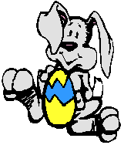
Egg Science
Talk about the parts of an egg - Shell, membrane, albumen, yolk, and germ spot. Crack open some real eggs into plastic bowl and find all the parts. Try some simple egg experiments such as spinning an egg to find out if it is raw or hard-boiled. You might also try floating an egg in plain water and then in salt water (salt water makes the egg buoyant so it floats).
Who's Hatching Today?
Display a large egg shape and each day hide a picture of a different animal underneath. Give the children three clues about the animal and have them guess the animal of the day.
Egg Guess
Put several small objects in different plastic eggs. Tape them closed and set them on a tray. Encourage the children to shake the eggs and listen carefully to the sound in each one. Try to figure out what is in each one.After several days talk about the possibilities and then open them up to see the real objects.
Surprise Egg
Send each child home with one plastic egg and the following note:
Dear parents,
Your child is bringing home an activity which requires your participation. Your child received one empty "surprise" egg and needs to do the following with you:
1. Find a single object to put in the egg.
2. Have your child tell you three clues about the object. Write the sentences on the clue sheet.
3. Place the clue sheet and the egg in a plastic baggie and return it to
school.
Below is the clue sheet. Fill it out with your child by (Date here).
WHAT"S IN MY SURPRISE EGG?
CLUE #1_________________________________
CLUE #2_________________________________
CLUE #3_________________________________
Child's Name: _______________________________
Easter Bunny "Skipping Game"
Materials needed:
1 Easter Basket (A lightweight, DEEP basket works best)
1 Dozen Plastic Eggs (The fillable kind, but leave them empty)
1 Bunny Ears Headband (I make a white headband, and attach 2 pink "ears" made from construction paper)
1 Record or Tape of any Easter Bunny song (such as "Here Comes Peter Cottontail")
How to play the game: All children stand in a large circle. Choose one child to be the "Easter Bunny". This child puts on the "ears", and gets the Easter basket, which is filled, with the plastic eggs. While the record or tape is played, the "Easter Bunny" skips around inside the circle of children, and hands out the eggs. As a child receives an egg from the Bunny, he/she joins the Bunny in skipping in the circle. The Bunny continues to pass out eggs, and is joined by the recipients, until the record is over. If the Bunny passes out all of the eggs before the song is done, the Bunny and egg holders just keep skipping to the music until it is over.
The children love playing this simple game, and it is great for practicing the gross motor skill of skipping. The Bunny could also hop, if you prefer to practice that skill, but the egg recipients should skip to keep the game moving. Variation: This same game can be played for other holidays as well. Only the record/tape and the props have to be changed to fit the new holiday theme.
Bunny Buzz
To Play: All players sit in a circle. Players take turns counting off numbers in turn: 1,2,3,4.... When the number seven is reached, that player must say, "I love the Easter Bunny", instead of seven. When she fails to do so and says seven, she is out of the game. The game continues until only one player is left to be declared the winner.
Bunny Flop
Equipment: 10 stiff paper rabbits. To play: This game may be played individually or in small teams. Cut 10 rabbits, about 8 cm in size, from stiff paper. Leave about a 3 or 4 cm tab at the bottom so the rabbits will stand when the tabs are bent. Space the rabbits out in a long row on the floor. Each child gets on her hands and knees and sees how many rabbits she can blow over with one breath.
Button Bunnies
Make paper rabbits with numbers on their stomachs and cover with clear adhesive plastic. Pass out rabbits to children and have them put as many buttons on the stomach as shown by the numeral. Pass rabbits to the left and repeat.
Number Guess
Say "I'm thinking of a number that tells me how many ears a bunny has.... a number that tells me how many paws a rabbit has..." Have children answer the questions
Matching Baskets
Set out baskets filled with straw or grass, clipping a number on the front of each basket. Children place appropriate number of plastic eggs in each basket.
Bunny Game (like Cootie)
Make bunny faces for four children out of construction paper. The bunny needs a white head, two white ears with pink inside, and two eyes made of any colour. The nose is a black circle on a pink oval with black whiskers drawn on. The mouth is a black smile shape with two large white teeth. You can make a bow tie for each bunny out of yellow. Laminate all pieces. The object of the game is to make a bunny face. Using a die, for each number rolled you get a piece of the bunny's face. For example, roll a one and get a head, roll a two and get an ear, roll a three and get an eye, roll a four and get a nose, roll a five and get a mouth and roll a six and get the tie. Keep rolling until all have created a bunny.

Cardboard Egg Hop Game
Draw and cut out two large cardboard eggs. Decorate them with paint, markers, or crayons. Have each player choose a partner and give each pair of players two eggs. To play: In each pair, there is a hopper and a helper. Starting at one end of the room, the helper places an egg on the floor in front of the hopper, who hops onto it with both feet. The helper then places the other egg a little way ahead and the hopper jumps onto it. This continues until the pair gets to the end of the room. Now players change roles. The first pair back to the starting line wins. If you don't want it to be a competition, young children have fun just hopping.
Chant Eggs
Have enough plastic eggs for each child in the class and one for yourself. In each egg, put a small rubber or plastic animal or insect that hatches from eggs. i.e. fish, snake, turtle, ant, bee, chicken, spider, etc. At circle time, give each child an egg and ask them to open it secretly and see what's inside but not tell anyone. Next begin chanting in rhythm with the children helping you: An egg, an egg, what kind of egg? (Still in rhythm say what kind of egg you have) A spi-der egg. (Everyone echo’s this) A spider egg. Continue chanting: An egg, an egg, Jenny, what kind of egg? (Next child says: a chick-en egg (everyone echo’s) a chick-en egg. Well, I think you got the idea. Continue chanting, inserting children’s' names until all the children have shared the contents of their egg.
Hide-An-Egg
My big thing now is to hide a plastic egg full of jellybeans (1 egg for each child) around my home. The little ones get the easiest eggs to find. When the child finds his egg, he can eat the jellybeans inside. I plan to do this nearly each day, until Easter.
Match the sounds
Put the same object in two or more eggs. Put them all in egg cartons. Let the children match the sounds and put them near each other in the cartons.
Basketful of eggs
Have a big basket full of large and small plastic egg halves. Set it on a table. Let the children put the eggs together and take them apart. After several days collect small objects that will fit inside the eggs. Put them in a container and set them next to the basket. Let the children mix and match the objects and eggs as they choose. Later, add several empty egg cartons to the activity. Get several large spoons. Use masking tape to make start and finish lines. Let the children put eggs
on their spoons and walk as quickly as they can from one line to another.
Pin the tail on the bunny
Just like the donkey birthday game, we played the bunny version, and blind folded the kids, (good for 4's and 5's) spun them around, and using a cotton ball with tape on it, they tried to put the bunnies tail on. We didn't do any type of reward to the one getting the closest, just had fun watching the kids try to put it on!

Bunny May I?
Played just like Mother May I? The girl and leader stand at opposite sides of a room. The child asks if he/she may: take so may step forward. i.e. "Mother may I Please take 3 baby steps forward?" the answer would be either, "Yes you may", or "No you may not." The child wins when they reach you. Encourage the use of descriptive words, such as little, big, huge, tiny, and giant. You can also play this with a group of children. The winner would be the one who reaches you first.
Egg Hunt
Hide plastic eggs, the girls hunt for them. Add a twist, put coins in the eggs (for children over 3).
Roll the Egg
. If you have more than one child it can be a race, or for one child you can time them. Here goes... place masking tape on the floor for the start and finish lines. Place one plastic egg on the starting line for each child. Explain that the object of the game is to roll the egg to the finish line with YOUR NOSE. If they get too good, add a few obstacles, such as a chair to go around, or tape a line for them to try to follow, be creative.
Easter Egg Match-Up
Collect different colour plastic eggs. Take the eggs apart and have your child find two egg halves of the same colour and put them together.
Easter Egg Sort
Have the children sort the eggs by size or colour.
Basket Game
Supply the children with 5 baskets and Easter eggs. Place a piece of paper with a number on it in each basket and instruct the children to place that many eggs in the basket. If the basket says "5" place five eggs in the basket.
Chick Sequence Cards
Make simple sequence cards for your child. Draw the different stages of a chick hatching from an egg. Draw an egg in its' nest, an egg cracking, a chick partly out of the egg, and a chick that is completely hatched.
Bunny Hop
Play the song "Bunny Hop". Have the child dance around until the Bump, Bump, Bump. Explain that that is the time to Hop. Dance and Hop with your child.
Egg Hunt Party
Use one or all of the art ideas to create invitations to an Egg Hunt party. A few ideas that I have seen have been:
-Place coins in the eggs.
-Place paper in the eggs that tells you what they have "won", like a toosie roll, or a sticker.
-Let the children turn in the eggs for the prizes, 1 egg, and 1 prize!
-Let the children keep the eggs, and hand out goodie bags too.

Easter Match Up
There are many ways to set this up depending on the skill level or the particular skill you wish to work on. Try this different set ups:
Cut out egg shapes (or ducks, bunnies) from different colours of paper. Give each child one egg. Ask the children to find one person with the same colour egg.
Cut out egg shapes from different colours of paper. Cut the egg in half using a puzzle type cut, like zig zag or interlocking pieces. Give each child one half of an egg, and ask them to find the person with the other half. Or, give the children two pieces and have the children make a circle, with one child that has one match on one side and the other match on the other side. You may end up with 2 or more circles depending on how the egg pieces are distributed.
Cut Easter shapes (eggs, ducks or bunnies) from one colour of paper. Label one set of shapes with numbers, i.e. if you have 20 children; label the shapes with the numbers one to ten. The other half draws one dot on one, two on another, and so on until ten. Give each child one shape and have them find the child with their match.
Cut the shapes from one colour of paper. Place matching stickers on two shapes. Give each child one shape and have them find the child with their match.
Cut the egg shapes from one colour of paper. Cut the egg in half using a puzzle type cut, like zig zag or interlocking pieces. Place matching stickers on each half of an egg. Give each child one egg half and have them find the child with their match.
Place matching Easter stickers on separate index cards. Give each child a card and ask it to find the child with its match.
Try all the above, but in a file folder format. Glue one part of the egg to the file folder and laminate it's match.
Egg Hop
Cut out large egg shapes from colour paper. Laminate them and cut them out. Place them on the floor and ask the children to hop from one egg to another. These may also be used at seat markers for group time. Or make bunny or duck footprints for the children to follow.
Where is your Egg?
Played like "Doggie Doggie where's your bone?" Have one child sit in the middle of the circle, and hide their eyes. Give another child an egg to hide behind their back. Have all the other children put their hands behind their back. Chant the following song:
Bunny, Bunny,
Your egg you can't find
Somebody has it,
check behind,
The child in the middle gets three guesses. Then the child
who had the egg goes into the middle.
What time is it Easter Bunny?
This is a fun game to play outside. You can change the name to suit any theme. The children all line up against a wall or fence. And one child, (Easter Bunny) or the teacher faces away from the children, a good distance away from the children. The children yell, what time is it "Easter Bunny", Easter Bunny answers 1 o'clock, and the children all take one step toward Easter Bunny. The children yell again, what time is it "Easter Bunny", Easter Bunny answers (fill in the blank) o'clock, and the children all take same number of step toward Easter Bunny. This continues until all the children are very close to Easter Bunny then Easter Bunny will answer it's midnight, and Easter Bunny chases the children back to the fence or wall that they started at. The first person Easter Bunny touches will be the new Easter Bunny.
Easter Fishing Game
Tie 3 feet of string to a wooden spoon. Attach a magnet to the end of the string. Cut and laminate many different colour, and Easter Shapes (eggs ducks and bunnies) from construction paper (not too big though). Attach a paper clip to each shape. Spread the shapes on the floor and let your child try to catch the shapes. Have them try to catch the red shape, or the biggest shape. For a twist, label the shapes with letters or numbers. Ask the children to catch a specific shape, or ask them which shape they caught.

Easter Shaped Games
The following games require you to cut out many different Easter shapes from construction paper. You may choose to laminate these shapes so they last longer.
Easter Shape Sizing
Cut out many different sized Easter shapes. Ask the children to line up the Easter shapes from largest to smallest.
Easter Shape Numbers
Cut out ten Easter shapes. Number them one to ten. Ask the children to line up the Easter shapes from one to ten.
Easter Shapes Colours
Ask the children to sort the Easter shapes by colour.
Easter Shapes Sort
Ask the children to sort the Easter shapes by size.
Easter Shapes
Cut out many different Easter Shapes. Ducks, bunnies and eggs. Ask the children to sort the shapes into three piles, ducks, bunnies and eggs.
Egg Toss
Supply the children with plastic eggs and an Easter basket. Place a piece of masking tape on the floor for a throw line. The distance from the basket to the line should vary with abilities. Have the children throw the eggs into the basket.
Bunny Bowling
Obtain 10 half-gallon milk cartons, or 2 litre bottles. Fill the bottles about 1/8 full with water and seal the lid. Then, decorate the bottles like bunnies, adding construction paper ears, and use permanent markers for the eyes and nose. Set the bottles up like they were bowling pins and have the children roll a ball to try to knock them over. If they don't knock over easily remove some of the water.
Lacing Cards
Cut colour poster board into an Easter shape (egg, bunny, duck) and punch holes around the edges. Them let your child lace yarn or a shoestring into the cards.
Stamping Patterns
Use Easter Theme rubber stamps to create a simple pattern on the top half of a piece of paper. Ask your child to help you recreate the pattern on the bottom half of the paper. Tip: Start with one stamp, and have your child pick which stamp you used. Start slowly and work your way up to more complicated patterns.
Easter Egg Balance
Supply the children with plastic eggs and a balance to play with.
Sand Egg Hunt
Hide plastic eggs in the sand table for the children to find.
Bunny Hop Race
Have the children race by hopping like bunnies or waddling like ducks.

Cooking Eggs
Let your child help you prepare scrambled eggs, or make an egg sandwich. For scrambled eggs, your child can mix the eggs and milk together, and you should cook them. But if you have a microwave, the egg sandwich works better. To make an egg sandwich, take one egg, put it in a clean dish, a clean cream cheese container works well, because it is round. Have your child scramble the egg and place a piece of cheese on top. Place the container in the microwave, and place a lid on top, or paper towel, but make sure that the cover is NOT airtight. Cook for about 40 seconds, check to see if it is cooked all the way through, and cook a little more if needed. Then toast an English muffin, or bread, and butter. Put the egg and cheese on the bread or muffin and serve. My son loves to push the buttons on the microwave, and set the toaster, but these things
should only be done under close adult supervision.
Vinegar and Eggs
Well we probably all have seen this at one time or another. Place a hard-boiled egg in a cup of vinegar, and see what happens. It bubbles. After one day, take out the egg, wipe it off with a paper towel and feel the egg. Ask your child questions about what you see and feel.

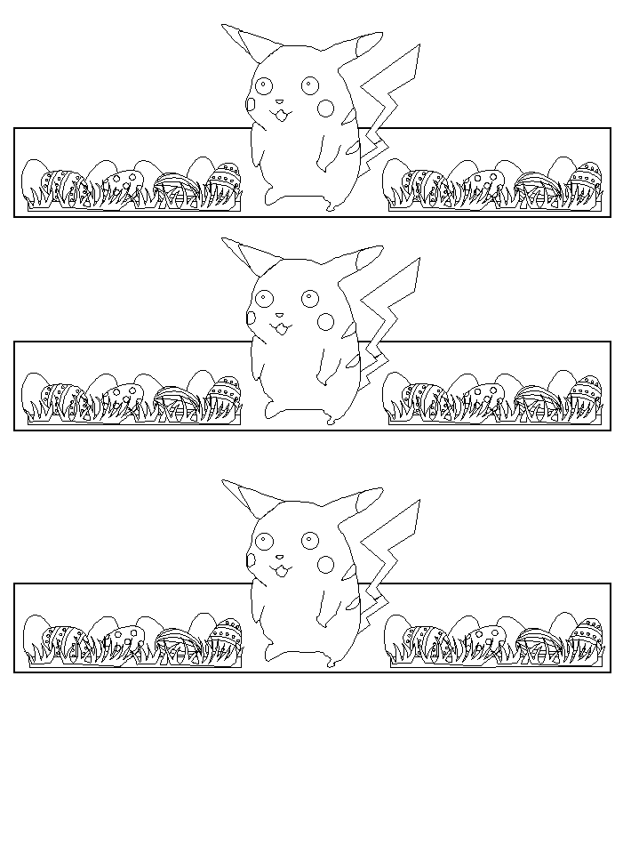

EGG HOLDER TEMPLATES
POKEMON EASTER EGG CUP HOLDERS

EASTER BUNNY BOX TEMPLATES

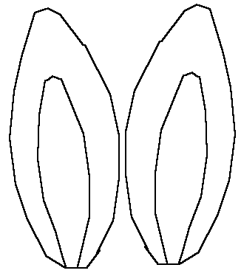

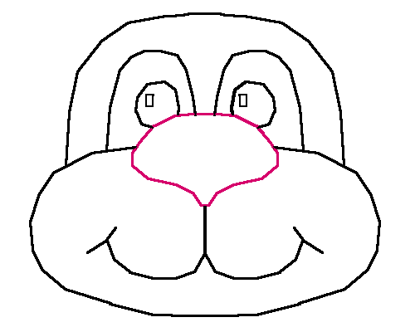

Easter Bunny Basket
Sup d:
Construction Paper
Ruler
Pencil
Scissors
Glue
Cotton Balls
Bunny Face & Ears (pattern below)

Lay your construction paper down flat on a table. The picture to the right shows you the layout of the lines you need to draw here. Try to get the same distance on point A... as you have on point B. (If A is 2"... then B should also be 2"). The Green lines show which lines should be cut. This will create flaps that will fold over. Cut a handle... you can make the length any size you want... I usually keep mine the long length of the construction paper... and about 1 1/2 to 2 inches wide. If I need a shorter handle later, I can cut it down to size.
Fold the one side of the paper up, and then fold over the flap. The next flap can be folded next... here shown as point X and point X on the picture. This is the area where you would add the glue to keep the paper together to form the box.
Fold the handle over ... one on one side, the other on the other side. You can glue the handles onto your box. You can staple them.
You want to glue a tail on your Easter Bunny... depending on the sized box I end up with... a smaller box, a cotton ball is perfect! For larger boxes, I cut out a circle with the white construction paper and glue a few cotton balls to the paper. Glue the tail onto the box.
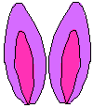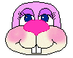
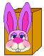
Print the Ears and Bunny Face. One set is in colour... the other set is in black and white so you can colour them yourself. Once you've printed them out, cut them out... glue the ears onto the face. Let this dry just a bit to make sure it is set up good. Once dry to the touch, glue the face onto the box! Fill the Easter Bunny Box with Easter Goodies! ...And whalla... what a nice Easter Treat you've just created!
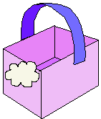
This would look cute as your Easter Dinner's centrepiece, or sitting on a coffee table to help decorate the room! You can even print out an extra set of Easter Bunny's ears and face and glue them to a piece of construction paper and use them as your place mats!
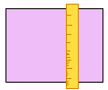
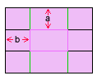
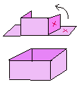
Or glue the Easter Bunny to a Lunch Bag... cute for the kids who carry their lunch to school... or you can fill it with goodies for the kids. Nice size to carry Easter colour books and crayons. ...
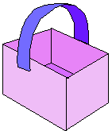
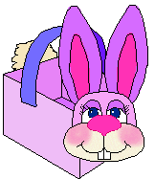
Easter Bunny Cotton Ball Game
EASTER BUNNY COTTONBALL GAME

Supplies Needed:

Scissors
Glue
Cotton Balls
Tape
Bunny Face, Ears & Body (pattern below)

Print the Ears and Bunny Face. One set is in colour... the other set is in black and white so you can colour them yourself. Once you've printed them out, cut them out... glue the ears onto face... then glue the face onto the body. Let this dry... make sure it is set up good.
Cut out the Bunny's tails. On each of the tails place a little bit of glue, and add a cotton ball. Allow this to dry really good before you start to play the game.
When you are ready to play... tape the Easter Bunny to ... our suggestions... door, wall or even the fridge works great. Put a piece of tape on the tails... now you are ready to begin the game.
Shut your eyes really tight... no fair peeking! Try to get the tail as close as you can to the centre... little circle. You can even have points on the different areas of the body... you can even give points if they get the tail on the Easter Bunny's nose...

TEMPLATE FOR EASTER BUNNY COTTONBALL GAME
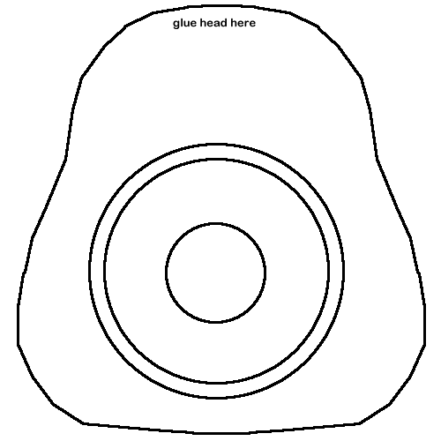
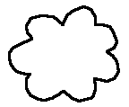
Easter Bunny
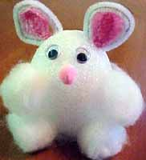
What You Need
- Cotton balls
- Styrofoam egg
- White chenille stem (pipe cleaner)
- Thicker pink chenille stem (pipe cleaner)
- Wiggle eyes
- Small pink pom-pom
- Thin wire
- Wire cutters
- Cardboard
- Scissors
- Glue
- Fabric or lace
How To Make It
- Glue cotton balls on a styrofoam egg for tail and feet.
- Bend white pipe cleaner around a thicker pink pipe cleaner for the ears.
- Add wiggle eyes, a small pink pom-pom nose and thin wire whiskers.
- Place on a cardboard circle with hole cut out for base of egg to rest in. The cardboard can be covered with fabric or lace.

Materials Needed:

EASTER BUNNY BASKET
- Paper Plate
- Crayons
- Stapler
- Glue
- Scrap Construction Paper
- Small Red or Pink Pom-Pom
- Cotton Ball

Instructions:

Fold the paper plate in half and staple the sides - leave it open at the top. Using the scrap construction paper cut out ear shapes and a strip about 12 inches long for a strap. Glue the strap into the opening on the curved side of the plate and glue on the ears to one side of the strap. Glue on the pom-pom for a nose and colour on an eye on each side of the folded plate. Glue the cotton ball on for a tail. Fill with Easter grass and treats!

KNITTED EASTER CRAFTS

EASTER CHICKEN

NO 10 NEEDLES, DOUBLE KNITTING WOOL IN YELLOW, FELT FOR BEAK, RIBBON, WOBBLE EYES, STUFFING, and EASTER EGG

Cast on 20 stitches and knit one row
Knit 16 rows increasing I stitch at beginning of each row till 36 stitches
Cast off 12 stitches at beginning of next 2 rows till 12 stitches
Knit 10 rows
Slip stitches on to wool and pull tight
Sew up
Pad head with stuffing
Glue on eyes and beak
Tie ribbon round next
Add egg into body

EASTER BUNNY

No 10 needles, white or light grey double knitting wool, mini pink pom pom, white pom pom, googly eyes, glue

Body

Cast on 11stitiches
Knit one row increasing one stitch into every stitch 22 stitches
Knit 22 rows
Next row knit 5.knit 2 tog, (6 times) knit 5 (20stitiches)
Knit 2 rows
Next row knit 6 Inc in next 4 stitches. Knit 6 (20 stitches)
Knit 8 rows
Next row knit 2 tog till end (11 stitches)
Knit a row back
Lace remaining stitches through a darning needle and sew up seam

Ears

Cast on 4 stitches
Knit 8 rows
Knit 1. Knit 2 tog, knit 1 (3 stitches)
Knit 3 rows
Knit 1, knit 2 tog
Knit 1 row
Knit 2 tog
Sew end into ear/ sew ears on

To make up stuff cotton wool into the head and tie ribbon round neck and stick on eyes and pom pom for tail and nose, then insert cream egg
Marshmallow Rabbit
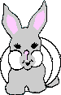
This project is rated VERY EASY to do.
What You Need
- Front and back rabbit patterns
- Card stock
- Crayons
- 1 large marshmallow
- 1 cotton ball
- Glue
- Scissors
How To Make It
- Print out the pattern.
- Glue the pattern onto card stock.
- Color the rabbit parts and cut out.
- Lay the front rabbit pattern face down and apply glue to the back. Set the marshmallow in the glue. Apply more glue to the marshmallow and set the back of the rabbit onto the glue. Apply a little more glue on the back of the rabbit and put on the cotton tail. Let dry.
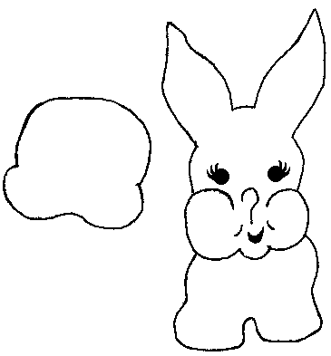
Easter Chick Card
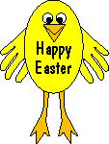

What You Need
- Yellow and orange construction paper (foam board can also be used for a more durable product)
- glue
- 2 small wiggle eyes
- 2 paper fasteners
- a pencil
- scissors
- a child's hands
How To Make It
- Trace your child's hands on the yellow paper; these will serve as the chicks wings.
- Cut an oval or egg shape out of the yellow paper. The size should be about 1/3 larger than your child's hands to be in scale with the wings.
- Fasten the wings onto the oval body with the paper fasteners.
- Use the orange paper to make the beak and legs. The beak should be shaped as a diamond, bend it in the middle and only glue the bottom half to the oval portion of the chick.
- Glue on the eyes.
- For the feet, make long thin legs with 3 pointy toes. Glue the legs to the back side of the chick and write a message on its body.
- Happy Easter!!

Cotton Ball Chick
Use these cute chicks to decorate an Easter Basket or table decoration.
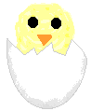
What You Need
- 2 yellow cotton balls (see tips)
- 1/2 of a clean egg shell or cup from egg carton
- Black construction paper
- Orange construction paper
- Scissors
- Hole punch
- Glue
How To Make It
- Use the hole punch to make eyes out of black construction paper.
- Cut a small square from orange construction paper and fold it in half to form a triangle for the beak.
- Glue one cotton ball into the bottom of the egg shell. Glue the other cotton ball on top for the head.
- Glue on the two eyes and beak.
- You're done!

Bunny Face Cloths

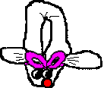
Material

Face cloth
Elastic band
Ribbon
2 goggle eyes
Easter egg
Small pom pom

Take a face cloth and roll it up from tip to tip till you form a long sausage

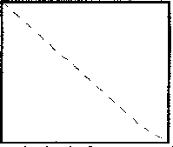

Fold in half lengthwise then fold back the tip ends 2/3 of way back
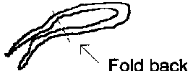
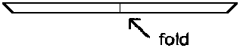

Using an elastic band secure the head which is the front half of the folded out section

Add ribbon over the band to hide it and tie a bow

Stick on goggle eyes and small pom pom for the tail

Pop an egg in the middle of the rabbit

Sitting Fun Foam Easter Bunny Craft

FUNKY FOAM BUNNY

What you will need: Fun Foam, fun foam flower shapes, stapler, glue, markers
What to do:
- Print out the pattern page.
- Use the patterns to cut the shapes from fun foam.
- Staple the body shape together to make a cone shape. Use markers to draw on toes and hands onto the feet and arm pieces. Glue them onto the body.
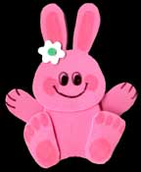
- Draw the face onto the bunny’s head. Glue a flower and circle shape onto the bottom of the bunny’s ear. Glue the head onto the bunny.
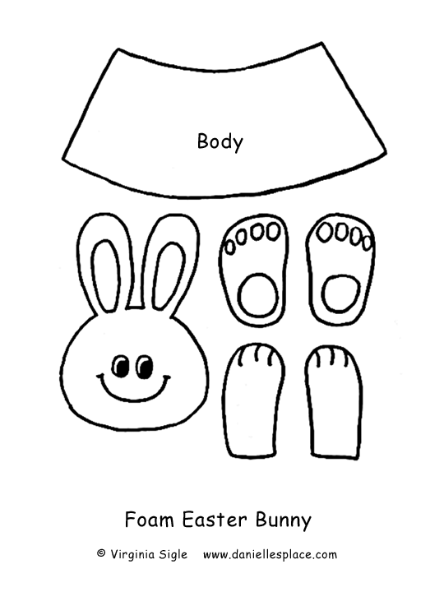

Funky foam bunny template
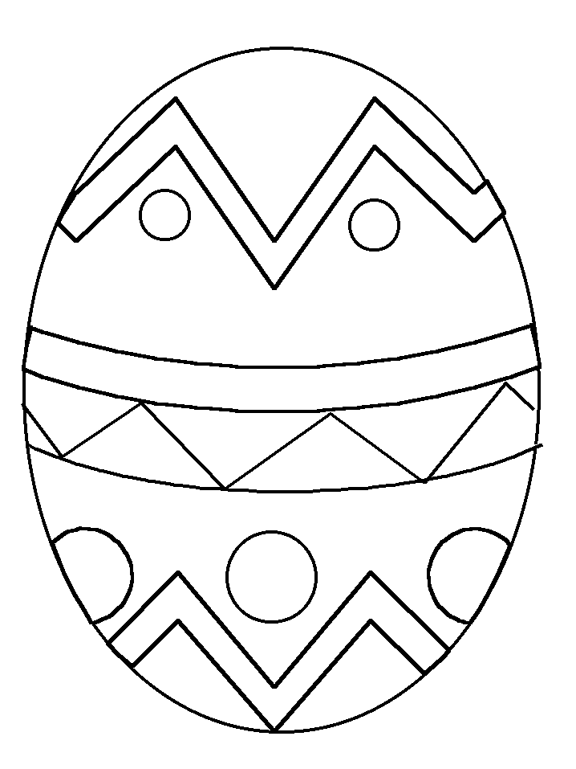

Large Easter egg colouring page
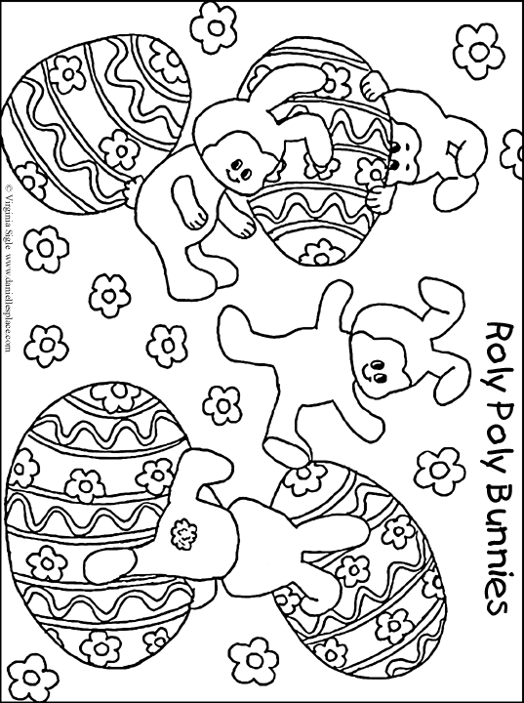
Roly Poly Bunny colour in picture
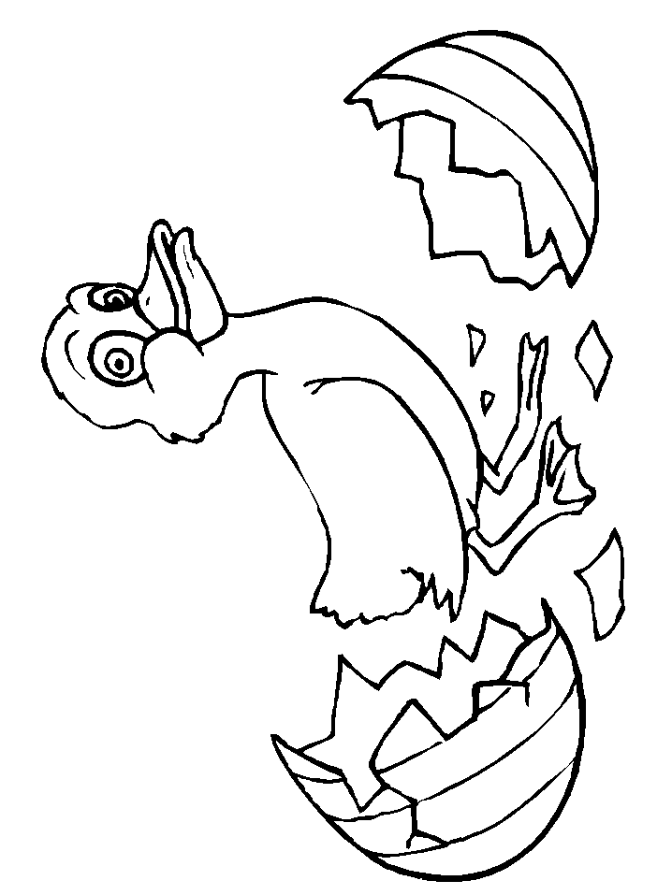
Duck in egg colour in picture

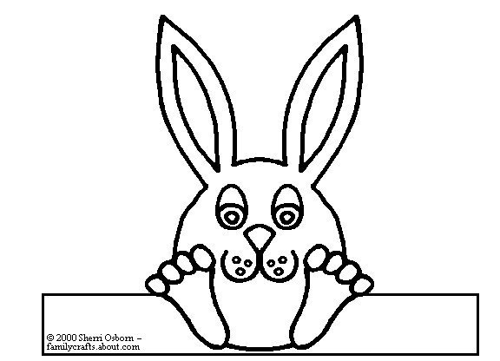
Easter cup holders

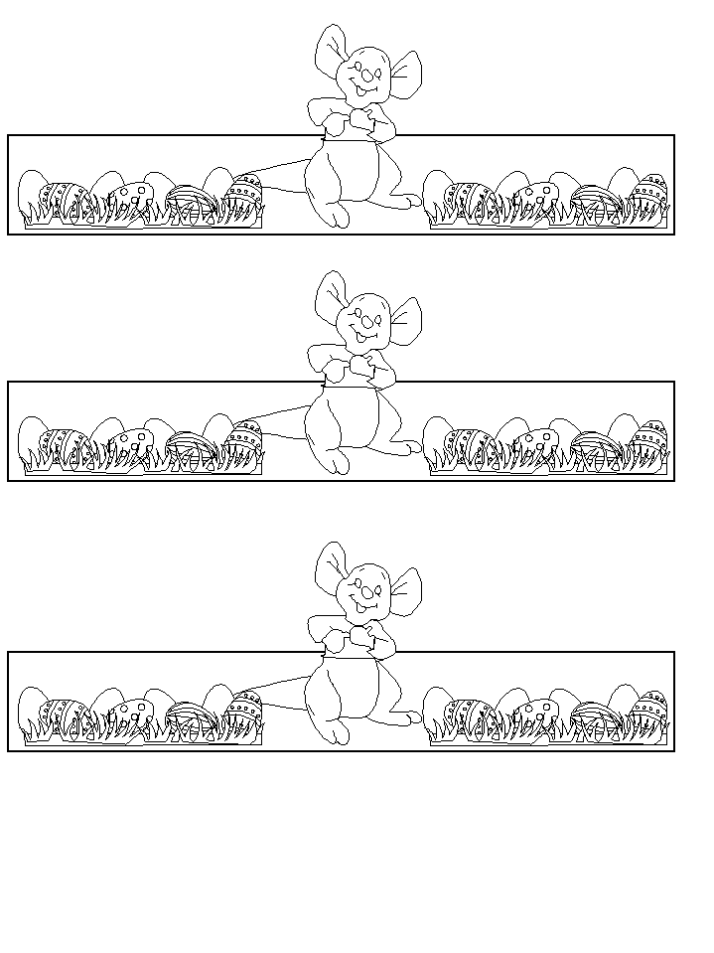
Roo egg cup holder
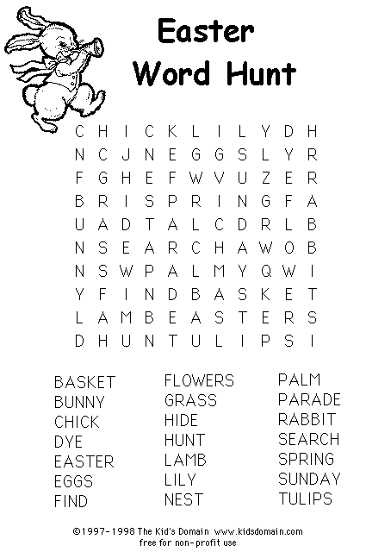
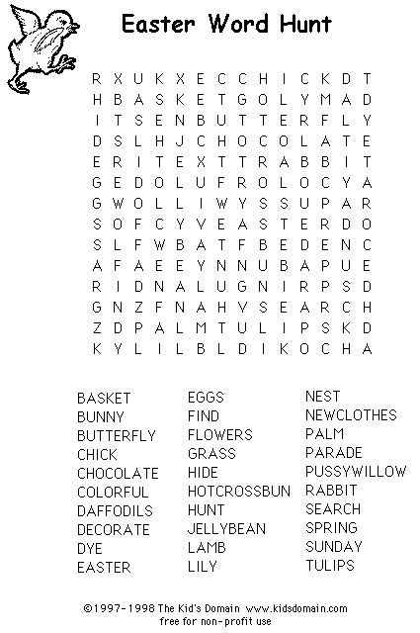
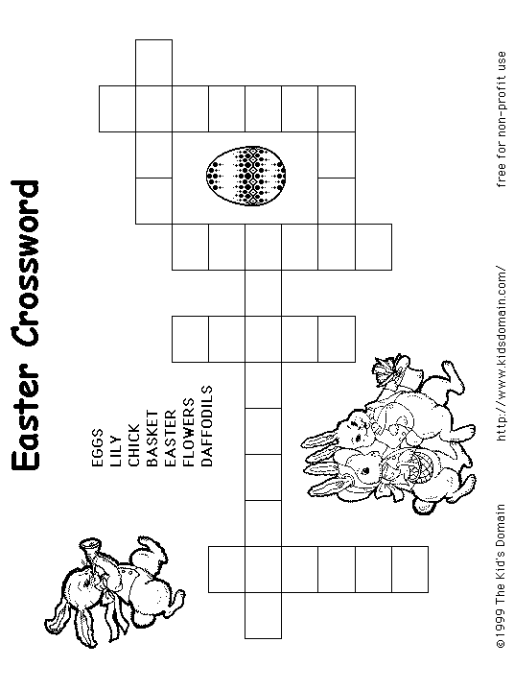
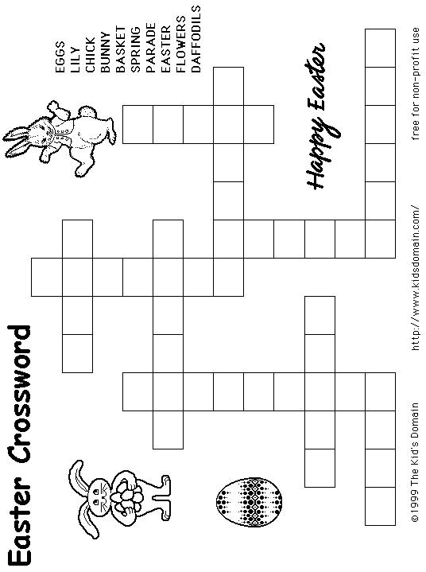
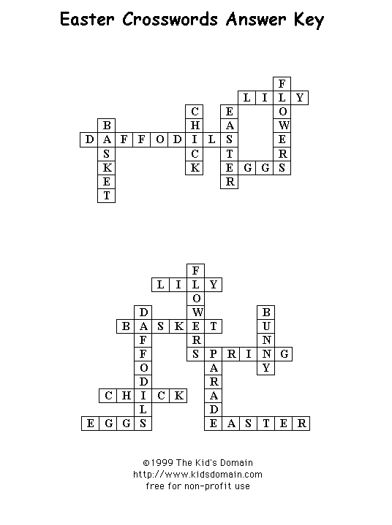
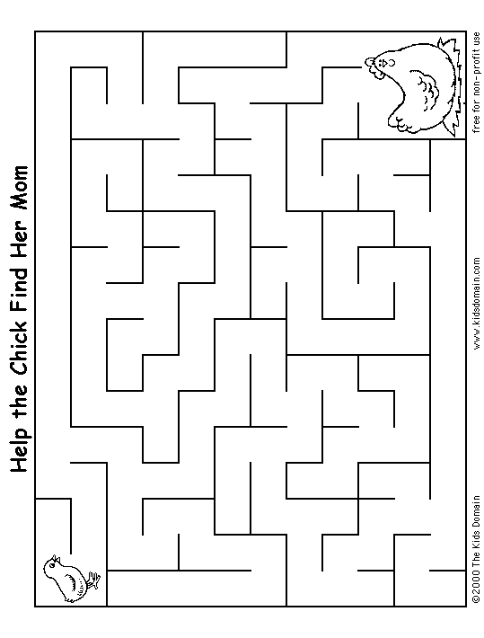
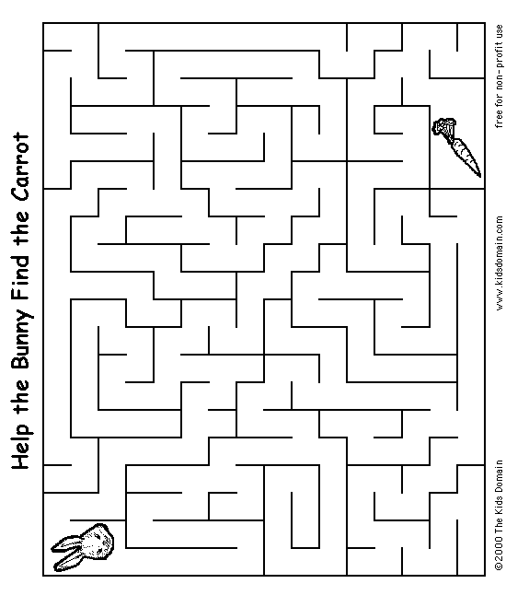
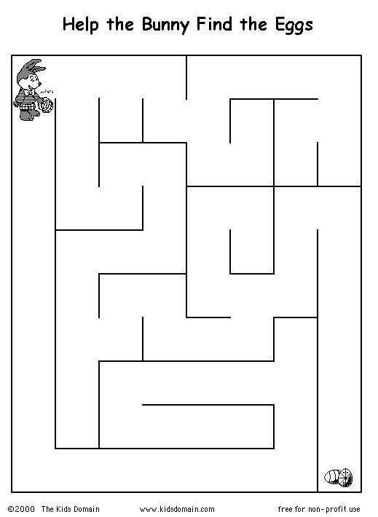
Web Pages

Colouring pages

http://www.coloring.ws/easter.htm

http://www.primarygames.com/holidays/easter/easter.htm

http://coloringbookfun.com/index.html

Printable

print a bunny mask

http://www.randomhouse.com/kids/bunny/

Easter mazes and puzzles

http://www.geocities.com/Heartland/7134/Easter/ffuneaster.htm

Easter crafts and activities

http://www.dltk-kids.com/crafts/easter/index.html

http://www.billybear4kids.com/holidays/easter/fun.htm

http://www.disney.co.uk/DisneyOnline/Easter/

http://www.night.net/easter/

http://www.heathersholidaze.com/index.html

http://www.freekidscrafts.com/holiday_crafts.htm

