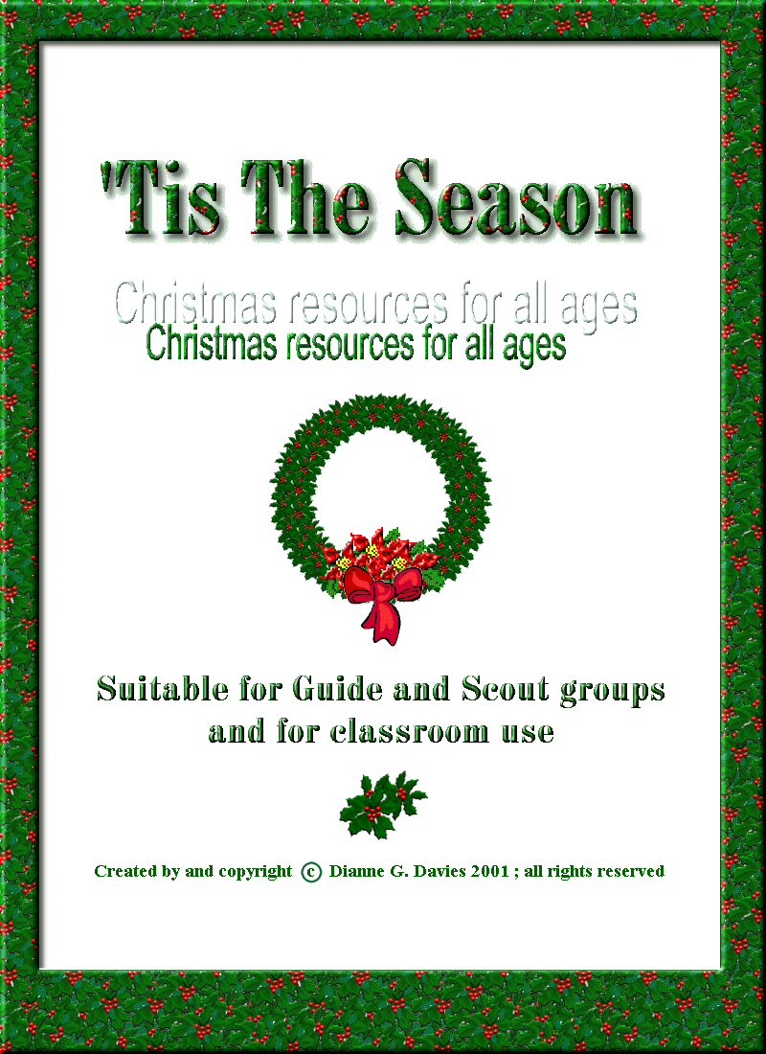
Index of Resources

Crafts
Advent Crown ……………………………………………………………. 2
Christmas Boxes…………………………………………………………. 3
Christmas Crackers…………………………………………………….… 4
Pomanders………………………………………………….……………. 4
Door wreath ……………………………………………………………… 5
Christmas cards ……………………………………….………………… 6
Plastic “canvas” decorations…………………………………………… 8

Snowflake mobile ………………………………………………………. 10

Assorted Templates……………………………………………………...12

Word Searches and Puzzles etc.

Christmas wordsearches ……………………………………………..... 16
Mazes ……………………………………………………………………. 19
Crosswords ………..……………………………………………………... 21
Dot-to-dot pictures ………………………………………………………. 25
Spot-the-difference/colouring pictures ……………………………… 29

Games
Rudolph’s Reindeer Game …………………………………………….. 31
Snowball Fight………………………………………………………….… 32
Ice Floes …………………………………………………………………. 33

Recipes
No-cook sweets…………………………………………………..……… 35
Quick Christmas cake…………………………………………………… 36
Fruit Punch……………………………………………………………….. 36
Spice Biscuits …………………………………………………………… 37
Gingerbread …………………………………………………………….. 37

Songs
The tunes to all these songs can be found on the “Singing Snowmen” website : http://www.geocities.com/singingsnowmen
It’s beginning to look a lot like Christmas……………………………. 39
Silver Bells………………………………………………………………. 40
Rocking around the Christmas tree…………………………………… 41 Walking in a Winter Wonderland……………………………………… 42
Frosty the snowman……………………………………………………. 43
Santa Claus is coming to town ……………………………………….. 44

Stories / Readings
The Christmas Spider …………………………………………………. 45
Love came down at Christmas………………………………………… 46
The Littlest Christmas Tree ……………………………………………. 47

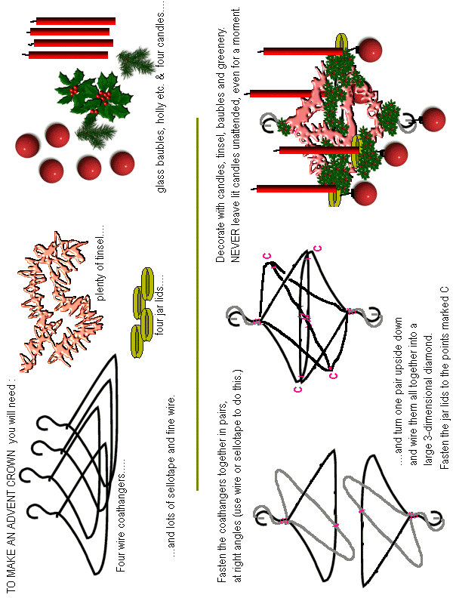
Advent Crown
(as pioneered by Blue Peter, MANY years ago……)

Gift Boxes

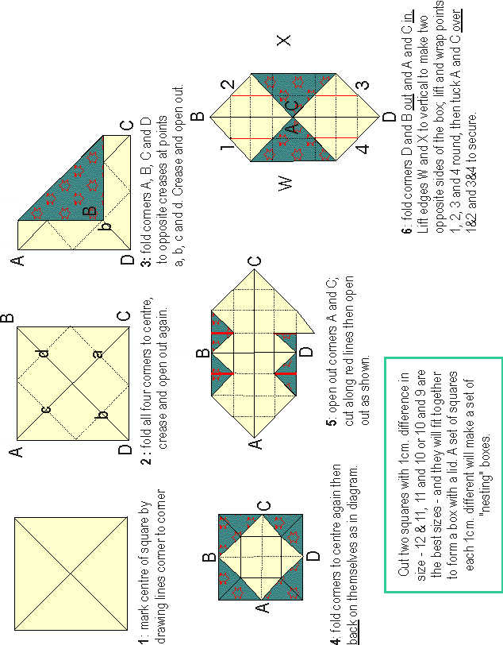
(Using recycled greetings cards)

Christmas Crackers
All you need to make your own crackers is empty toilet roll tubes, paper, thread and glue,
plus something to put in them and something to decorate them with.

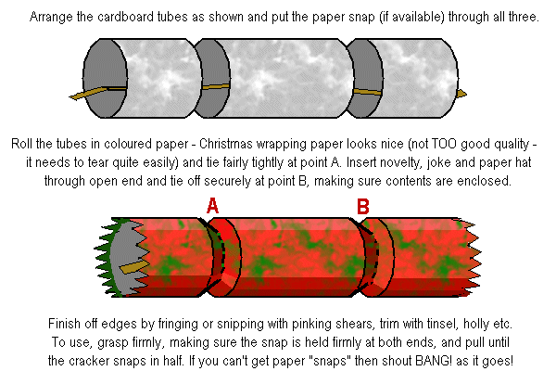

Pomanders
Pomanders were once carried around on the person, either on a stick or hung around the neck, to ward off the noxious smells of the streets in pre-sanitation days. We can now use these delightful-smelling objects to decorate our homes and Christmas trees. For best results, make your pomanders at least a month before Christmas. When you have studded the surface of the orange with cloves, place it in a PAPER bag and add a generous handful of powdered orris root or, if you can't get that, talcum powder (the weaker the scent the better - baby powder is probably best.) Screw the neck of the bag up and give it all a good shake, and place in a WARM, DRY place such as the airing cupboard for at least a month or until the orange has shrivelled, dried and shrunk.
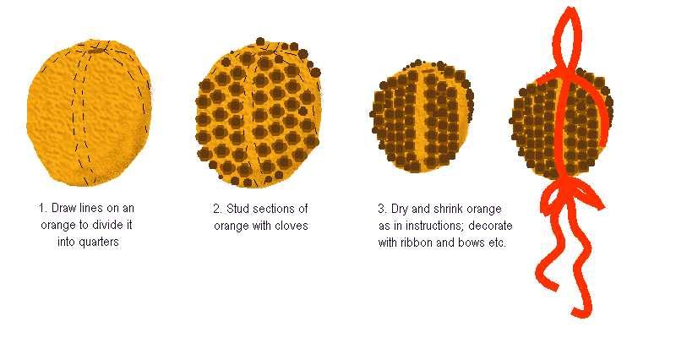
Weather-proof Door Wreath

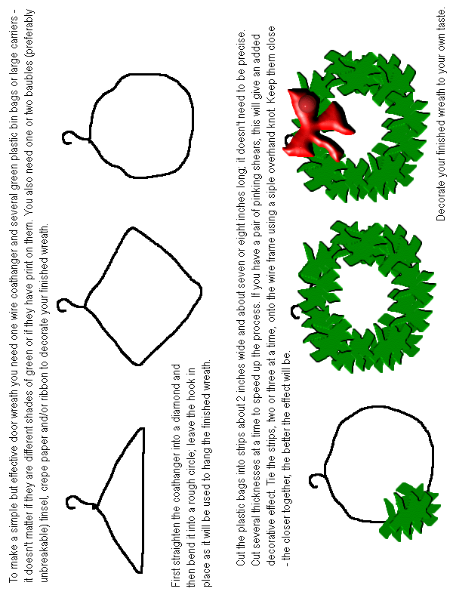

Christmas Card 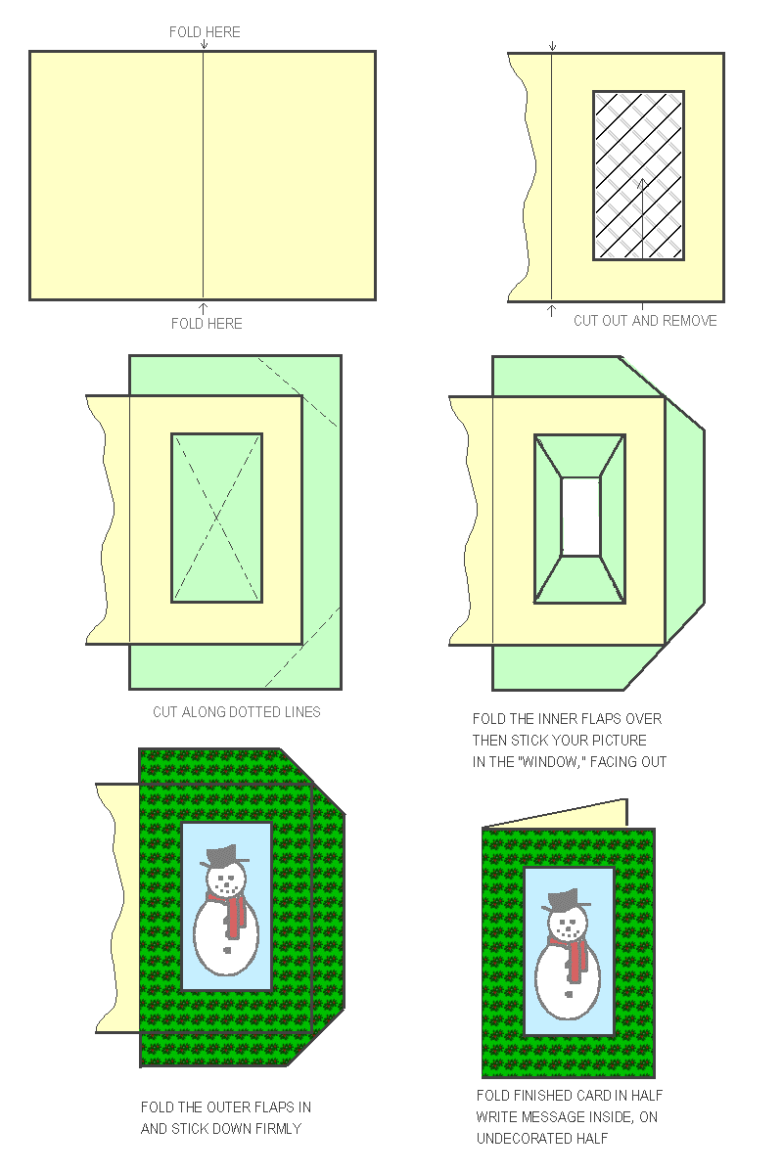
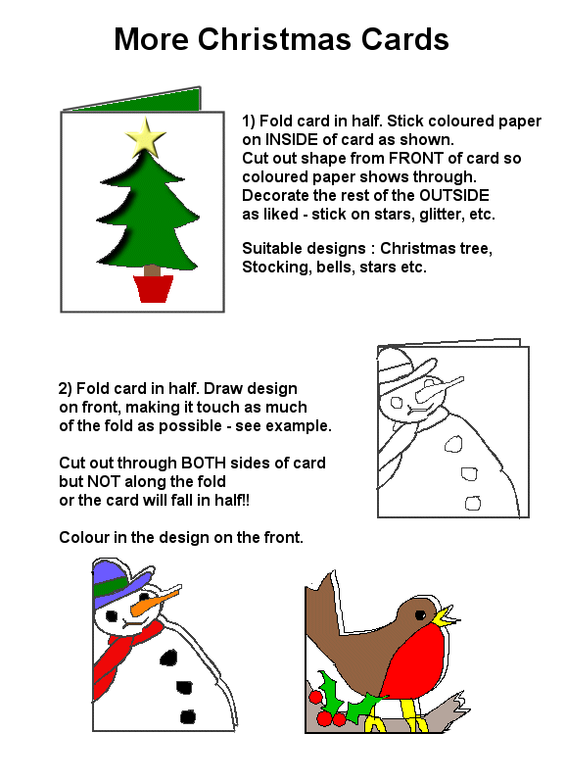
Using “Plastic Canvas”

Plastic craft grid, or plastic “canvas,” is readily available at most craft suppliers and is inexpensive to buy, easy to use, and an ideal medium for Guides of all ages, from the smallest Rainbows to the Senior Section – and beyond.

All the designs in this booklet are meant to be worked in cross-stitch or half cross-stitch, using wool of the appropriate colours. For younger girls it is probably easiest to stiffen the end of the wool with sellotape or glue (leaving it to harden first) rather than spend your whole time re-threading needles!) but older girls who are capable of a) keeping the wool in the needle and b) re-threading the needles themselves if they don’t, will probably prefer to use tapestry needles.

Once you have chosen your design (or made your own design) cut a piece of plastic canvas slightly larger than the finished design – the canvas cuts easily with ordinary scissors. Make sure you count the bars of the canvas, not the holes – the cross-stitches are worked over the intersections of the bars of the grid. Leaving an extra couple of bars on all four sides allows for miscalculations…..


If using thick wool, half-cross-stitch (see left) will probably work OK, and will certainly be much quicker – if the grid is filled in when you’ve worked the stitches in one direction there’s no need to go over them again the other way!

If your wool is thinner, however, you may need to do a full cross-stitch : stitch the first row diagonally across the intersections of the canvas grid as shown (depending on the age and dexterity of the girls, you may want to do the colour blocks completely all in one direction, or row by row.) If the grid is not sufficiently filled in, then work a second row of diagonal stitches, with the stitches lying in the opposite direction so the threads form a cross (see diagrams to the right.) It’s easier than it looks and the best way to learn how is by doing it.

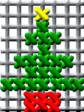
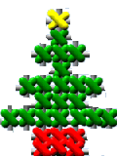
Once you have completed your design you can either fill the background in with a contrasting colour or trim away the excess plastic grid. If you decide to cut the shape out, DON’T cut too close to the stitches or they will come undone - leave enough plastic to support the stitches (if in any doubt, or if the stitches are particularly loose as they may be of done by younger girls, don’t cut it out.)

These designs, when finished, make effective Christmas tree decorations – simply add a loop of wool to the top to hang them by.

If the girls want to make their own designs, simply provide them with squared paper and felt-tip pens!
Christmas Designs for Plastic “Canvas”
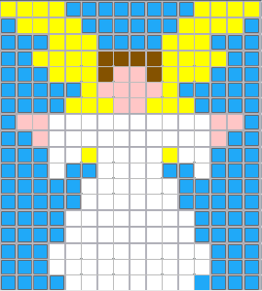 | 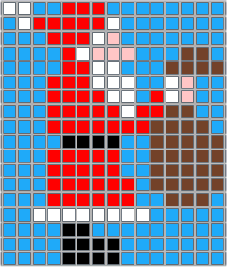
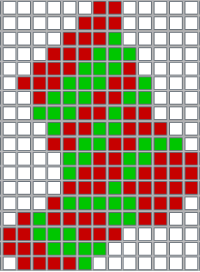 | 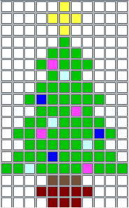
 | 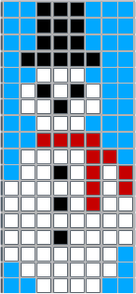

Basic Cut-out Snowflake

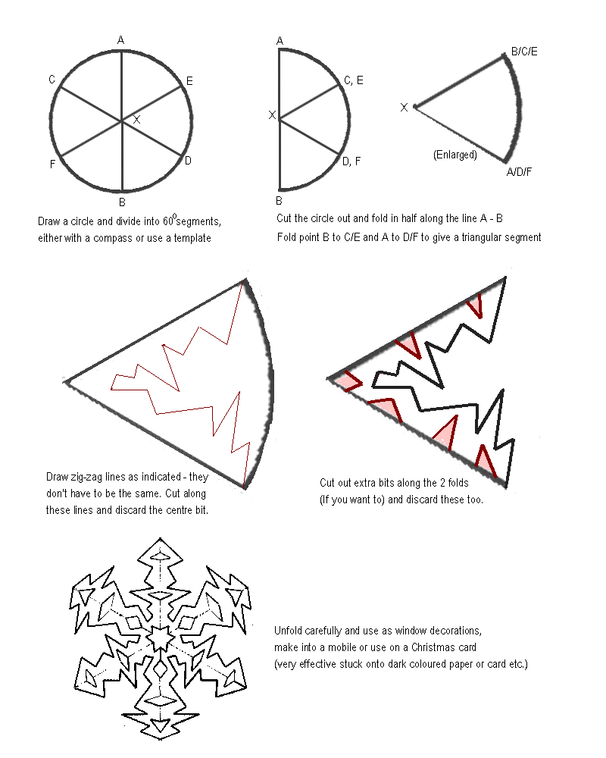

Snowflake Mobile
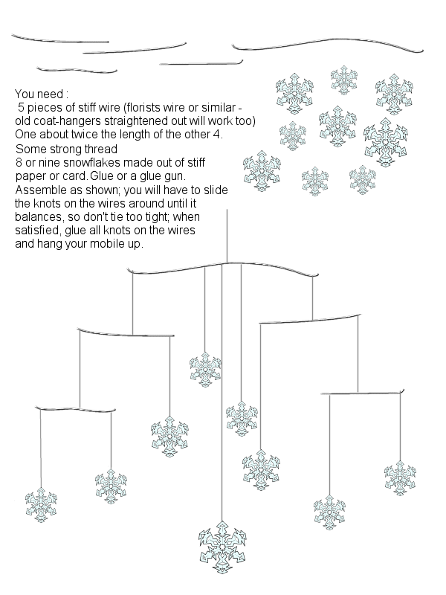

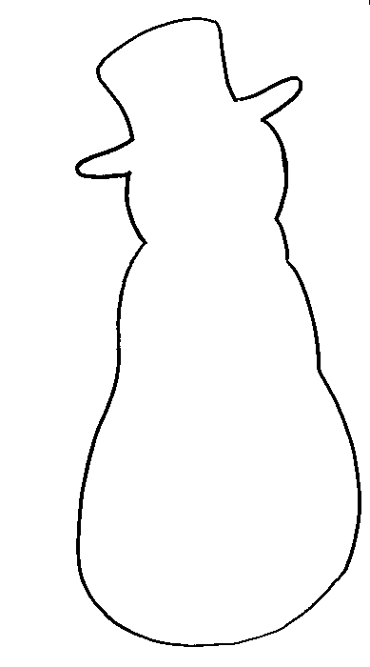
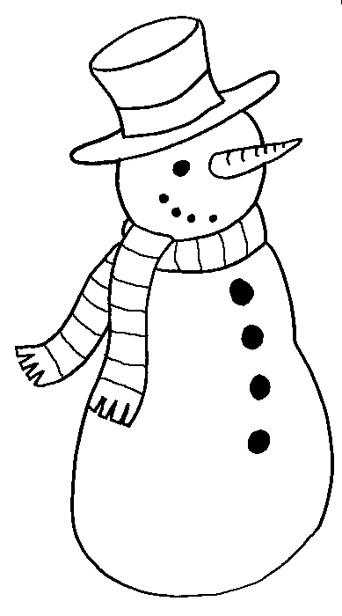
Snowman Templates

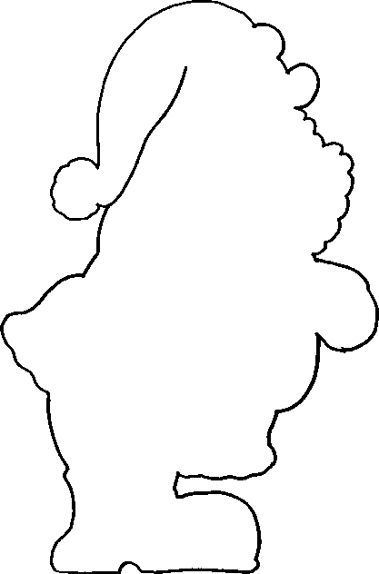
Santa Templates

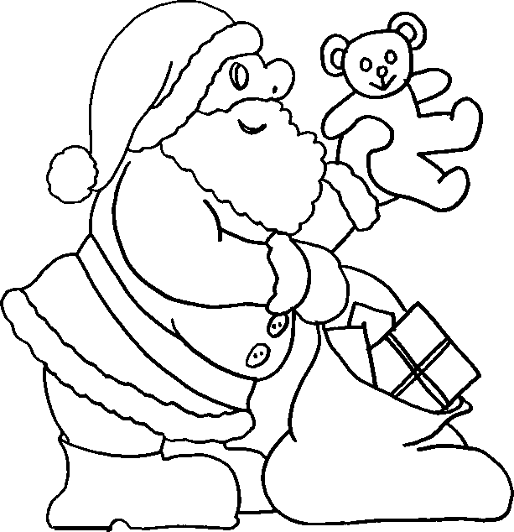

Christmas Tree templates
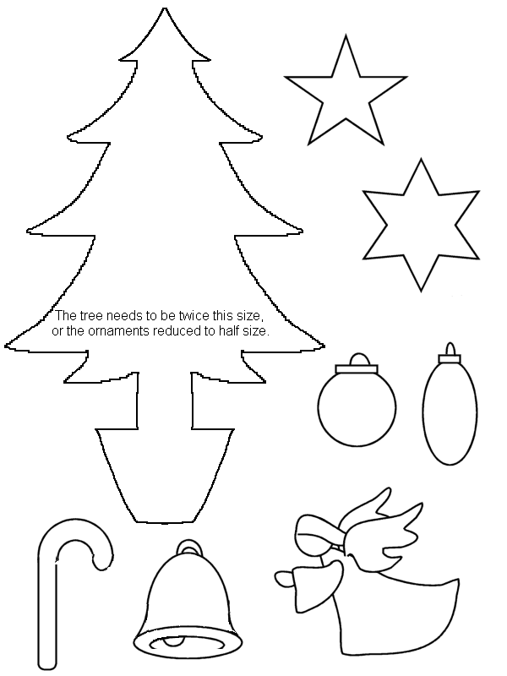
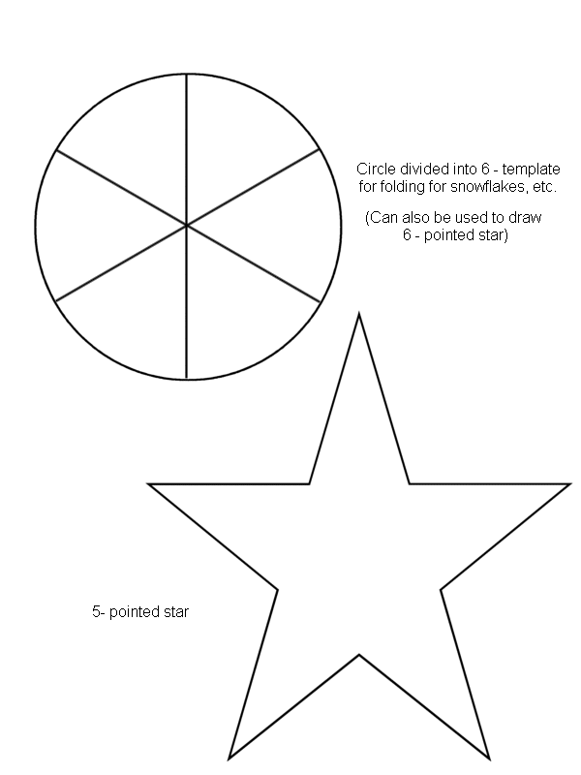
Miscellaneous templates

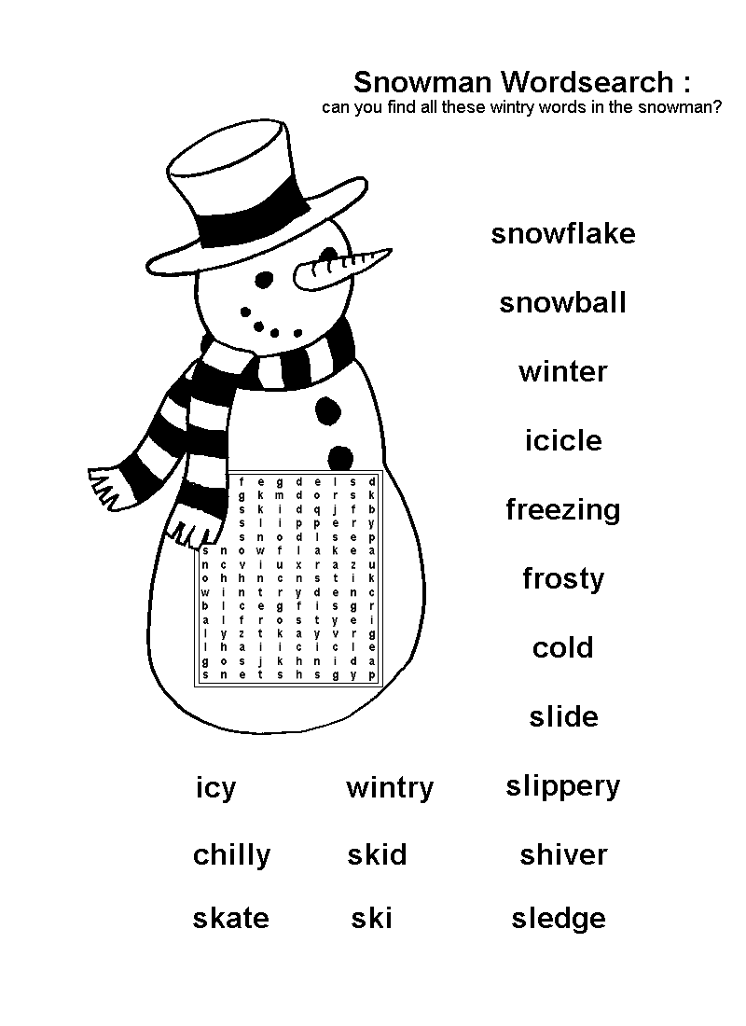
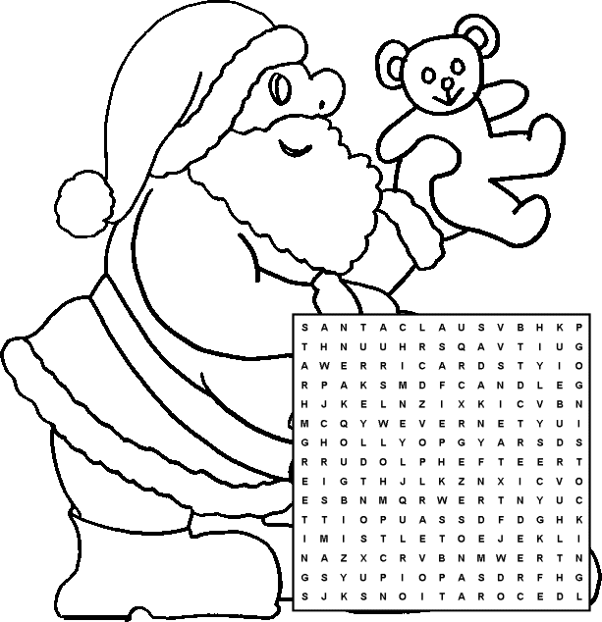
DECORATIONS  PUDDING  TURKEY  REINDEER  STAR  CHRISTMAS  MISTLETOE | SANTA CLAUS  TREE  HOLLY  GREETINGS  IVY  CARDS | CHIMNEY  CANDLE  STOCKING  CRACKER  PRESENT  RUDOLPH  TOY

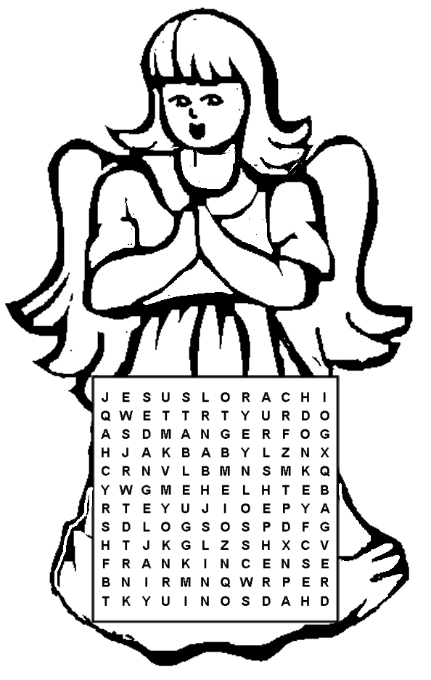

JESUS  MARY  JOSEPH  BETHLEHEM  MANGER  BABY | SHEPHERD  ANGEL  FRANKINCENSE  GOLD  MYRRH  DONKEY | KINGS  STAR  INN  STABLE  CAROL
Christmas Maze #1 (Easy!)

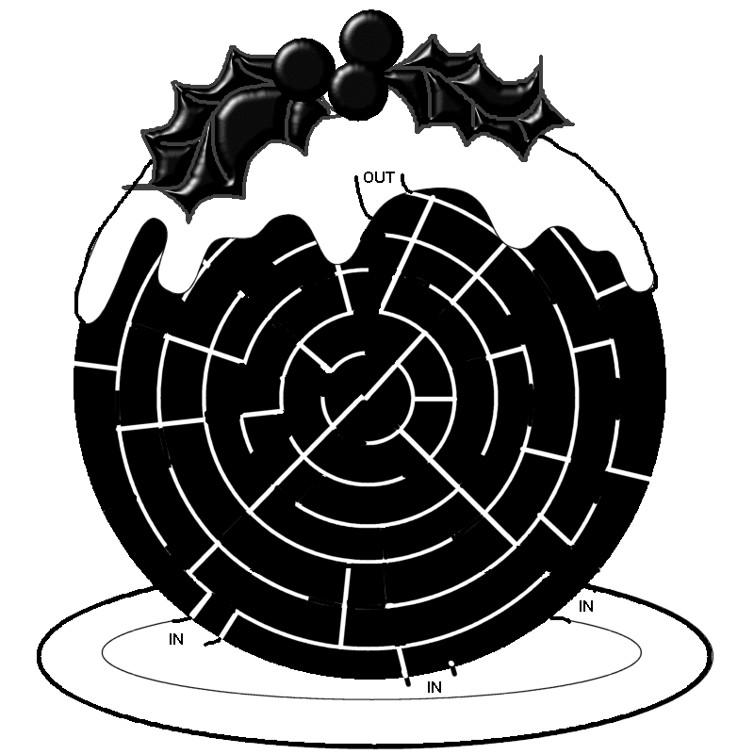

Can you get through the pudding, from the plate to the holly?
Christmas Maze #2 (a bit harder!)
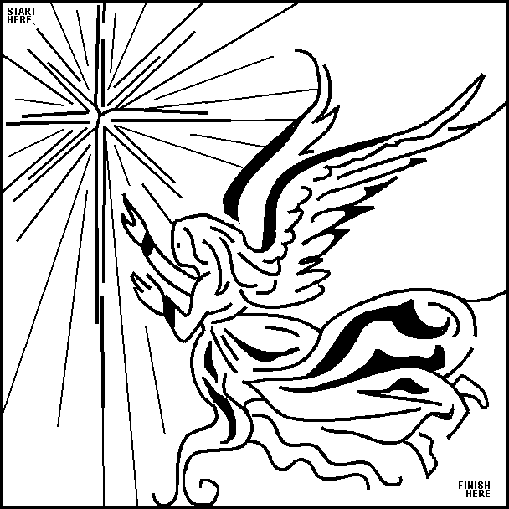

Christmas Crossword #1

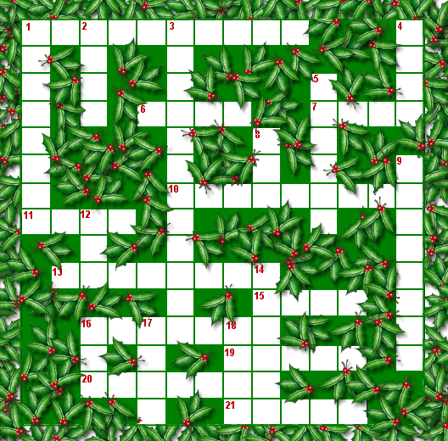
Clues
Across  1. He comes to give you presents.  6. What you do when you stir the pudding mix.  7. The top of the cake is this  10. You are supposed to kiss under this.  11. Another word for “present.”  13. Santa brings you them.  15. It gives light.  16. A strong-smelling substance.  19. When it gets dark, it is ….  20. To burn on the fire at Christmas.  21. The colour of Santa’s beard. | Down  1. You hang it up on Christmas Eve.  2. Another word for “Christmas.”  3. December 24th  4. In winter it is usually this.  5. You hang it on the tree.  8. It keeps your head warm.  9. They pull Santa’s sleigh.  12. The real name for a Christmas tree.  14. Pulled by Rudolph and his friends.  16. The holly and the …  17. Don’t catch one of these for Christmas!  18. We all hope it does this for Christmas!

Answers on next page :

Answers to crossword #1

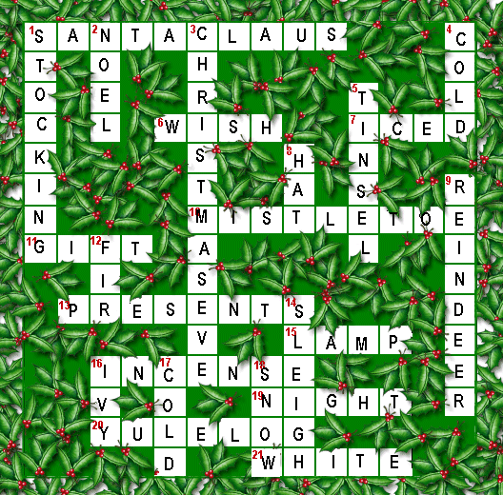
Christmas crossword #2

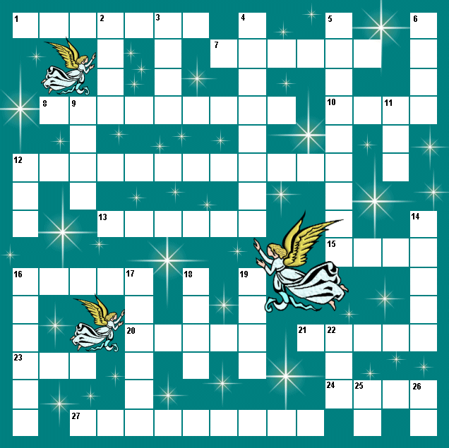
Clues :
Across :  1. They were waiting for him when Jesus was born.  7. Jesus was put in one of these.  8. Jesus’ birthday.  10. “Silent Night, ------------ Night” (carol)  12. One of the gifts brought by the three Kings.  13. “Thus spake the ----------------- “ (carol)  15. Jesus’ mother  16. The baby whose birth we celebrate at Christmas  20. A heavenly messenger  21. The act of being born  23. Female sheep  24. “The first ------------- “ (carol)  27. They were the first to be told of Jesus’ birth | Down:  2. The Kings followed one.  3. A long time  4. Where Mary and Joseph lived  5. The town where Jesus was born  6. An infant  9. “Do you ----------- what I -----------?” (carol)  11. What cattle do!  14. One of the gifts the kings brought to the baby Jesus  16. Mary’s husband  17. Jesus was born in one.  18. Another name for the Kings  19. Something which rings  22. There was no room at it  25. One of the animals traditionally in the stable  26. “---- and behold.”
Christmas Crossword #2 – answers

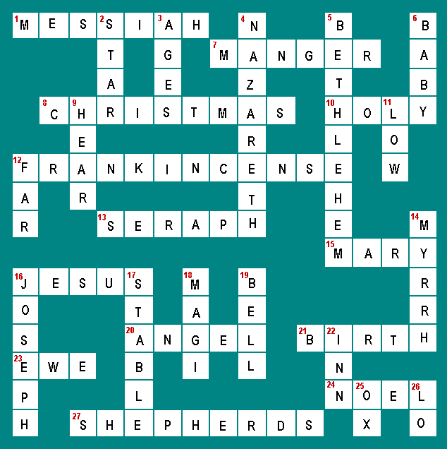
Christmas dot-to-dot #1

Join the dots to see what is here!

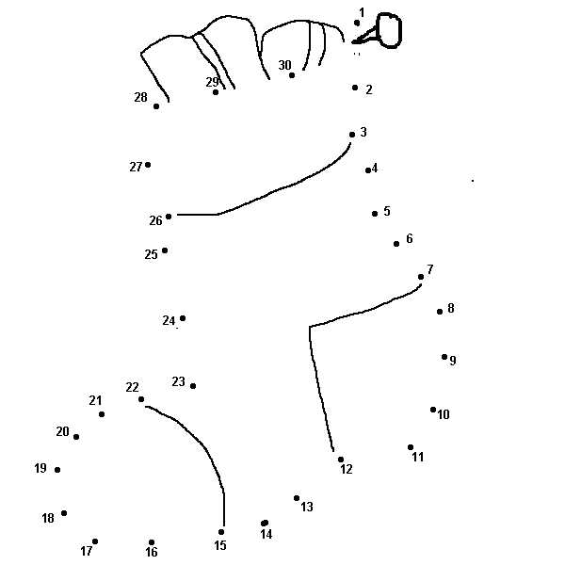
Christmas dot-to-dot #2

Join the dots to finish the picture….

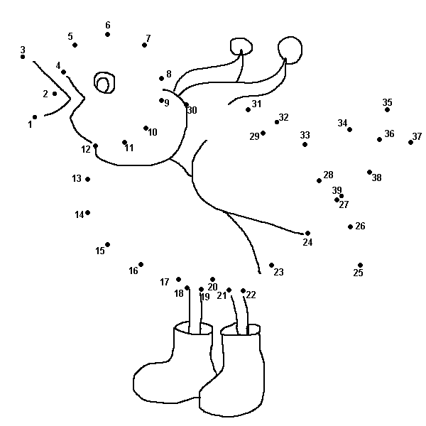

Dot-to-dot Christmas Tree

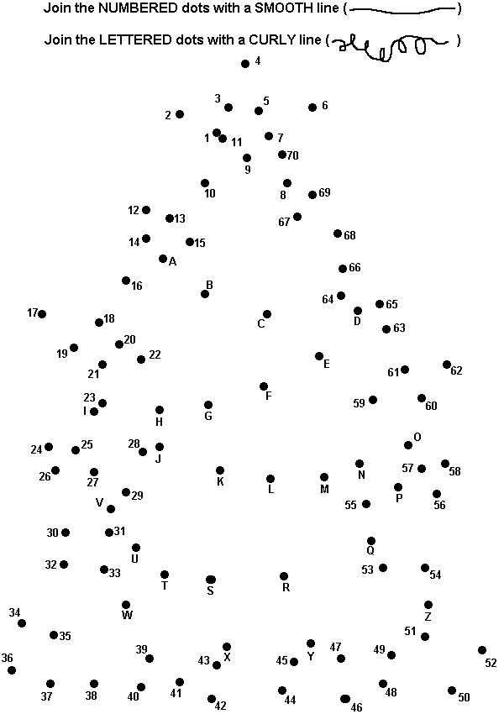
Dot-to-dot : Santa’s Sack
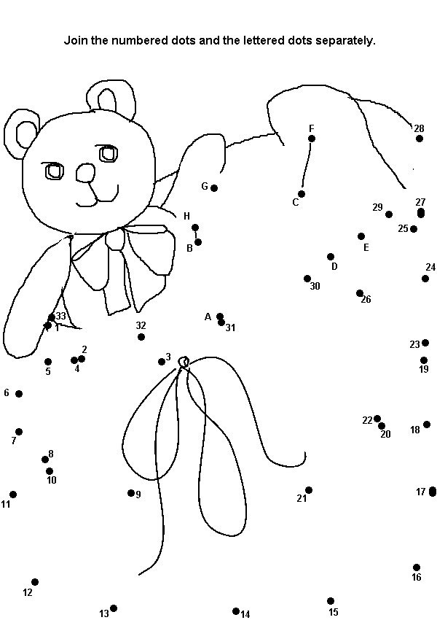
Spot the differences
There are ten differences between these two pictures – can you find them all? (You can colour the pictures in when you’ve found them all.)

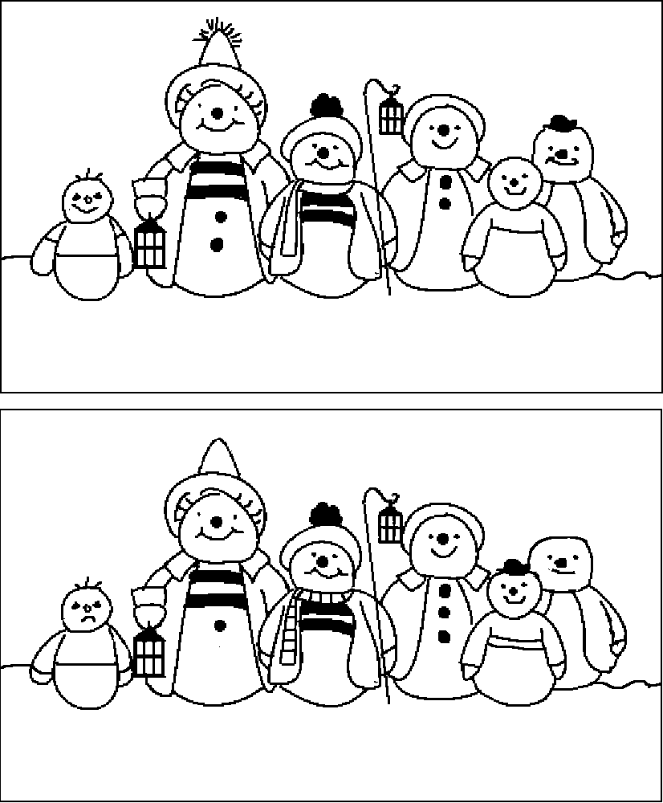

Spot the differences
There are fifteen differences between these two pictures – can you find them all? (You can colour the pictures in when you’ve found them.)

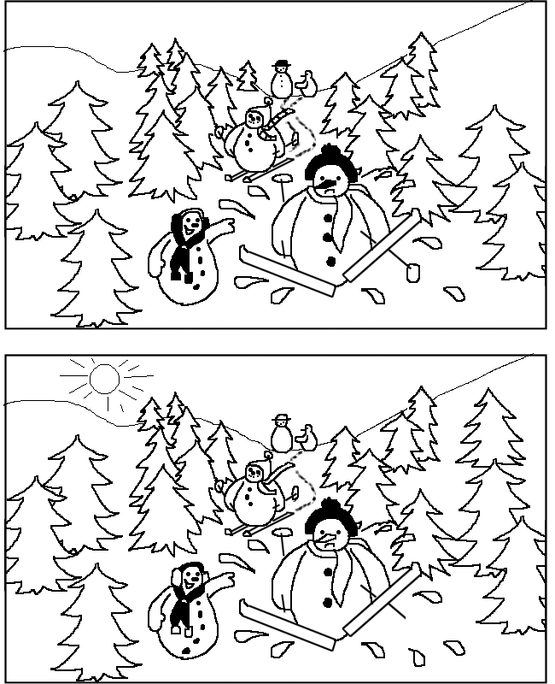

Rudolph’s Reindeer Game

Remember the line in the song where “They wouldn’t let poor Rudolph join in any reindeer games?” Well, here’s a game EVERYONE can join in!!

All you need is a large group of willing players and plenty of space – ideal for the average Guide Hut, Village or Church Hall.

EQUIPMENT NEEDED : one large plastic hoop (or similar) per group/patrol/six. LOTS of “toys” or toy substitutes – bean bags, small balls, quoits – ANYTHING – you could even use potatoes at a push!

TO PLAY : Divide the players into teams of “reindeer” – either into sixes, patrols or random groups, all with the same number of players in the team if possible. Each team has to have a “sack” for the “toys” – this is where you place the hoops in the corners of the room and possibly midway down the long sides if your hall is the typical rectangle and you have six teams. Share the toys put equally between all the sacks – it doesn’t matter who gets what, because it isn’t going to stay like that for long!

The teams of reindeer have to steal “toys” from the other reindeers’ “sacks” – one at a time, and from all the other team’s “sacks,” and place them back in their own team’s “sack.” Start on a whistle or call “GO!” and play for a set length of time. The winning team is the one which has the most “toys” in their sack at the end of the playing period.

RULES : Only one “toy” to be taken on each raid, and only one “sack” to be raided – stolen goods must be returned to the team’s home sack before going for another “toy.”
No individual member of a team can take from the same sack in consecutive raids – they must go for another sack (this stops teams from simply raiding the ones nearest them.
No defending your sack or obstructing other players!
You can “steal back” toys but only once they have been placed in a sack.
Toys which don’t stay in the sack (e.g bounce out, miss if thrown) have to be retrieved and placed in the sack by the person who threw them /missed the sack – it is best to place them in, not throw them, as otherwise time is wasted getting them back!

WARNING : this gets very noisy and chaotic, so don’t play for too long, and have plenty of adults and/or YLs on hand to supervise/referee!

Snowball Fight!

Divide the girls into two teams and provide each team with a pile of newspapers, preferably tabloid size. (NOTE – count the pages first – each team needs the same number of pages) and a couple of buckets, boxes or similar containers (these don’t necessarily need to be the same size.)

Mark off a line at each end of the hall a short distance away from the back wall, or you could consider letting the teams build a barricade of chairs etc., it all depends on your particular circumstances. Send the teams to the opposite ends of the hall with their newspapers and buckets.

On a given signal, the teams should begin to prepare their ammunition : tear the tabloid sheets (Express, Mail, Sun – that sort of size) into two separate pages (broadsheets eg. the Guardian, Times etc.. are better torn in 4 pieces) and crumple each sheet tightly to form a “snowball,” and place in one of the buckets or boxes for use.

When all the newspapers (give them plenty!) are turned into snowballs, the teams can commence firing at their opponents. They can use any snowballs which come in from the opposing team, but these MUST cross their defence line, they can’t go out and retrieve any shortfalls. They also can’t start to fire back until they have made all their newspapers into snowballs themselves.

Play until the point of boredom, or time runs out, or for a set length of time : if you must have a winner, the losing team is the one which, when the final whistle blows, has the MOST snowballs behind its lines. (They will soon realise it pays to make their snowballs well in the first place, as they will fly further and better and can be aimed more accurately. )

“Ice Floe” Games

A simple seasonal variant on “Musical Chairs.”

EQUIPMENT : sheets of newspaper – one fewer than the number of people playing the game.
Music – something suitably wintry or Christmassy, either live (eg. a pianist) or on tape / CD, plus the means to play it.

You need at least two people to supervise and preferably more, one to take charge of the music and one to supervise the game.

Spread the sheets of paper, opened out, all round the floor , as widely spaced as possible. Play as in any other “musical chairs / mats” game : the players move round to the music while it is playing; when it stops they must stand on the nearest sheet of newspaper (only one “penguin” per “ice floe!”) The person without an ice floe is out and can help referee, especially in the later stages of the game.

When the music starts again, remove one sheet and then everyone has to fold or tear their sheet of paper in half and lay it out flat again, then continue as before, the “ice floes” shrinking and the numbers decreasing each round. As the “floes” get smaller and smaller, be very strict – any penguin which falls off its ice floe before the music restarts is also out (remove an extra sheet for each person out.)

The winner, obviously, is the last one left on an ice-floe!

A team ice-floe game :

Again, issue newspaper “ice floes, ” this time one per patrol or six. At a given signal, all members of the patrol have to stand on the sheet of paper. (Easy at first!)

Fold the paper in half and again, everyone has to stand on it.

Continue, folding the paper in half each time – as it gets smaller, it becomes more difficult but to succeed, every member of the patrol / six must be on the sheet. If someone falls off or touches the floor when they are supposed to be on the “ice floe” the whole patrol / six is out.

The winning team is the one who can get all their patrol / six on the smallest ice-floe (it is physically impossible to fold a piece of paper more than seven times, but don’t worry, they’ll be out long before then!)

Some Simple
Christmas Recipes

No – cook sweets
Last-minute Christmas cake
Non-alcoholic mulled wine
Traditional Spice Biscuits
Gingerbread

Christmas no-cook sweets

CANDLE
need - mini roll per person and a pack of ready roll icing
1. stand roll on end
2. shape a piece of icing to look like a flame and add to the top.

FATHER CHRISTMAS
need - swiss roll (cut into slices), pack of ready roll icing
(white), pack of ready roll icing (red), Smarties and strawberry
shoelaces.
1. lay swiss roll on plate.
2. cut santa hat shape from red icing and place at top of cake
3. cut santa beard shape from white icing and plact at bottom of cake
4. stick eyes and nose on with water icing
5. put mouth (shoelace) on beard - smile is best.

JESUS IN MANGER
need - rich tea fingers (manger), white ready roll icing (pillow and
blanket), jelly babies (Jesus)
1. roll icing out and cut circles
2. wrap jelly baby in circle (like you would a baby)
3. make a pillow out of the remaining icing and place at one end of
biscuit.
4. lay baby with head on pillow.
5. you can use a cocktail stick to score a pattern onto the blanket
if you want.

CHRISTMAS TREES
need - rectangles of sponge cake, green ready roll icing, silver
balls and mini M&Ms
1. stand rectangle on plate so it stands tall.
2. drape a circle of icing over so that it looks like a tree.
3. put a silver ball at the top and use M&Ms to decorate like you
would a tree.

From The Best of GuidingUK www.guidinguk.com

Quick Christmas Cake
Ingredients
- 8 oz self-raising flour
- 5 oz soft margarine
- 5 oz caster sugar
- 3 oz dried fruit
- 1 lb jar mincemeat
Method: Grease and line an 8" cake tin and switch the oven to gas mark 2 / 300 degrees F / 150 degrees C
Beat all the ingredients together and spoon into the pre-prepared tin. Bake for approximately 2 to 2 and a half hours; test the cake by pushing a knitting needle or skewer into the centre - if done, it will come out clean. Leave in the tin until cool enough top handle then turn out onto a wire rack until cold. Decorate as wished.

Non-Alcoholic “Mulled Wine”

Ingredients
- 1 bottle non-alcoholic raisin wine
- 1 bottle red grape juice
- 1 cup blackcurrant cordial, undiluted
- 1 bottle lemonade
- 6 sticks cinnamon
- handful cloves
- 1 tsp grated nutmeg
Method: pour all the liquids into a large pan or bowl and add the spices, stir and heat. Serve hot, ideally from a punch bowl, but it will taste the same ladled out of the pan!

Traditional Spice Biscuits

INGREDIENTS :
110g (4 oz) Butter
150g (5 oz) Caster sugar
2 Egg yolks
225g (8 oz) Plain flour
1 teaspoon ground mixed spice
1 teaspoon ground cinnamon
METHOD
Pre-heat oven to 180 °C / 350 °F / Gas 4.Cream the butter and sugar together until pale and fluffy. Add the egg yolks and beat well.
Stir in the flour and spices and mix to a fairly firm dough. Knead lightly on a lightly floured surface and roll out to about 0.5 cm (¼ inch) thickness. Cut out 6 cm (2½ inch) rounds with a fluted or shaped cutter and put onto greased baking sheets.* Bake for 15 minutes until lightly browned and firm to the touch. Transfer to wire racks to cool. Store in an airtight container.
* You can make shapes such as stars, bells, Christmas trees, etc, by making a cardboard template and placing it on the rolled-out dough then cutting carefully round it with a sharp knife.
Gingerbread
Use to make gingerbread houses or men
350g (12 oz) Plain flour
1 tsp Bicarbonate of soda
2 tsp Ground ginger
110g (4 oz), Butter - diced
175g (6 oz) Soft light brown sugar
4 tbsp Golden syrup
1 beaten Egg
Currants or icing to decorate
METHOD :
Pre-heat oven to 190 °C / 375 °F / Gas 5. Sift the flour, bicarbonate of soda and ginger into a mixing bowl. Rub in the butter until the mixture resembles fine breadcrumbs, then stir in the sugar.
Beat the syrup into the egg, then stir into the flour mixture. Mix together to make a smooth dough. Knead the dough until smooth, then divide in half.
Roll out, half at a time, on a floured surface until about 0.5 cm (¼ inch) thick.
To make Gingerbread Men : Using a gingerbread man cutter, cut out gingerbread men until all the dough has been used up, re-rolling and cutting the trimmings. Repeat with the second half of the dough. Place the gingerbread men on greased baking sheets and decorate with currants to represent eyes and buttons.
To make a Gingerbread house : cut four rectangles all the same size (2 walls and a roof) 2 squares the same size as the short sides of the rectangles, and two triangles with sides the same length as the sides of the squares. [When baked, allow to cool before assembling in the shape of a house – stick together and decorate with icing.]
Bake for 12-15 minutes until golden brown. Leave on the baking sheets to cool slightly, then transfer to wire racks to cool completely. Store in an airtight container.

Christmas Song Selection

You can hear the tunes to all the following songs on “The Singing Snowmen” website

http://www.geocities.com/singingsnowmen

It's beginning to look a lot like Christmas
Silver Bells
Rocking around the Christmas tree
Winter Wonderland

Frosty the snowman
Santa Claus is coming to town!
It's beginning to look a lot like Christmas

Music can be heard on http://www.geocities.com/singingsnowmen/itsbeginningtolook.html

It's beginning to look a lot like Christmas
Everywhere you go
Take a look in the five-and-ten,
Glistening once again
With candy canes and silver lanes aglow
It's beginning to look a lot like Christmas
Toys in every store
But the prettiest sight to see
is the holly that will be
On your own front door
A pair of hopalong boots and a pistol that shoots
Is the wish of Barney and Ben
Dolls that will talk and will go for a walk
Is the hope of Janice and Jen
And Mom and Dad can hardly wait for school to start again
It's beginning to look a lot like Christmas
Everywhere you go
There's a tree in the Grand Hotel,
One in the park as well
The sturdy kind that doesn't mind the snow
It's beginning to look a lot like Christmas
Soon the bells will start
And the thing that will make them ring
Is the carol that you sing
Right within your heart

Silver Bells

Music can be heard on http://www.geocities.com/singingsnowmen/silverbells.html

City sidewalks, busy sidewalks,
Dressed in holiday style,
In the air there's a feeling of Christmas.
Children laughing, people passing,
Meeting smile after smile,
And on ev'ry street corner you'll hear...
Silver bells, silver bells,
It's Christmas time in the city.
Ring-a-ling, hear them ring,
Soon it will be Christmas day.
Strings of street lights, even stop lights,
Blink a bright red and green,
As the shoppers rush home with their treasures.
Hear the snow crunch, see the kids bunch,
This is Santa's big scene,
And above all this bustle you hear...
Silver bells, silver bells,
It's Christmas time in the city,
Ring-a-ling, hear them ring,
Soon it will be Christmas day.

Rocking around the Christmas tree
Music can be heard on http://www.geocities.com/singingsnowmen/rockaround.html

Rocking around the Christmas tree
At the Christmas party hop;
Mistletoe hung where you can see
Every couple tries to stop.
Rocking around the Christmas tree,
Let the Christmas spirit ring;
Later we'll have some pumpkin pie,
And we'll do some carolling.
You will get a sentimental feeling when you hear
Voices singing let's be jolly,
Deck the halls with boughs of holly!
Rocking around the Christmas tree,
Have a happy holiday;
Everyone dancing merrily,
In the new old-fashioned way!
(Repeat)

© Johnny Marks

Winter Wonderland

Music can be heard on http://www.geocities.com/singingsnowmen/winterwonderland.html

Sleigh bells ring, are you list'nin'?
In the lane snow is glist'nin'
A beautiful sight, we're happy tonight
Walkin' in a winter wonderland!
Gone away is the bluebird
Here to stay is the new bird
He sings a love song as we go along
Walkin' in a winter wonderland!
In the meadow we can build a snowman
Then pretend that he is Parson Brown
He'll say "Are you married?" We'll say, "No, man!"
but you can do the job when you're in town!"
Later on we'll conspire
As we dream by the fire
To face unafraid, the plans that we made
Walkin' in a winter wonderland!
Sleigh bells ring, are you list'nin'?
In the lane snow is glist'nin'
A beautiful sight, we're happy tonight
Walkin' in a winter wonderland!
Gone away is the bluebird
Here to stay is the new bird
He's singing a song as we go along
Walkin' in a winter wonderland!
In the meadow we can build a snowman
And pretend he's a circus clown
We'll have lots of fun with Mister Snowman
Until the older kiddies knock 'im down!
When it snows, ain't it thrillin'
Tho' your nose gets a chillin?
We'll frolic and play the Eskimo way
Walkin' in a winter wonderland!
Walkin' in a winter wonderland!
© Dick Smith and Felix Bernard

Frosty the snowman
Music can be heard on http://www.geocities.com/singingsnowmen/frosty.html

Frosty the snowman was a jolly happy soul,
With a corncob pipe and a button nose,
And two eyes made out of coal.
Frosty the snowman is a fairy tale they say,
He was made of snow but the children know,
How he came to life one day.
There must have been some magic in that old silk hat they found,
For when they placed it on his head he began to dance around.
Oh, Frosty the snowman was alive as he could be,
And the children say he could laugh and play,
Just the same as you and me.
Frosty the snowman knew the sun was hot that day,
So he said "Let's run and we'll have some fun,
Now before I melt away."
Down to the village with a broomstick in his hand,
Running here and there all around the square,
Saying "Catch me if you can."
He led them down the streets of town, right to the traffic cop,
And he only paused a moment when he heard him holler STOP!
For Frosty the snow man had to hurry on his way,
But he waved goodbye saying "Don't you cry,
I'll be back again some day."
Thumpetty thump thump,
Thumpety thump thump,
Look at Frosty go......
Thumpetty thump thump,
Thumpety thump thump,
Over the hills of snow!

Santa Claus is coming to town!
Music can be heard on http://www.geocities.com/singingsnowmen/santaclaus.html
You better watch out,
You better not cry,
Better not pout,
I'm telling you why,
Santa Claus is coming to town!
He's making a list,
And checking it twice,
Gonna find out
Who's been naughty and nice,
Santa Claus is coming to town!
He sees you when you're sleeping,
He knows when you're awake,
He knows if you've been bad or good,
So be good for goodness sake!
Ohhh......You'd better watch out,
You better not cry,
Better not pout,
I'm telling you why,
Santa Claus is coming to town!
With curly head dolls
That waddle and coo,
Elephants, boats,
And kiddie carts too,
Santa Claus is coming to town!
And little tin horns,
And little toy drums,
Rooty toot toot,
And Rup-a-tum...tums,
Santa Claus is coming to town!
The kids in girl and boyland
Will have a jubilee,
They're gonna build a toyland
All around the Christmas tree.
Soooo....you better watch out,
You better not cry,
You better not pout,
I'm telling you why,
Santa Claus is coming to town!
The Christmas Spider

A long time ago in Germany a mother was busily cleaning for Christmas. She swept every corner of the house completely clean, for she wanted everything bright and shiny in time for Christmas Day. The spiders fled upstairs to the attic to escape the broom, for they knew she was far too busy to follow them up there.

On Christmas Eve, as soon as the house became quiet, the spiders slowly crept down for a peek. They scuttled into the living room and oh what a sight they saw! A beautiful Christmas Tree! In their excitement they scurried up the trunk and out along each branch. They were filled with happiness as they climbed among the glittering beauty. Alas, by the time they had finished climbing, the tree was completely covered with dusty grey spiders' webs.

Midnight came, and Santa Claus came with the gifts for the children. When he saw the tree, he smiled to see how happy the spiders were, but he knew how heartbroken the mother would be if she saw the tree covered with dusty webs. So he turned the grey spiders’ webs to silver and gold. The Christmas Tree sparkled and shimmered and was even more beautiful than before.

That is why we have tinsel on Christmas Trees, and every tree should have a Christmas spider in its branches.

Love Came Down At Christmas
Christina Rossetti (1830 –1894)

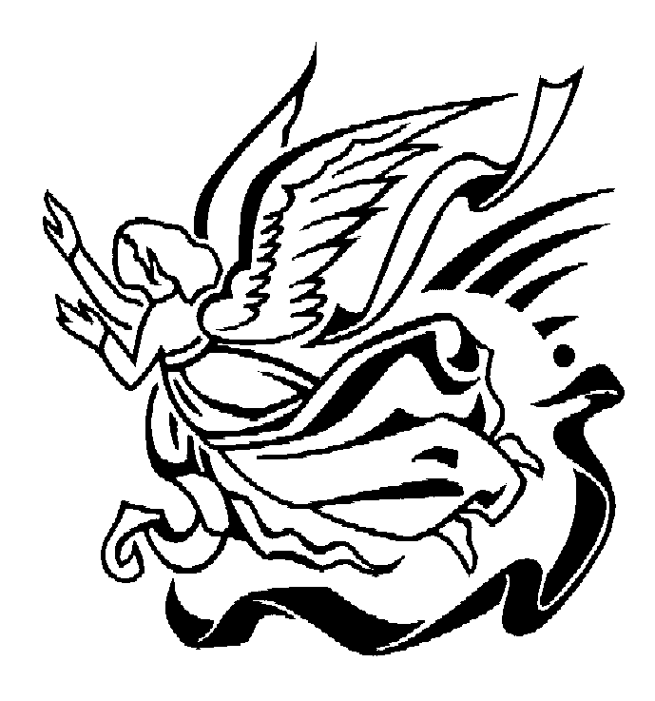
Love came down at Christmas,
Love all lovely, love divine;
Love was born at Christmas,
Star and angels gave the sign.
Worship we the Godhead,
Love incarnate, love divine;
Worship we our Jesus:
But wherewith for sacred sign?
Love shall be our token,
Love shall be yours and love be mine,
Love to God and to all men,
Love for plea and gift and sign.

I heard the bells on Christmas Day
Henry Wadsworth Longfellow (1807-1882)

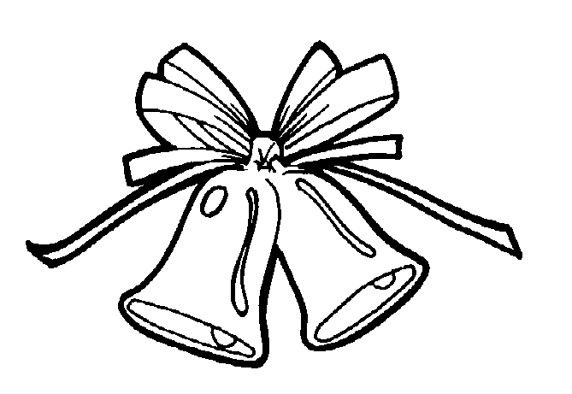
I heard the bells on Christmas Day
Their old familiar carols play
And mild and sweet the words repeat,
Of peace on earth, good will to men.
I thought how as the day had come,
The belfries of all Christendom
Had roll'd along th' unbroken song
Of peace on earth, good will to men.
And in despair I bow'd my head:
"There is no peace on earth," I said,
"For hate is strong, and mocks the song
Of peace on earth, good will to men."
Then pealed the bells more loud and deep:
"God is not dead, nor doth He sleep;
The wrong shall fail, the right prevail,
With peace on earth, good will to men."
'Til ringing, singing on its way,
The world revolved from night to day,
A voice, a chime, a chant sublime,
Of peace on earth, good will to men!

