Balance the books!

You have finally got your first job! You are an office junior earning £8,500 per year. Does that sound a lot? It’s just about £710 per month… or £610 per month after tax. How much would you spend on each of the following?

There are cards showing various options: pick the ones you like the sound of & write them down… then change them around until you can afford them all! Then list what’s not included!

 | Somewhere to live! | Yes, you need somewhere!
 | Bills – gas, electricity, council tax | THESE ARE COMPULSORY… but they might be cheaper if you share your home.
 | Food! | How much do you want to eat out?
 | Phone | If you want a phone at home you’ll have to pay the bill
 | Internet access | Going online… which option?
 | Mobile phone | Can’t live without your mobile?
 | Transport | How will you get about?
 | Television | If you want a TV you’ll need a TV licence
 | Birthdays & Christmas | How many people do you want to buy birthday & Christmas presents for?
 | Savings | Are you going to put anything aside “for a rainy day”?
 | Hobbies | How are you going to spend your spare time?
 | Holidays | Getting away from it all… how often, how long & where?

Somewhere to live



Where would you like to live? And where can you afford to live??

Here is a rough idea of how much it’ll cost to live in various places:

With generous parents: £200/month
With friends – rent a flat in town: £250/month
On your own – rent a 1 bedroom flat in town - £420/month
On your own – buy a 3 bedroom flat in …………. - £250/month
On your own – buy a 1 bedroom flat in ……………. - £385/month
On your own – buy a 3 bedroom house in ………… - £1065 /month

Bills

(gas, electricity, council tax)



The only time you get these free is if you’re living with your parents!

Otherwise you’ll be paying something like …

Shared flat - £30/month
Own flat - £120/month
Own house - £160/month

Food!

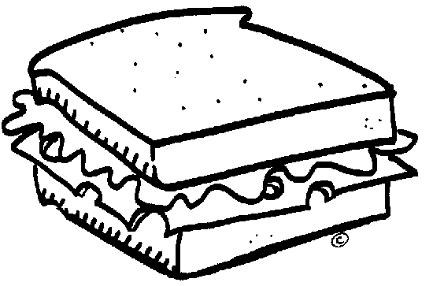

How much do you eat?? And where?
You’ll need THIRTY each of breakfasts, lunches and teas.
Pick from…

Breakfast at home – 50p
Breakfast at Starbucks – £3

Lunch at sandwich shop – £3
Lunch or tea at chip shop – £4
Packed lunch – £1
Lunch or tea at Macdonalds – £4

Tea made yourself - £1.50
Tea (microwave ready meal) - £2.50
Tea at Pizza Hut or Pub - £6
Tea at Restaurant - £20

The absolute minimum you can spend here is £3 per day, which is £90 per month (£15 for breakfasts, £30 for lunches, £45 for teas). Actually you can live on less, but it can be quite hard work!

Internet access

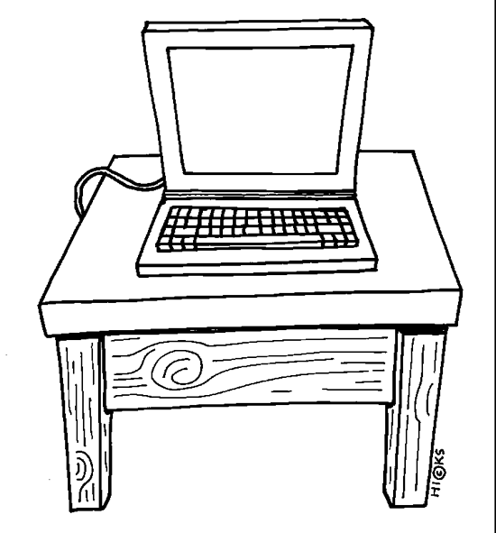

Broadband £25/month
Unmetered access £15/month
Free weekends and evenings £7/month

Telephone



Mobile or landline, both or neither? You decide!

Landline

Just in case - £12/month
Local cheap rate calls only - £15/month
Mostly cheap rate calls - £25/month
Include calls during the day - £50/month

Mobile
(and no, you don’t have to have one if you don’t want!)

Just in case - £15/month
Use it occasionally - £25/month
Use it quite a lot - £40/month
Use it all the time - £80/month
Transport

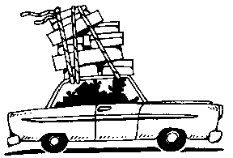

Bus

Bus pass £33/month

Car

insurance £25/month
road tax £10/month
servicing £20/month (or £5/month if you can do it yourself)
(these are compulsory if you are going to have a car)

If your car is new, you’ll probably be buying it on credit so add:
£200/month for a small car
£375/month for a medium sized car

Bicycle

£2/month & you’ll get much fitter!

Television

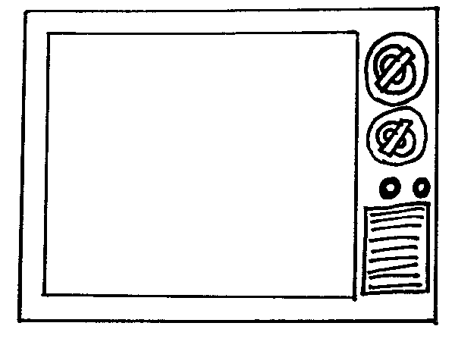
If you have a TV at all then you will need:
TV licence £10/month

Plus if you want more than 5 channels…
Sky – basic package - £12.50/month
Sky – films & other channels - £35/month

Birthdays & Christmas



Christmas

If you buy presents for 6 people and spend £20 on each one then spreading the cost over the year makes it £10/month.
If you buy for only 3 people that’s £5/month
If you buy for 12 people that’s £20/month

If you get cheaper presents you can pay only half that.

If you want to buy expensive presents there is no upper limit to how much you can pay!

Birthdays
Use the same costs – are you more generous for birthdays or for Christmas?

Savings



How much are you going to save, and what for?

Save to buy something special, or for a big holiday, or just save for a rainy day.

Shopping



Books - £6 for a paperback, £16 for a hardback

CDs - £8 for an oldie, £16 for a chart album

Clothes - £20+ per item

What else are you likely to buy?

Hobbies



What will you do when you’re not at work?

Gym membership £25/month
Swimming £2.50 per visit
Cinema - £5 per visit
Football match - £25 each or £25/month season ticket
Theatre - £15 per visit
Bowling - £5 per visit
Be a Guide leader! – free ☺

Holidays

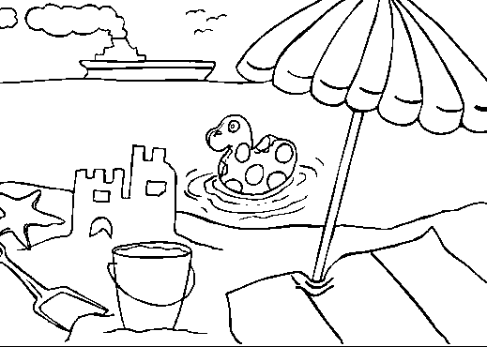

You can take as many as you can afford… but remember most jobs only give you about 4 weeks off, and that includes odd days here and there.

Week camping in the Lake District (eating out) - £150, ie. £12/month
Two weeks in Spain - £600, equivalent to £50/month
Two weeks in Florida - £800, equivalent to £67/month
Weekend in London (with hotel and show) - £300, ie. £25/month
Week in b&b in the Highlands - £300, ie. £25/month
3 weeks travelling around Europe - £700, ie. £58/month
Long weekend in Paris - £300, ie. £25/month
Long weekend adventure holiday - £300, ie. £25/month
CHANCE CARDS

Cut these up and deal them out at random to the teams (one per team, or more if you like). Afterwards, find out if the “bank error” people spent their money – did they realise they’d have to pay it back??

CHANCE CARD  ☹  A relative is ill & you have to visit – last minute travel costs £200 | CHANCE CARD  ☺  Bank error in your favour! £200 | CHANCE CARD  ☺  You get 4 numbers on the lottery and win £80
CHANCE CARD  ☹  Your toilet starts leaking – plumber £60 or DIY £10 if you know how | CHANCE CARD  ☹  The dentist says you need to have a filling - £20 basic NHS, £50 private | CHANCE CARD  ☹  You lose your job – from next month you’ll have almost no money coming in, how much can you save?
CHANCE CARD  ☹  You lose your new winter coat & have to buy another - £80 | CHANCE CARD  ☺  You find £10 in the street | CHANCE CARD  ☺  You get a raise! An extra 5% on your pay packet

